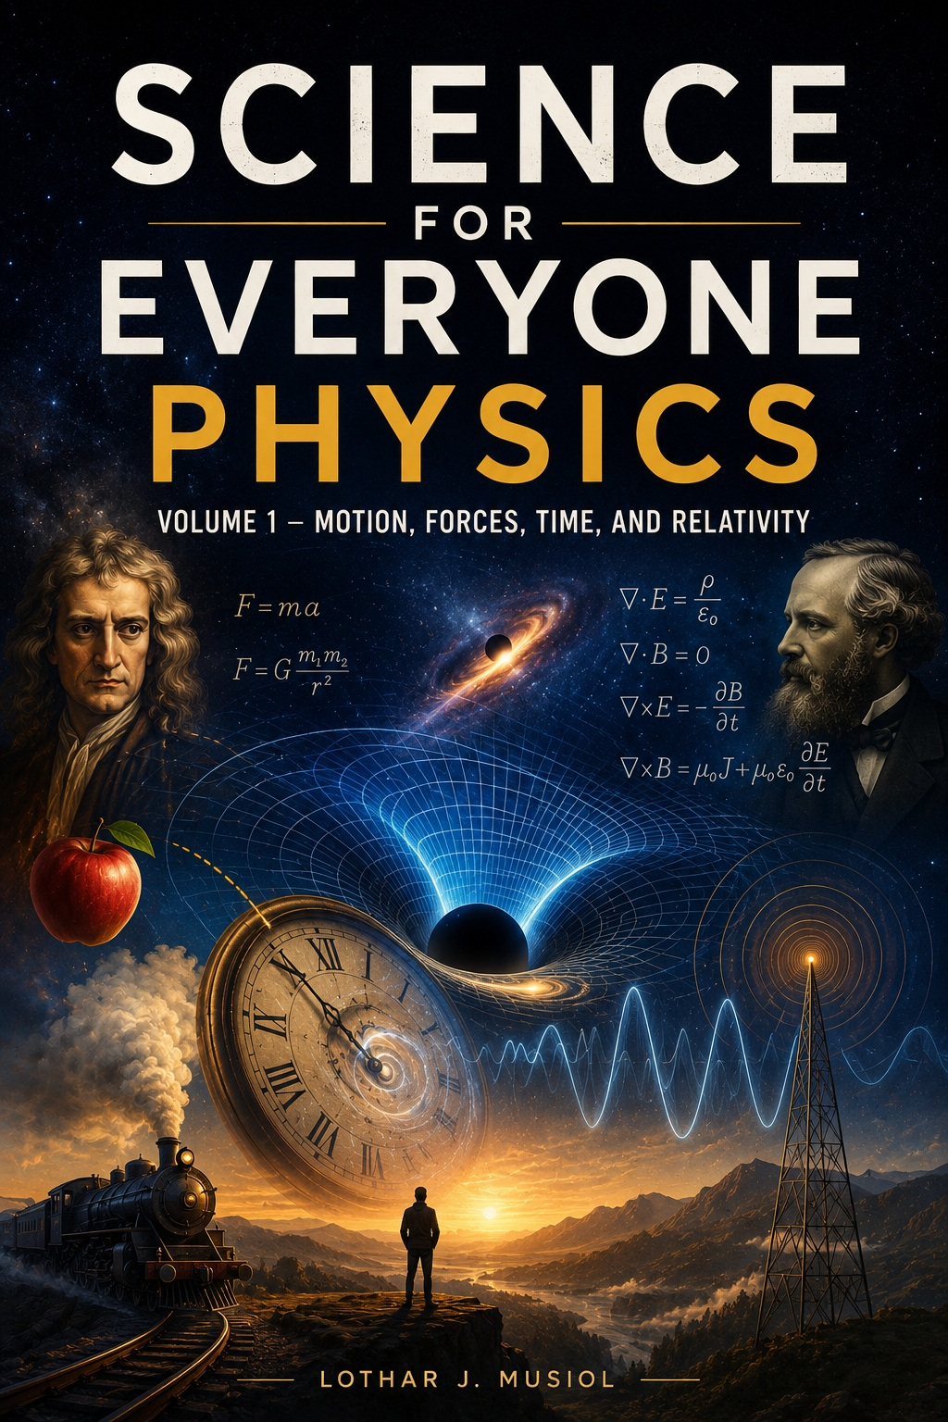

Science for Everyone: Physics

Volume 1 - Motion, Forces, Time, and Relativity

A Science for Everyone Volume

Lothar J. Musiol

Copyright © 2026 Lothar J. Musiol
All rights reserved.

No part of this publication may be reproduced, distributed, or transmitted in any form or by any means, including photocopying, recording, or other electronic or mechanical methods, without the prior written permission of the author, except in the case of brief quotations embodied in critical reviews and certain other noncommercial uses permitted by copyright law.

This book is intended for general educational and informational purposes. Every effort has been made to ensure the accuracy of the science described; some topics discussed represent active or speculative areas of research, and this is noted in the text where relevant.

First edition.
Science for Everyone series
Table of Contents

Prologue: Newton, Maxwell, and the Universe Before It Became Weird
Chapter 1: Electricity, Magnetism and Radio Waves
Chapter 2: The Universe Is Stranger Than You Think
Chapter 3: Motion Is a Matter of Perspective
Chapter 4: Forces
Chapter 5: Energy
Chapter 6: Momentum
Chapter 7: Angular Momentum and Spin
Chapter 8: Springs, Pendulums, and their Rhythm
Chapter 9: Waves
Chapter 10: Least Action
Chapter 11: Light
Chapter 12: Why Does Time Have a Direction?
Chapter 13: What Is Time Anyway?
Chapter 14: Does Time Really Exist?
Chapter 15: The Direction of Time
Chapter 16: The Omega Point
Chapter 17: A History of Measuring Time
Chapter 18: Special Relativity
Chapter 19: Limits of Nature

Also in This Series

Volume 2 — Gravity, Cosmology, and the Quantum World
Volume 3 — Particles, Fields, and How Physics Thinks
Volume 4 — Quantum Technology and the Frontiers of Physics

Science for Everyone

PROLOGUE

Newton, Maxwell, and the Universe Before It Became Weird

Before the Universe Became Weird
Before quantum mechanics. Before curved spacetime. Before black holes. Before anyone seriously suggested that reality might be holographic—or simulated.
There was a simpler universe. At least, it looked simpler. Objects had positions. Forces pushed them.
Light travelled. Clocks ticked. And if you knew enough about everything now, you could imagine calculating what happened next. Then two men arrived who changed that picture forever.
One was Isaac Newton. The other was James Clerk Maxwell. They did not merely add facts to physics. They changed what physics was.

Newton's Apple Has Been Given Too Much Credit
The famous apple story is useful because it captures the essential question. Why does an object fall? Newton's great achievement was not discovering that apples fall. People had noticed.
His achievement was realizing that the same law governing the falling apple could govern the Moon. The Earth pulls the apple. The Earth pulls the Moon. The difference is not the law.
It is the circumstances. Suddenly the heavens and the Earth belonged to the same physics. That was an extraordinary act of simplification.

The Universe Becomes a Machine
Newton's laws gave physics a remarkable ambition. If you knew the forces and the initial conditions, you could calculate what happened next. Planets became predictable. Projectiles became predictable.
Tides became understandable. The solar system became a dynamical system. Nature looked almost mechanical. This picture became so successful that generations of scientists began to believe that the universe itself was fundamentally a gigantic clockwork machine.
There was only one small problem. The universe had not agreed to be one.

Time Was Absolute—Or So It Seemed
Newton treated space and time as an absolute stage. Space existed. Time flowed. Events happened on that stage.
Everyone, in principle, shared the same universal time. It was an extraordinarily useful picture. For everyday life, it still works beautifully. Your breakfast does not require Lorentz transformations.
Neither does a bus timetable. But eventually physics began moving objects faster, measuring light more precisely, and asking questions Newton's stage could not answer.

Then There Was Electricity
Electricity had been known as a collection of curious phenomena. Magnets were another curiosity. Charges attracted and repelled. Currents produced magnetic effects.
But nobody had yet seen the great unity. Then nineteenth-century physics began connecting the pieces. Electricity and magnetism were not two unrelated subjects. They were aspects of one electromagnetic theory.

Maxwell Sees the Pattern
James Clerk Maxwell took the experimental laws of electricity and magnetism and turned them into a mathematical theory of fields. This was a conceptual revolution. The universe was no longer merely a collection of objects exerting forces on other objects. There were fields filling space.
An electric field. A magnetic field. And, most astonishingly, the equations predicted that disturbances in those fields could travel as waves.

The Speed of the Wave
Maxwell calculated the speed of electromagnetic waves. It came out astonishingly close to the measured speed of light. The conclusion was almost unavoidable: light is an electromagnetic wave.
Think about what had just happened. Optics. Electricity. Magnetism.
Three subjects that had seemed different had collapsed into one theory. Physics had found another layer of unity.

The Trouble With Maxwell
But Maxwell's theory created a new problem. If light is a wave, what is waving? Sound needs air. Water waves need water.
What was carrying an electromagnetic wave? Physicists proposed an invisible medium: the ether. It sounded reasonable. It also turned out not to be necessary.
The attempt to detect Earth's motion through the ether failed to reveal the expected effect. Something was wrong. And this time, the problem was not Maxwell's equations. The problem was the old idea of absolute space and time.

Einstein Walks Through the Door
In 1905, Einstein took the next step. What if the speed of light is the same for all inertial observers? Then Newton's absolute time cannot survive unchanged. Space and time must adjust.
Clocks can disagree. Lengths can differ. Simultaneity becomes relative. And the universe acquires a four-dimensional structure:
spacetime. The Newtonian stage has disappeared. The actors are still there. The stage itself has become part of the physics.

From Newton to Maxwell to Einstein
That is the real beginning of this book. Newton unified terrestrial and celestial motion. Maxwell unified electricity, magnetism and light. Einstein unified space and time—and then made gravity itself part of spacetime geometry.
Quantum mechanics came next and challenged our ideas about matter, measurement and reality. Quantum field theory went deeper. Cosmology turned the entire universe into an object of physical investigation. And now we ask questions that Newton could not possibly have anticipated:
Does spacetime emerge? Is information fundamental? Could entanglement be connected to geometry? Could reality itself be simulated?
The journey begins with a falling apple. It ends somewhere much stranger.

One Last Look Back
Newton gave us laws of motion. Maxwell gave us fields. Together, they helped create the classical world—the world in which physics seemed to be about objects moving through space under forces. Then physics discovered that space and time are not what they seemed.
Matter is not what it seemed. Light is not what it seemed. And the vacuum is not what it seemed. That is why we start here.
Not because Newton and Maxwell were wrong. Because they were so right that their theories carried us to the questions they could not answer.

Now Turn the Page
The universe is about to become much less polite. Time will slow down. Space will curve. Stars will collapse.
Quantum particles will refuse to behave. Empty space will turn out not to be empty. Particles will become excitations of fields. Entanglement will connect distant measurements.
And somewhere along the way, we will discover that the deepest questions are not always the ones with the longest equations. Sometimes they are very simple: What is space? What is time?
What is matter? What is information? And finally: What, exactly, is real?
Let us begin.

Science for Everyone

Chapter 1

Electricity, Magnetism and Radio Waves: The Invisible Forces Around Us

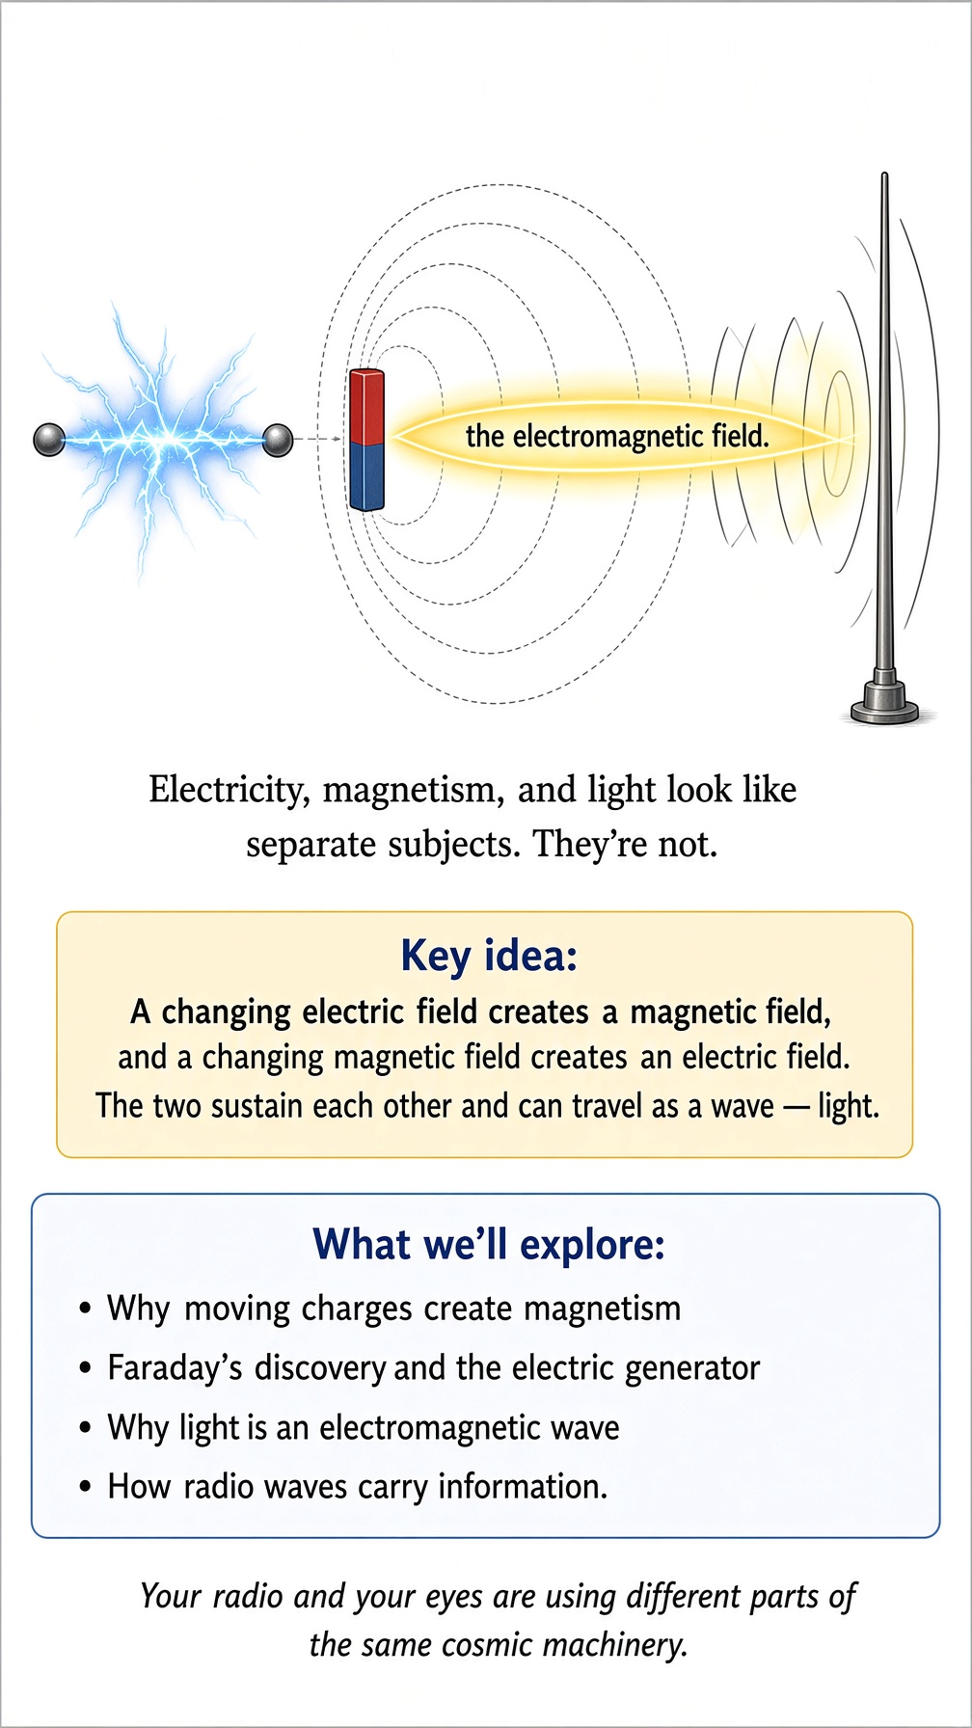

You Are Already Living in an Electromagnetic Universe
Before we talk about relativity, quantum mechanics, black holes, or the expanding universe, we need to meet something you have been surrounded by your entire life: electromagnetism. Electricity runs your refrigerator. Magnetism makes your speakers work. Light lets you read this sentence. Radio waves bring signals to your phone, television, GPS receiver, and Wi-Fi router.
These may look like separate subjects. They are not. They are different faces of one of the great structures of physics: the electromagnetic field.

Electric charge: the first oddity
Some particles carry a property called electric charge. Electrons have negative charge. Protons have positive charge. Neutrons have no net electric charge.
Like charges repel. Unlike charges attract. That sounds simple enough. Then you ask the obvious question: why?
Physics can describe the force extraordinarily well, but at the deepest level we eventually stop saying “because something pulls” and start talking about fields and interactions. The universe does not provide a little mechanical hook attached to every electron.

An electric field is not an invisible wind
Put an electric charge somewhere and it changes the electromagnetic environment around it. We describe that change with an electric field. If another charged particle enters the region, the field tells us what force it experiences. This is much more useful than imagining one charge reaching across empty space with a tiny invisible arm.
The field exists throughout space and gives the interaction a local description. Physics likes local rules. The universe apparently prefers doing its bookkeeping one neighborhood at a time.

Magnets are not magic either
Magnets have been confusing people for a very long time. A magnet can attract a piece of iron without touching it. Put two magnets together and they can attract or repel depending on how they are oriented. The familiar picture of little magnetic poles is useful, but electromagnetism goes deeper.
Magnetic fields are connected to moving electric charge. And electricity and magnetism are not really two independent forces. They are parts of the same electromagnetic field.

Moving charges make magnetism
Run electric current through a wire and a magnetic field appears around the wire. That is not a coincidence. Moving charge produces magnetic effects. This immediately gives us a beautiful connection: electricity can produce magnetism.
But the story goes the other way too. A changing magnetic field can produce an electric field. The two are talking to each other. Once you see that, the word “electromagnetism” stops looking like a committee meeting and starts making sense.

Faraday's great discovery
Michael Faraday discovered experimentally that changing magnetic fields can induce electric currents. Move a magnet through a coil of wire and you can produce an electric current. Move it the other way and the current reverses. Stop changing the magnetic field and the induced effect disappears.
This is the principle behind electric generators. A power station is therefore, at a fundamental level, an elaborate way of moving magnetic fields and conductors around so that electrons are persuaded to rearrange themselves.

Maxwell puts the pieces together
James Clerk Maxwell took the experimental laws of electricity and magnetism and turned them into a unified mathematical theory. Then he noticed something astonishing. A changing electric field can produce a magnetic field. A changing magnetic field can produce an electric field.
That means the two fields can sustain one another and travel through space. A self-propagating electromagnetic disturbance. A wave. Light.

Light is an electromagnetic wave
Maxwell's equations predicted the speed of electromagnetic waves from electrical and magnetic constants. The result was extraordinarily close to the known speed of light. That led Maxwell to a spectacular conclusion: light itself is an electromagnetic wave. Visible light is therefore not a completely separate phenomenon from electricity and magnetism.
It is electromagnetic radiation that happens to fall within the narrow range of frequencies our eyes can detect. Your eyes are electromagnetic detectors. Very sophisticated ones. They also complain if someone shines a laser pointer into them, which is a useful reminder that sophistication does not imply invulnerability.

The electromagnetic spectrum
Visible light is only a tiny slice of the electromagnetic spectrum. At lower frequencies we have radio waves and microwaves. Then come infrared waves. Then visible light.
Beyond visible light are ultraviolet, X-rays, and gamma rays. They are not seven different kinds of mysterious stuff. They are electromagnetic radiation with different frequencies and wavelengths. The same basic electromagnetic field is involved throughout the spectrum.
Your radio and your eyes are therefore using different parts of the same cosmic machinery.

Radio waves: invisible light
A radio wave is an electromagnetic wave. It is not sound traveling through the air. That distinction matters. Sound needs a material medium such as air, water, or a solid.
Radio waves do not. They can travel through the vacuum of space. When a radio transmitter sends a signal, it creates changing electromagnetic fields that propagate outward. A radio receiver detects the electromagnetic disturbance and converts it into an electrical signal.
Your favorite song has therefore been transformed several times before it reaches your ears.

How an antenna talks to space
An antenna contains electric charges that can be driven back and forth. Accelerating charges produce changing electromagnetic fields. Those changing fields can propagate outward as radio waves. At the receiving end, the incoming electromagnetic wave causes charges in another antenna to move.
The receiver extracts information from that tiny electrical response. The basic process is wonderfully simple. The engineering required to do it reliably while millions of devices shout at once is considerably less simple.

Why radio waves can carry information
A radio wave by itself is just a physical electromagnetic signal. To communicate information, we modify some property of the wave. We can change its amplitude, frequency, phase, or other features. This is called modulation.
The receiver measures the changes and reconstructs the information. That information might be speech, music, a television image, a text message, or the location data that helps your phone decide where you are. The electromagnetic wave is the carrier. The changing pattern is the message.

Radio, television, Wi-Fi, and your phone
Different technologies use different frequency ranges and modulation schemes, but the underlying physics is electromagnetic. Radio broadcasting uses radio waves. Television uses electromagnetic radiation. Wi-Fi uses radio-frequency electromagnetic waves.
Bluetooth does too. Cellular networks use electromagnetic radiation. GPS signals are electromagnetic waves traveling from satellites to receivers on Earth. The modern world is therefore absolutely saturated with invisible electromagnetic traffic.
If you could see all of it, the sky would look considerably busier.

Why light can travel through empty space
Sound cannot cross the vacuum between planets because sound is a vibration of matter. Light can. Radio waves can. That is because electromagnetic waves are not vibrations of air.
They are propagating changes in the electromagnetic field. This is one reason Maxwell's theory was so revolutionary. It turned light into a phenomenon of fields rather than requiring a material substance through which light had to move.

The mysterious ether
For a long time, physicists wondered whether light needed a medium. Sound needs air. Water waves need water. Perhaps light needed an invisible substance called the ether.
It was a reasonable idea. Experiments designed to detect Earth's motion through this supposed ether failed to find the expected effect. The Michelson–Morley experiment became famous for this reason. The failure did not immediately solve the mystery, but it helped prepare the ground for special relativity.

Einstein removes the ether
Einstein's special theory of relativity changed the question. The speed of light in vacuum is the same for all inertial observers. You do not have to imagine light moving through a preferred invisible medium. Instead, space and time themselves adjust in the way required by the geometry of spacetime.
This is where our electromagnetic story joins relativity. Maxwell's equations were already hinting that c was special. Einstein showed that taking that fact seriously changes our understanding of space and time.

Electricity and magnetism depend on the observer
Here is one of the most beautiful consequences. An electric field in one reference frame can appear partly as a magnetic field in another. Electricity and magnetism are therefore not completely separate things. They are different aspects of the electromagnetic field seen from different states of motion.
This is deeply related to special relativity. What one observer calls “mostly electric” another observer can describe as a mixture of electric and magnetic effects. The universe is not changing its mind. We are changing how we slice spacetime.

Energy travels in the field
When electromagnetic radiation travels from the Sun to Earth, there is no material substance that has to make the journey like a stream of tiny bullets. Energy and momentum are carried by the electromagnetic field. That energy can later be absorbed by matter. A plant can use sunlight to build chemical energy.
A solar panel can turn it into electrical energy. Your skin can turn some of it into heat. The field carries the energy across space, and matter can receive it.

The bridge to quantum physics
Maxwell's classical theory describes electromagnetic waves beautifully. But eventually the theory runs into the quantum world. Light can behave as though it arrives in individual packets called photons. The photoelectric effect shows that light's interaction with matter depends on discrete amounts of energy.
This is where our classical electromagnetic story becomes the doorway into quantum mechanics. The wave and the photon are not competing stories. Quantum electrodynamics eventually provides the deeper framework that contains both.

One force, many familiar experiences
Static electricity. Magnets on your refrigerator. Electric motors. Generators.
Radio. Microwaves. Visible light. X-rays.
All of these belong to the same electromagnetic family. The same field that makes your phone communicate with a cell tower also makes the Sun visible. That is a rather extraordinary thing to discover hiding inside everyday life.

Why this chapter comes first
We began the book with the broad idea that physics is about finding the hidden unity behind apparently unrelated phenomena. Electricity and magnetism are one of the best examples. Faraday saw connections between changing magnetic fields and electric currents. Maxwell unified the equations and discovered that electromagnetic disturbances should propagate as waves.
Light turned out to be part of the same family. Radio waves turned out to be invisible light. Einstein then showed that the structure of electromagnetism points directly toward a new understanding of space and time.

The electromagnetic picture to remember
If you remember only a few things from this chapter, remember these. Electric charge produces electric fields. Moving and changing charges produce magnetic effects. Changing magnetic fields produce electric fields.
Electric and magnetic fields are aspects of one electromagnetic field. Electromagnetic disturbances can propagate as waves. Light is electromagnetic radiation. Radio waves are electromagnetic radiation at lower frequencies than visible light.
The electromagnetic field carries energy and momentum. And the speed c is built into the structure of electromagnetism.

One last radio wave
Imagine a radio signal leaving an antenna. It travels outward at the speed c. It does not need air. It does not need a material ether.
It is a changing electromagnetic field propagating through spacetime. Eventually it reaches another antenna. Charges there respond. Electronics amplify and interpret the signal.
A speaker moves. Air vibrates. And suddenly a human voice is in the room. A chain beginning with Maxwell's equations has ended with somebody saying, “Can you turn that down?”
That is physics.

Chapter 2

The Universe Is Stranger Than You Think

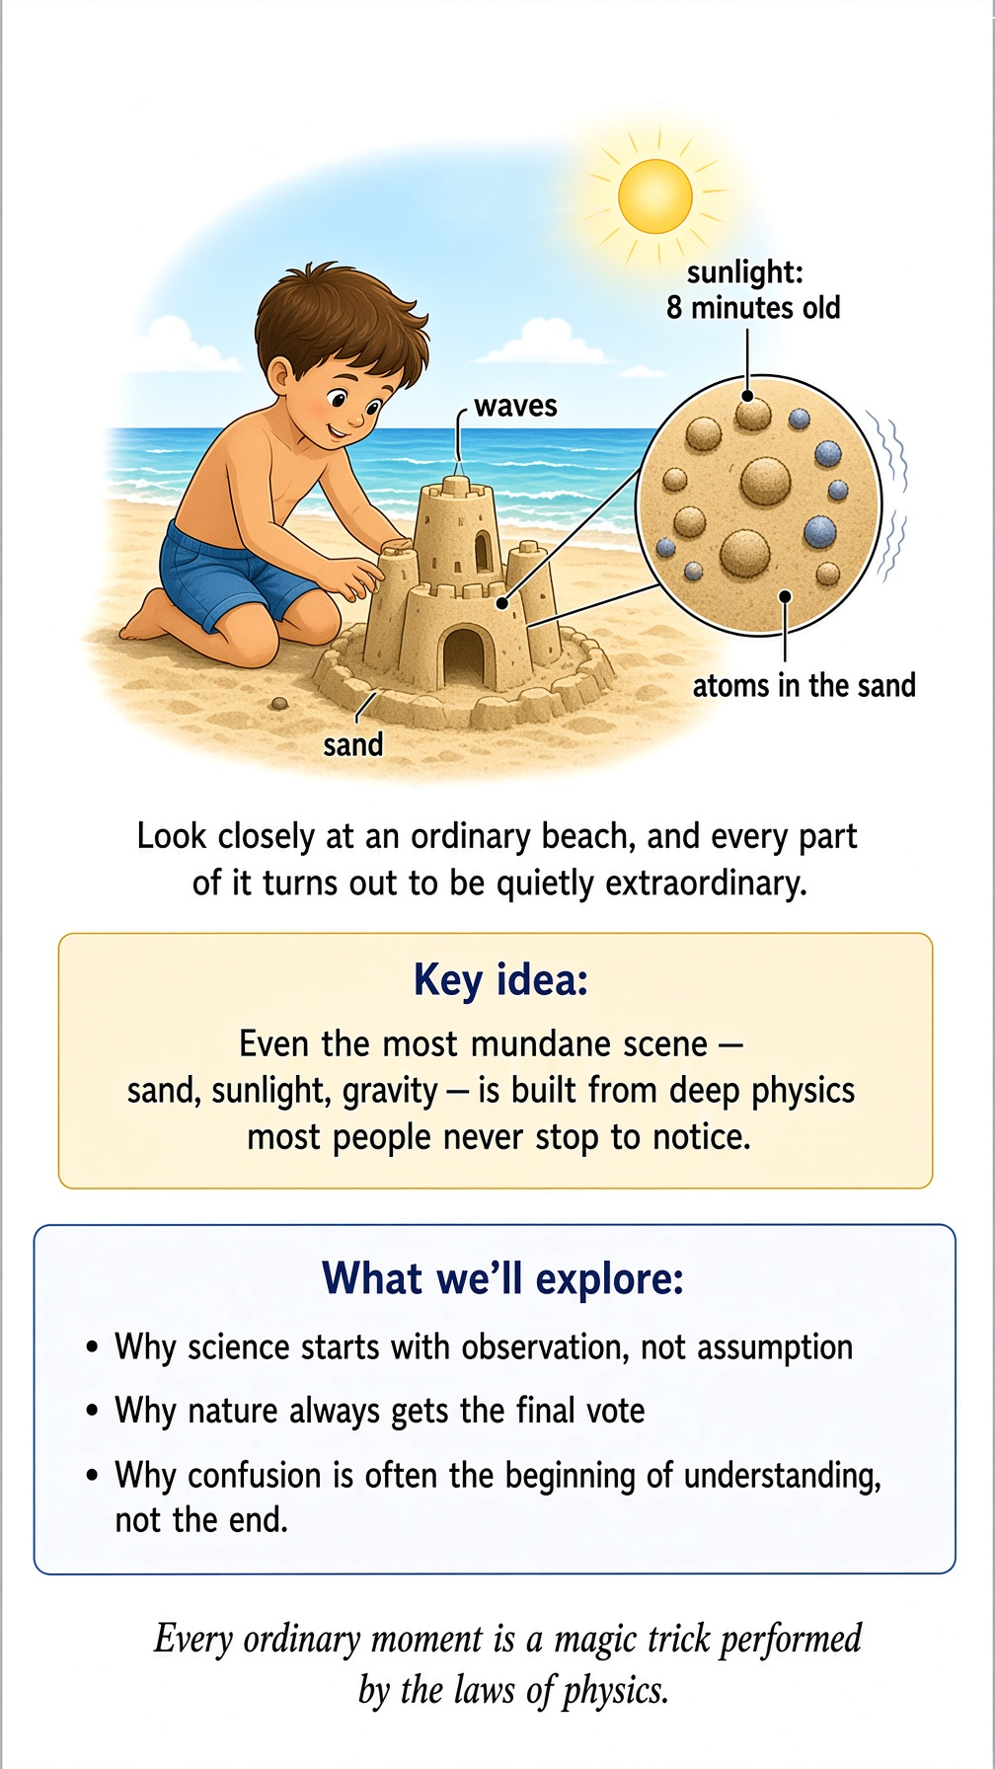

Suppose you are standing on a beach. There is nothing particularly scientific about this. You are probably thinking about the ocean, the weather, whether you remembered the sunscreen, and why sand manages to get into places where sand has absolutely no business being. Now look out at the water. A wave comes toward you. It rises, curls, and breaks. You could simply say, “Nice wave.” And that would be perfectly reasonable.
But physics has a rather peculiar habit of asking annoying questions. What exactly is a wave? What is moving? The water, perhaps? But if the water itself is traveling toward you, why doesn't the entire ocean eventually end up on the beach? It doesn't.
The wave comes toward you, but the water mostly goes up and down. Already, something interesting has happened: The thing that carries something is not necessarily the thing that travels with it. That sounds like a small distinction. It isn't. It is one of the great ideas of physics. And once you start looking for such distinctions, the ordinary world begins to look rather strange.
For example, consider a stadium crowd doing “the wave.” The people aren't actually traveling around the stadium. If they were, the manager would have a serious problem. The people mostly stand up, sit down, and pass the pattern along. The wave travels. The people don't. Physics is full of things like this: patterns that travel through stuff without the stuff itself making the journey.

The universe does not look like a physics textbook
Physics is often presented as a collection of equations. You are shown something like F = ma and told that this is Newton's second law.
Then someone gives you a problem: a block of mass 4 kilograms is pushed by a force of 20 newtons. What is its acceleration?
20 N ÷ 4 kg = 5 m/s²
Wonderful. You have successfully made a block accelerate.
Unfortunately, you have not necessarily understood anything. The important question is not whether you can manipulate the equation. The important question is: Why does nature behave this way? That is the question we will keep asking throughout this book. Sometimes the answer will be mathematical. Sometimes it will be a picture. Sometimes it will be a thought experiment. And sometimes the answer will begin with something as ridiculous as an imaginary elephant falling off a roof.
Physics has no objection to ridiculous elephants. In fact, they can be very educational. There is another danger in learning physics: equations can give you the comforting illusion that you understand something because you have successfully moved symbols from one side of an equals sign to the other. This is rather like claiming you understand French because you can successfully operate a French vending machine. Useful? Certainly. The same thing? Not quite.

A strange business called “observation”
Let us perform an experiment. You don't need a laboratory. You don't even need to get off the beach. Pick up a pebble. Hold it at eye level. Now let go. It falls. Of course it does. You knew it would.
But notice what you actually observed. You did not observe “gravity.” You observed the pebble changing its position. That distinction matters.
Science does not begin by seeing invisible things. It begins by noticing what visible things do. The pebble falls. A ball rolls. A flame flickers. A shadow moves. The Moon changes position in the sky. A dropped glass hits the floor. Those are observations.
Then comes the dangerous question: Why? Humans are extraordinarily good at answering “why?” Unfortunately, we are also extraordinarily good at inventing answers. Ask a three-year-old why the sky is blue and you may receive a completely confident explanation involving clouds, dinosaurs, or the fact that blue is the sky's favorite color. Adults are not always much better. We simply use longer words.
That is why science needs experiments. Nature gets to mark the exam paper. And nature is notoriously unimpressed by confidence.

Nature gets the final vote
Imagine that you have a theory. You believe that heavy objects fall faster than light objects. It sounds plausible. A cannonball certainly feels as though it ought to fall faster than a feather.
So you perform an experiment. You drop two objects. They fall. Perhaps the heavier one arrives first. You might congratulate yourself. But then someone points out that air resistance affects the feather.
So you try two objects of different masses but similar shape. You keep experimenting. Eventually you discover something remarkable: When air resistance is removed, objects fall with the same gravitational acceleration, regardless of their mass. Nature has just told you that your original intuition was wrong. This is one of the most useful lessons in all of science: Nature does not care what seems reasonable to us.
Our brains evolved to deal with rocks, trees, predators, food, weather, and other humans. They did not evolve specifically to understand quantum mechanics, relativity, four-dimensional geometry, or why an electron can behave like a wave. Your brain is a superb device for deciding whether you should cross a road. It is not necessarily a superb device for deciding what happens to a clock traveling near the speed of light. That is not a criticism of your brain. It is simply asking a Stone Age hunter to understand a modern traffic roundabout.

The advantage of being confused
There is a peculiar moment that occurs when you are learning physics. You encounter an idea that makes no sense. At first, this feels like failure. It isn't. It is often the beginning of understanding.
Suppose I tell you that a moving clock runs slower than a clock at rest. Your first reaction might reasonably be: “What?” Good. That is exactly the reaction we want.
Because now we have a question. And a good question is more valuable than a bad answer. The purpose of this book is not to eliminate that feeling of “What?” It is to make the “What?” gradually turn into: “Oh.” And eventually: “Of course!”
The second reaction is one of the great pleasures of science. There is also a third possible reaction: “Hang on. That's still weird.” That one is perfectly acceptable too.
Some of the deepest ideas in physics never become completely ordinary. You understand them, you can calculate with them, you can predict what will happen—and they can still feel wonderfully peculiar. That is not a defect. The universe is under no obligation to make sense to our instincts.

A universe full of invisible things
Look around you. You can see a chair. You can see the ocean. You can see your hands. But you cannot see an electric field. You cannot see gravity. You cannot see an atom. You cannot see a radio wave. You cannot see the molecules in the air you are breathing.
Yet these invisible things have very visible consequences. This gives us another important idea: Science is often the art of discovering invisible rules from visible effects. You cannot see gravity itself. But you can watch a stone fall. You cannot see the magnetic field around a magnet. But you can watch iron filings arrange themselves in a pattern. You cannot see an electromagnetic wave coming from the Sun. But you can feel sunlight warming your face.
Think about Wi-Fi. Your phone is sitting there apparently doing nothing, while invisible electromagnetic waves are flying through your room carrying information. This would have looked like wizardry to people a few centuries ago. Today we get annoyed when the Wi-Fi takes three seconds longer than expected. The underlying physics has not become less astonishing. We have simply become spoiled.

The trick of changing the question
Here is one of the most powerful tricks in science. If a question seems impossible, change the question. Suppose you ask: “Why does a ball fall?” That is a perfectly good question. But perhaps we can do better. Ask: “How does its motion change as it falls?”
Now we can measure things. Where is the ball after one second? Where is it after two seconds? How fast is it moving? How does its speed change? Now we have numbers. And numbers are wonderfully difficult to argue with.
Eventually we arrive at a concept called acceleration. Acceleration is not simply “going fast.” A car traveling steadily at 60 miles per hour is moving fast, but it is not necessarily accelerating. A car changing from 30 to 40 miles per hour is accelerating. A car turning a corner can also be accelerating, even if its speedometer remains at exactly 40.
This last point tends to annoy people. The car is going 40. The speed has not changed. “How can it be accelerating?” Because velocity includes direction.
Imagine walking around a circular track at a perfectly steady pace. Your speed stays the same, but your direction changes every moment. Physics therefore says you are accelerating. Common sense says, “I'm just walking.” Physics says, “Yes. And you are also accelerating.”
This is one of the recurring themes of physics: ordinary language is useful, but sometimes nature needs a more precise vocabulary.

The world is not made of equations
There is a temptation, when learning physics, to believe that the universe is somehow made out of mathematics. It isn't. The universe is the universe. Mathematics is something we invented that happens to be astonishingly good at describing patterns in it. This distinction is important.
If a tree falls in a forest, nature does not consult Newton's equations before deciding how quickly the tree should accelerate. The tree falls. Newton's equations are our remarkably successful way of describing what happens. Mathematics is the map. Nature is the territory. And a very good map can be wonderfully useful. But you should never confuse the map with the landscape.
Imagine handing a GPS to a medieval knight. The knight might stare at the little blue line and reasonably ask where the tiny horse is. The map is not the journey. It is a representation of the journey.
Physics uses mathematics for the same reason maps are useful: patterns that are difficult to hold in our heads can become precise enough to calculate and test. And sometimes the mathematics tells us something our intuition never would have guessed.

Why bother learning physics?
There is a practical answer. Physics explains an extraordinary amount of the technology around you. Your phone works because of physics. GPS works because of physics. Electric motors, lasers, medical imaging, satellites, computers, solar panels, radio, television, and nuclear power all depend on physics.
But there is a more interesting answer. Physics gives you a different way of looking at the world. You begin to notice that a rainbow is not merely beautiful. It is sunlight being separated into its component colors. A sunset is not merely a sunset. It is light traveling through an atmosphere. A ringing bell is not merely a sound. It is matter vibrating and sending a pattern through the air.
The warmth of the Sun is energy arriving across nearly 150 million kilometers of empty space. And the fact that you are standing on the beach at all is the result of an astonishing chain of events involving stars, atoms, gravity, chemistry, geology, biology, and several billion years of cosmic history. The ordinary world is not ordinary. We simply become accustomed to it.
Your refrigerator is an example. It takes heat out of a cold box and dumps that heat into your kitchen. That sounds backwards. It is not magic. It is thermodynamics.
But if your refrigerator stopped working tomorrow, you would not stand in the kitchen admiring the laws of thermodynamics. You would shout at it. Physics explains both the miracle and the shouting.

One final experiment
Before we leave this chapter, try one experiment. Look at your hand. It appears solid. Now ask a ridiculous question: Is it really solid?
You may object that this is an absurd question. Your hand is obviously solid. You can knock on a table. You can pick up a cup. You can stand on the ground. Everything seems solid.
But your hand is made of atoms. Atoms are mostly empty space. The apparent solidity of matter comes from the behavior of particles and the electromagnetic interactions between them—not from tiny billiard balls packed together like marbles in a box. So the table is solid. Your hand is solid. The floor is solid. And yet, at a deeper level, the universe is doing something much stranger than the word “solid” suggests.
Try another thought experiment. Imagine shrinking yourself. Not shrinking like in a fairy tale, where you suddenly need a thimble for a bathtub. Really shrinking. Smaller and smaller.
Eventually you would encounter structures that your everyday senses never reveal. The apparently smooth surface of the table would have a microscopic story. The air around you would become a swarm of molecules. The solid object beneath your hand would become a vast collection of atoms and fields and interactions.
The world you experience is real. But it is not the whole story. That is the pattern we will follow throughout the book. We will take things that seem obvious. Then we will ask questions about them. And sometimes, when we look closely enough, the obvious answer will turn out to be wrong.
That is not a problem. That is the fun. Because physics is not really the study of things that are difficult. It is the study of things that are familiar enough to overlook and strange enough to surprise us when we finally look properly.
So let us begin. The universe is waiting. And it has some explaining to do.

Chapter 3

Motion Is a Matter of Perspective

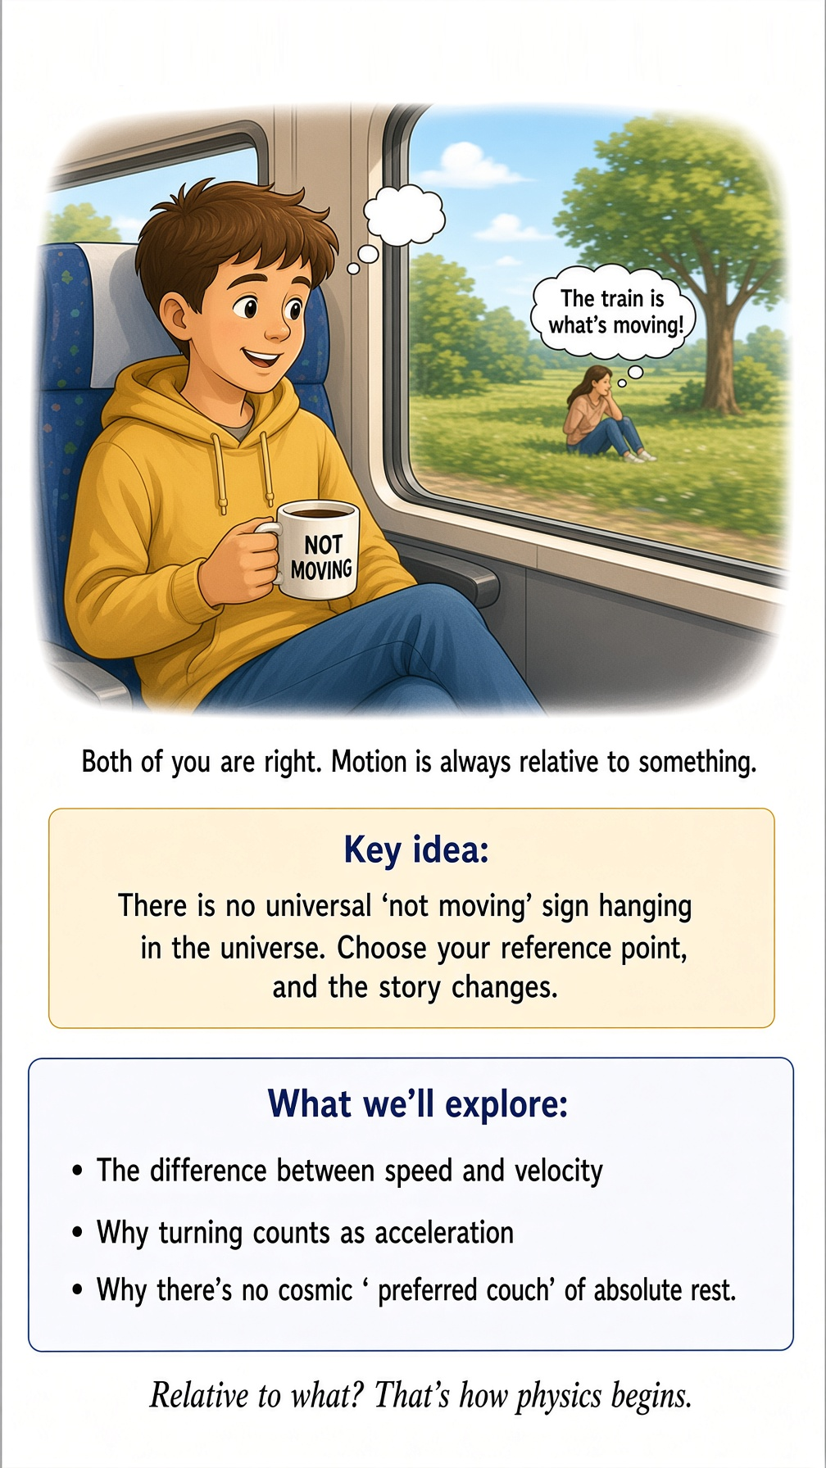
Imagine you are sitting in a train. The train is moving smoothly through the countryside. You look out the window and see a tree. The tree appears to move backward. Obviously, you think. You are sitting still, and the tree is moving. But now imagine someone sitting under that tree. To them, the tree is sitting perfectly still. And you? You are the thing moving. So who is right? Both of you.
This sounds like a philosophical trick, but it is actually physics. Motion is not something an object simply “has.” Motion is something we describe relative to something else. And this turns out to be much more important than it sounds.

The universe has no “still” sign
Let's make the situation slightly more ridiculous. You are sitting in a perfectly smooth train, eating a sandwich. The sandwich is sitting on the table. As far as you are concerned, the sandwich is stationary. You could even put a little label on it: “SANDWICH: NOT MOVING.”
Unfortunately, the universe has not approved your labeling system. The train is moving relative to the ground. The Earth is rotating. The Earth is orbiting the Sun. The Sun is moving through the Milky Way. The Milky Way is moving relative to other galaxies. And the entire universe is participating in a much larger cosmic dance.
Your sandwich, meanwhile, is sitting there looking innocent. So is the sandwich moving? Yes. And no. It depends what you mean by “moving.”
Relative to the train table: no. Relative to the ground: yes. Relative to the Sun: yes. Relative to the center of the Milky Way: also yes. Relative to some distant galaxy: yes, again.
The sandwich has not changed. What has changed is the reference frame from which we describe it. This is our first important idea of the chapter: To describe motion, you need a reference point.

The great art of choosing your chair
You already do this without thinking. Suppose you are sitting in your living room. Your dog walks from the sofa to the kitchen. You might say, “The dog moved five meters.” What you really mean is something like, “The dog's position changed by five meters relative to the room.” You don't normally say that because nobody wants to sound like a malfunctioning physics textbook. But the reference is there whether you mention it or not.
Now suppose your dog is sitting in the back seat of a moving car. Relative to the seat, the dog might be completely stationary. Relative to the road, the dog is moving at 60 miles per hour. Relative to a person in another car going in the opposite direction at 60 miles per hour, your dog could appear to be moving at about 120 miles per hour. Your dog, naturally, knows nothing about any of this. It is probably wondering whether you brought snacks. Physics, however, is interested.

Speed: how fast is fast?
Once we have established that something is moving, we want to know how fast. This sounds easy. A car traveling at 60 miles per hour is going 60 miles every hour. A runner traveling at 10 miles per hour is going 10 miles every hour. A snail traveling at 0.03 miles per hour is going 0.03 miles every hour. The snail may not be impressed by the number. It may have other priorities.
Speed is essentially a measure of how much distance is covered in a certain amount of time. In symbols, we can write:
speed = distance / time
That's all. No dragons. No quantum mechanics. Not even an elephant.
Yet there is a subtlety hiding here. Suppose you drive from Los Angeles to San Diego. Your trip takes two hours. The distance is about 120 miles. Your average speed is therefore:
120 miles ÷ 2 hours = 60 mph
But you probably did not drive at exactly 60 miles per hour for the entire trip. You may have driven at 70. Then 55. Then 12. Then zero. Then 72. Then zero again because someone ahead of you has apparently decided that merging onto a freeway is an activity best performed at the speed of a cautious tortoise.
Your average speed smooths all of that out. It tells us the overall rate. It does not tell us exactly what happened every second. And that distinction will become very useful.

Speedometers are surprisingly unhelpful
Your car has a speedometer. At any moment, it might say: 47 mph. That is not your average speed for the journey. It is telling you approximately how fast you are moving right now.
Physics calls this instantaneous speed. Think of it as asking: “If I could freeze time at this exact instant, how fast would I be going?” This is a slightly strange question. But physics likes slightly strange questions. In fact, many of the most useful ideas in physics come from asking what happens if we examine something over a smaller and smaller interval.
One minute. One second. One tenth of a second. One millionth of a second. Eventually we get remarkably precise descriptions of motion. And then mathematics arrives to help us handle all those tiny intervals without having to carry a stopwatch the size of a refrigerator.

Speed is not velocity
Now we have to make life slightly more complicated. Physics uses two different ideas: speed and velocity. In everyday conversation, we often use them as though they mean the same thing. Physics is less forgiving.
Speed tells you how fast something is moving. Velocity tells you how fast and in what direction. Suppose you are driving at 60 miles per hour. Your speed is 60 mph. Now imagine you turn around and drive back in the opposite direction at exactly 60 mph. Your speed is still 60 mph. But your velocity has changed.
That means something important has happened even though the number on the speedometer has stayed exactly the same. This is why turning counts as a change in motion. Imagine running around a circular track at a constant speed. You never speed up. You never slow down. But you are constantly changing direction. Therefore your velocity is constantly changing. And that means you are accelerating.
If this seems unfair, take it up with Newton. He has been unavailable for several centuries, but perhaps he will get back to you.

Acceleration is not what most people think
Ask someone what acceleration means and they will probably say: “Going faster.” That's not quite right. Acceleration means that velocity changes. That can mean getting faster. It can mean getting slower. Or it can mean changing direction.
Imagine a car traveling at 50 mph. The driver presses the accelerator. The car reaches 60 mph. Acceleration.
Now imagine the driver brakes and drops from 60 to 40 mph. Acceleration again—this time in the opposite direction. Now imagine the car travels around a curve at a constant 50 mph. Still accelerating.
Your everyday intuition may protest. Physics does not care. This is an important feature of physics: Precise definitions sometimes disagree with ordinary language. That does not mean ordinary language is bad. It means ordinary language was designed for conversation, not for describing nature to six decimal places.
If your friend says, “I'm going fast,” you do not demand a vector analysis. You understand perfectly well. But when physicists want to predict what a spacecraft will do, “going fast-ish” is not quite good enough.

The peculiar business of sitting still
Let's return to your train. You are sitting in your seat. You are not moving relative to the seat. But you are moving relative to the railway station. So you are both stationary and moving.
This sounds contradictory. It isn't. The words “stationary” and “moving” are incomplete unless we specify relative to what. Now consider the Earth. You are standing on it. You feel stationary. But the Earth rotates once roughly every 24 hours. So you are moving in a huge circle around Earth's axis. At the equator, that motion is roughly 1,000 miles per hour.
You don't feel it. Why? Because you, the ground, the atmosphere, your house, your coffee cup, and your coffee are all moving together. Your coffee does not splash out of the cup every morning because the Earth is spinning. Thankfully. There are already enough problems before breakfast.
The same idea explains why you can walk around inside a smoothly moving airplane without being thrown against the back wall. The airplane, its air, and everything inside it are already moving together. You can throw a ball upward. It comes back down to roughly the same place. From inside the airplane, ordinary motion works almost exactly as it does on the ground.

The experiment you can perform without leaving your chair
Take a coin. Hold it above your hand. Drop it. It falls into your hand.
Now imagine you are inside a train moving at constant speed. Hold the coin and drop it. Where does it land? If the train is moving smoothly, it lands in your hand again. It does not fly backward and hit the wall.
Why not? Because before you dropped it, the coin was already moving forward along with you. When you release it, it keeps that forward motion. At the same time, gravity pulls it downward. The result is that, from inside the train, it appears simply to fall straight down.
This is an extraordinarily important idea. Objects do not need to be pushed continuously in order to keep moving. That may sound obvious now. Historically, it was not obvious at all.

The universe has no preferred couch
There is another consequence of all this. If you are sitting comfortably in a room and the room is moving at a constant velocity, you have no simple experiment you can perform entirely inside the room that tells you: “Aha! We are moving at exactly 37 miles per hour through space!” You can measure motion relative to things outside. But there is no universal cosmic couch labeled: ABSOLUTE REST — PLEASE SIT HERE.
That idea was once deeply puzzling. Eventually, physicists discovered that the laws of motion work beautifully without needing a universal state of rest. And this prepares us for one of the great revolutions in physics. Because once we start asking whether motion is relative, we inevitably begin asking: What about time?
If two observers are moving relative to one another, do they necessarily agree on how much time has passed? For everyday speeds, the answer appears to be yes. For speeds approaching the speed of light, nature gives a much more interesting answer. But we are getting ahead of ourselves. First, we need to understand something even more basic.

A universe where change matters
Everything we have discussed so far can be reduced to a surprisingly simple idea: Physics is largely about change. Where is something? Where was it before? Where will it be later? How quickly is its position changing? How is that rate changing?
These questions sound almost embarrassingly simple. But keep asking them carefully, and they lead us toward Newton's laws, energy, momentum, relativity, and eventually the structure of the universe itself. This is one of the recurring pleasures of physics. The deepest ideas often begin with questions a child could ask. The difference is that physicists are stubborn enough to keep asking them after everyone else has become bored.
So the next time you are sitting in a moving car, look at the person beside you. You are both moving. Neither of you is moving. The road is moving relative to neither of you. The Earth is moving beneath you. The Earth is spinning. The Earth is orbiting the Sun. And somewhere in all of this, you are probably arguing about who should have taken the next exit.
Physics does not stop ordinary life from being ordinary. It simply reveals that ordinary life is taking place inside something vastly stranger. And that is where our journey continues.

Chapter 4

Forces: Why Things Don't Just Keep Doing What They're Doing



Put a coffee cup on a table. It sits there. You leave it alone. It continues to sit there. This seems so uninteresting that nobody has ever made a blockbuster movie about it.
But something remarkable is happening. The cup is not doing anything. And yet, according to Newton's laws, this is exactly what we should expect. The cup is not secretly deciding to remain where it is. It is not tired. It is not attached to the table by an invisible emotional bond. It is simply obeying one of the most important rules in physics: An object will continue doing what it is doing unless something changes its motion.
If it is sitting still, it stays still. If it is moving in a straight line at constant speed, it keeps moving that way. This is called inertia. And once you understand inertia, you begin to realize that the surprising thing is not that objects sometimes move. The surprising thing is that they ever stop.

The problem with everyday experience
You may be thinking: “That can't be right. If I push a box, it eventually stops.” Exactly. And this is where everyday life has been quietly misleading you.
Push a heavy box across the floor. It moves. Then it slows down. Then it stops. So you might reasonably conclude: “Objects need a force to keep moving.”
It seems obvious. But it is wrong. The box stops because forces are acting on it. There is friction between the box and the floor. There may be air resistance. The force you applied is no longer there. The box is not naturally trying to stop. Friction is making it stop.
Try the same experiment on a very smooth surface. The box travels farther. Make the surface even smoother. It travels farther still. Remove friction almost completely, and the box would keep moving for a very long time.
Now we are getting closer to the strange truth. Motion does not need a reason to continue. A change in motion needs a reason. That reason is a force.

Newton's first great annoyance
Isaac Newton expressed the idea more formally in what we now call his First Law of Motion. An object remains at rest, or continues moving with constant velocity, unless acted upon by a net external force. That sentence is worth reading twice. The important word is net.
Several forces can act on an object at the same time. Imagine your coffee cup sitting on the table. Gravity pulls it downward. The table pushes it upward. The two forces balance. The cup does not accelerate.
Now imagine the table disappears. The upward force disappears. Gravity wins. The cup accelerates downward. The coffee may become considerably less useful.
This is a good example of something physicists do all the time: Instead of asking, “Is there a force?” they ask, “What are all the forces, and what is their combined effect?”

The tug-of-war nobody can see
Imagine two people pulling on a rope. One pulls to the left with 100 pounds of force. The other pulls to the right with 100 pounds. The rope doesn't accelerate. The forces cancel.
Now imagine the person on the left pulls with 120 pounds while the person on the right pulls with 100. The net force is 20 pounds to the left. The rope accelerates to the left. This is essentially what happens with objects everywhere. Forces are constantly competing. Gravity pulls. Friction resists. Muscles push and pull. Air pushes back. Springs tug. Magnets attract or repel. Electric charges push and pull.
And sometimes enormous numbers of tiny forces combine to produce something as ordinary as a chair sitting quietly in a room. The chair looks peaceful. Physics knows better.

Why you don't fall through the floor
Stand up. You are now being pulled downward by Earth's gravity. So why aren't you falling through the floor? Because the floor is pushing upward on you. This upward force is sometimes called the normal force.
No, it does not mean the floor is judging you. “Normal” here means perpendicular to the surface. The floor pushes upward. Gravity pulls downward. If the forces balance, you remain standing.
The same thing happens with the chair. The chair pushes upward on you. You push downward on the chair. The chair pushes down on the floor. The floor pushes back. And beneath all of this, Earth's gravity is pulling everything downward.
A perfectly ordinary person sitting in a perfectly ordinary chair is therefore participating in a small but very complicated force diagram. You were probably unaware of this while watching television. The universe was not.

Newton's second law
Now we are ready for one of the most famous equations in physics:
F = ma
Force equals mass times acceleration. This equation is wonderfully compact. It says that a net force causes acceleration. And the amount of acceleration depends on the object's mass.
A small shopping cart is easy to accelerate. A fully loaded shopping cart is harder. A bicycle is easier to accelerate than a truck. A truck is easier to accelerate than a mountain. The mountain is not particularly interested in participating in your experiment.
Mass is essentially a measure of how resistant an object is to changes in its motion. That resistance is called inertia. So if you want to accelerate something with a large mass, you need more force. If you apply the same force to a smaller mass, you get more acceleration.
This is why pushing an empty shopping cart feels very different from pushing one that has somehow accumulated the contents of an entire supermarket.

The shopping-cart experiment
Here is a useful experiment. Go to a supermarket. Find an empty shopping cart. Push it. It moves easily.
Now put one small item in it. Still easy. Add a few more. Still manageable.
Now imagine filling it with 40 bags of dog food. The cart has become considerably less cooperative. You can still push it. But you need more force to get the same acceleration.
This is Newton's second law in everyday life. You don't need a laboratory. You need a supermarket and poor impulse control.

Mass and weight are not the same thing
Here is another place where ordinary language causes trouble. We often say: “I weigh 180 pounds.” Physicists would prefer to distinguish between mass and weight. Your mass is related to how much matter you have and how much you resist acceleration. Your weight is the gravitational force acting on that mass.
That distinction becomes obvious if we take you to the Moon. The Moon's gravity is much weaker than Earth's. Your mass does not change. But your weight does. You would weigh about one-sixth as much.
You would not suddenly become one-sixth of a person. Your clothes would not fall off in protest. Your mass would remain the same. Only the gravitational force acting on you would change.
This is why an astronaut can hop around on the Moon looking as though someone has secretly attached invisible springs to their shoes. Same astronaut. Same mass. Different gravitational force.

The Moon is not trying to throw astronauts around
When astronauts bounce around on the Moon, it is tempting to think that the Moon has “less gravity.” That's true, but let's be precise. The Moon has gravity. It simply has less mass than Earth, and therefore its gravitational pull at its surface is weaker.
The astronaut is still being accelerated downward. Just not as strongly. If an astronaut jumps upward, the Moon's gravity gradually slows the upward motion, brings the astronaut to a momentary stop, and then accelerates them downward again. That little pause at the top of the jump is a beautiful example of acceleration. At the very top, the astronaut's instantaneous velocity is zero. But the acceleration is not zero. Gravity is still pulling downward.
A moment later, the astronaut is coming back down. Physics is full of these moments where the words “stopped” and “accelerating” can both be true at the same time.

Newton's third law: the universe pushes back
Now comes one of the most famous and most misunderstood laws in physics. Newton's Third Law says: Whenever one object exerts a force on another object, the second object exerts an equal and opposite force on the first. You push on the wall. The wall pushes back. You may not notice because the wall has no intention of moving. The wall is remarkably stubborn. But the force is real.
Jump upward. Your feet push downward on the ground. The ground pushes upward on you. You accelerate upward.
A rocket works on the same basic principle. The rocket pushes hot gases downward. The gases push the rocket upward. This surprises people because there is a common misconception: “But what is the rocket pushing against?”
Nothing. It does not need to push against the air. The rocket pushes the exhaust gases. The exhaust gases push the rocket. A rocket can therefore work in the vacuum of space.

The balloon that escapes
You can see a tiny version of rocket propulsion with a balloon. Inflate a balloon. Do not tie it. Let it go.
The balloon shoots around the room in a direction that seems almost deliberately chosen to be inconvenient. It does not know where it is going. It does not care. Air rushes out one way. The balloon moves the other way.
Newton's third law. The balloon is essentially a very badly controlled rocket. And if you have ever released one at a birthday party, you have probably witnessed experimental physics followed immediately by a small amount of social embarrassment.

Why pushing yourself away from something works
Imagine standing on a skateboard. Now throw a heavy ball forward. You roll backward. Why? You pushed the ball forward. The ball pushes you backward. The forces come in a pair.
This is the same basic principle behind rockets, recoil from a firearm, swimming, rowing, and many other forms of motion. A swimmer pushes water backward. The water pushes the swimmer forward. A rower pushes water backward with an oar. The water pushes the boat forward. A rocket pushes exhaust backward. The exhaust pushes the rocket forward.
Physics keeps repeating the same trick. Push something one way. It pushes you the other way. Nature apparently enjoys symmetry.

Forces are not mysterious invisible hands
When we first learn about forces, it is tempting to imagine them as invisible hands pushing objects around. That picture is useful up to a point. But modern physics gives us a deeper understanding. Forces arise from interactions. Gravity is an interaction. Electricity and magnetism involve interactions between charges and fields. Friction comes from interactions between surfaces at microscopic scales. A spring force comes from the structure of the material and the interactions holding it together.
So when you push a table, you are not merely “applying a force.” You are interacting with an enormous collection of atoms. The table pushes back because matter has structure. The apparently solid world is constantly negotiating forces at microscopic scales. Fortunately, it handles the negotiations without requiring lawyers.

What happens when forces balance?
Suppose you are standing still. Gravity pulls down. The floor pushes up. Net force: zero. You don't accelerate.
Now imagine you are in an elevator. If the elevator begins accelerating upward, the floor must push upward on you more strongly. You feel heavier. If the elevator accelerates downward, the floor pushes upward less strongly. You feel lighter.
If the elevator were falling freely, you would feel weightless. This is a fascinating clue. Your sensation of weight is not simply “gravity.” It is strongly connected to the support force acting on your body.
This idea will become enormously important later. Much later, when we meet Einstein, we will discover that gravity itself is stranger than Newton's picture suggests. But we are not going there yet. We have enough trouble with shopping carts.

The world is a constant tug-of-war
Look around you. Everything you see is participating in forces. The book on your desk. The desk itself. The chair. The walls. The floor. Your coffee. Your body. The air. The Earth. The Moon. The Sun.
None of these things is simply “there.” They are interacting. Some forces cancel. Some don't. When they don't, things accelerate.
Sometimes the acceleration is obvious. A rocket takes off. Sometimes it is subtle. A planet changes direction as it orbits the Sun. Sometimes it is invisible. The atoms in a solid vibrate.
And sometimes the forces balance so perfectly that nothing appears to happen at all. Which brings us back to our coffee cup. It is sitting quietly on the table. Gravity is pulling it down. The table is pushing it up. The forces balance.
Nothing happens. And that is not nothing. It is physics.

One last thought experiment
Imagine a universe with no forces. No gravity. No friction. No electrical forces. No magnetic forces. No forces holding atoms together. No forces between particles. No forces of any kind.
What would happen? It would be a very boring universe. In fact, there would be no coffee cups. No tables. No people. No planets. No stars. No galaxies. No book called Science for Everyone.
Forces are not merely things that make objects move. They are part of what allows the structured universe we know to exist. The next time you see a glass sitting on a table, resist the temptation to dismiss it as boring. It is a tiny battlefield of competing forces. And somehow, remarkably, everyone has agreed to hold still.
For now. In the next chapter, we will ask a different question: Where does all the energy come from—and what does it actually mean to say that something has energy?

Science for Everyone

Chapter 5

Energy: The Universe Keeps the Books

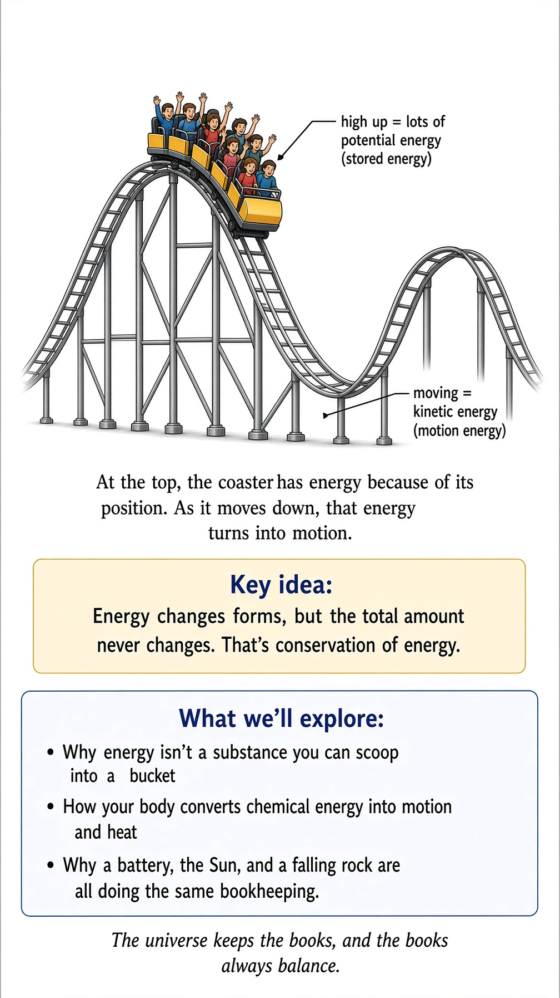
Imagine you are holding a bowling ball. It is heavy. You are holding it above your head. Nothing particularly exciting is happening. Now let go. The bowling ball falls. If it lands on your foot, you will discover something about physics that you may have preferred to learn from a book.
Where did the ability to do damage come from? The ball was sitting quietly in your hand. It wasn't moving. It wasn't hot. It wasn't glowing. It wasn't making a noise. And yet, when you lifted it and then released it, something changed. The ball acquired speed. And a moving object can do things that a stationary object cannot.
Physics has a name for the capacity to produce such changes: energy. Energy is one of the most useful ideas in all of science. It is also one of the most abused. People talk about “positive energy,” “negative energy,” “energy fields,” “energy healing,” “energy drinks,” and the mysterious energy that apparently appears whenever someone has had enough coffee. Physics means something much more precise. And, fortunately, much more interesting.

Energy is not a substance
One of the easiest mistakes is to imagine energy as a kind of invisible fluid. Perhaps you have a mental picture of energy flowing around inside things. A battery contains energy. The battery sends the energy through a wire. The energy enters the light bulb. The bulb lights up.
That picture isn't completely useless. But it can get us into trouble. Energy is not a mysterious substance that you can scoop into a bucket. You cannot open a box labeled “ENERGY — 17 KILOGRAMS.” Energy is a property of a physical system. It tells us something about what that system can do and how physical processes can change.
And here is the remarkable part: energy can change form without simply disappearing. That is why energy is such a powerful bookkeeping idea. The universe appears to keep very careful accounts. It may move energy from one place to another. It may change energy from one form into another. But the total energy is conserved. The universe, in other words, appears to be an accountant. A very strange accountant. But a remarkably competent one.

The roller coaster knows about energy
Imagine a roller coaster at the top of a huge hill. The car is almost stationary. The passengers are probably pretending not to be terrified. Yet the car has gravitational potential energy because of its position. It is high above the ground.
Now the car begins to descend. As it loses height, it gains speed. The gravitational potential energy decreases. The kinetic energy—the energy associated with motion—increases. At the bottom, the car is moving rapidly. Then it climbs the next hill. The car slows. Some of its kinetic energy becomes gravitational potential energy again. Up. Down. Up. Down. The energy changes form. The total bookkeeping still works.
Of course, a real roller coaster eventually comes to a stop. That might seem like a problem. If energy is conserved, why doesn't the roller coaster continue forever? Because energy has gone into other places. Friction has heated the wheels and track. Air resistance has warmed the surrounding air. The wheels and structure vibrate. Sound has escaped into the environment. The energy has not vanished. It has simply become spread out into forms that are much less useful for making the roller coaster climb another hill.
This is a theme we will return to later. Energy conservation does not mean that energy remains equally useful. That distinction will eventually lead us into thermodynamics. And thermodynamics has some rather rude things to say about perpetual motion machines.

Kinetic energy: the energy of motion
Let's begin with the simplest form. A moving object has kinetic energy. The faster it moves, the more kinetic energy it has. The more massive it is, the more kinetic energy it has. For ordinary speeds, the kinetic energy is:
K = ½mv²
where m is mass and v is speed. There is something interesting hiding in that little square: the speed is squared. Double the speed, and the kinetic energy becomes four times as large. Triple the speed, and it becomes nine times as large.
This is why speed matters so much in collisions. A car traveling twice as fast does not merely have twice the kinetic energy. It has four times as much. This is one reason speed limits are not arbitrary numbers invented by people who enjoy making you late. Physics has opinions about speed.

The unfortunate shopping trolley
Imagine pushing a shopping trolley through a supermarket. At walking speed, it is easy enough to stop. Now imagine the trolley somehow reaches jogging speed. You can still stop it. Now imagine it reaches highway speed. At this point, the supermarket manager has probably called security. The problem isn't simply that the trolley is moving. It is that its kinetic energy rises rapidly with speed. This is why collisions at high speed can be so destructive. A modest increase in speed can produce a surprisingly large increase in kinetic energy.
The square in the equation is doing the heavy lifting. And this is a good example of why equations can be useful. Without the equation, you might guess that doubling the speed doubles the effect. The equation says: “No. It gets considerably worse.” Nature is sometimes more dramatic than our intuition.

Potential energy: the energy of possibility
Now return to our bowling ball. Hold it above your head. It is not moving, so its kinetic energy is zero. But you would probably agree that dropping it could produce an event. The ball has gravitational potential energy. Its position gives it the potential to gain kinetic energy as it falls. The higher you lift it, the more gravitational potential energy it has.
Put it on a shelf. Nothing happens. Move it to a higher shelf. Still nothing happens. Move it to the top of a skyscraper. Still nothing happens. Drop it from the top of the skyscraper. Now things become considerably more interesting.
The energy was associated with the arrangement of the ball and Earth. That is an important point. Potential energy often belongs not to one object by itself but to a system. The ball and Earth together have gravitational potential energy because of their separation. This is one reason physics sometimes asks us to stop thinking of individual objects and start thinking about systems. Nature does not always respect the boundaries we draw in our minds.

A battery is not a little box of electricity
Take a battery. It looks disappointingly ordinary. A little cylinder. Perhaps you have several in a drawer because you keep buying replacements instead of remembering where you put the previous ones.
Inside the battery, chemical processes have arranged things so that electrical energy can be delivered to a circuit. Connect the battery to a flashlight. The battery's stored chemical energy is transformed through the electrical circuit. The light bulb or LED emits light. Some energy becomes heat. The battery gradually changes chemically. Eventually the flashlight goes dark. Where did the energy go?
It went into the light. It went into heat. It went into the surrounding environment. The energy did not disappear. The battery simply stopped being able to deliver it in the same useful way. This is an important distinction: energy conservation does not mean that you can always get the energy back in the form you want. If it did, your dead phone battery would be a much less annoying problem.

The phone in your pocket is an energy conversion machine
Your smartphone looks like a communications device. It is. But from another point of view, it is an elaborate energy-conversion machine. Chemical energy in the battery becomes electrical energy. Electrical energy drives circuits. Those circuits produce electromagnetic signals. Light comes from the screen. Sound comes from the speakers. Heat leaves the device. Your phone is constantly transforming energy.
And if you have ever felt your phone become warm while doing something demanding, you are witnessing a little piece of this process. The phone has not “lost” energy in the sense of energy ceasing to exist. Energy has been transferred into thermal motion in the phone and its surroundings. Unfortunately, that heat is not particularly useful for answering your emails. The universe has kept the books perfectly. Your phone has merely converted some of its useful energy into forms you don't particularly want.

Work: the bridge between force and energy
Now we need another concept: work. In everyday language, work means something that requires effort. In physics, work has a more specific meaning. When a force acts on an object and moves it through a distance, energy can be transferred. For a simple case where the force and motion point in the same direction:
W = Fd
Work equals force times distance.
Push a box. If the box moves, you have transferred energy to it. Push harder. More energy can be transferred over the same distance. Push the same amount of force over a longer distance. More energy can be transferred.
This gives us a beautiful connection: force changes motion; work transfers energy. These are not separate ideas floating around in different chapters. They are different ways of describing the same physical story.

The world's least efficient exercise
Suppose you carry a heavy suitcase upstairs. You are doing work against gravity. You exert an upward force on the suitcase. The suitcase moves upward. Its gravitational potential energy increases. When you reach the top, you may feel exhausted. The suitcase does not.
This seems unfair. You have converted chemical energy from your body into mechanical work. Some of that energy has increased the suitcase's gravitational potential energy. Much of the rest has become heat. Your muscles are not perfectly efficient machines. Neither are engines. Neither are batteries. Neither, apparently, are human beings who have decided to carry a suitcase up six flights of stairs instead of taking the elevator. But the energy accounting still works. Your body has transferred energy. The suitcase now has more gravitational potential energy. And you are looking for a chair.

Power: how quickly can you use energy?
Now suppose two people carry identical suitcases to the same floor. Both perform roughly the same amount of work. But one takes ten minutes. The other runs up the stairs in thirty seconds. Who used more energy? Not necessarily the runner. The total work can be approximately the same. But the runner transferred the energy much faster.
Physics calls the rate at which energy is transferred power:
P = E/t
Power is energy transferred per unit time.
This is why a powerful engine can do a particular job quickly. A small motor might eventually lift a heavy object. A powerful motor can lift it much faster. Power is about the rate. Energy is about the amount. Think of it this way: energy is roughly how much, and power is roughly how fast. A bathtub and a fire hose can deliver the same amount of water. The fire hose simply has rather stronger opinions about how quickly you should receive it.

Your breakfast is physics
You eat breakfast. Perhaps eggs. Perhaps toast. Perhaps something healthier. Perhaps something that comes in a box with a cartoon tiger on it. Your body takes chemical energy from food. It uses that energy to maintain body temperature, operate muscles, power biochemical processes, and keep your organs functioning.
You then walk. Your muscles convert chemical energy into mechanical work and heat. You climb stairs. More chemical energy becomes mechanical work and heat. You sit down. Your body continues using energy. Even while you are reading this sentence, your body is busy. Your heart is beating. Your lungs are working. Your brain is consuming energy. Your cells are performing an enormous number of chemical reactions. You are, from a physics perspective, a rather complicated energy-conversion system that happens to have opinions about politics, music, and whether pineapple belongs on pizza. Physics does not have an opinion about the pineapple. Yet.

Energy from the Sun
Almost all the energy driving life on Earth ultimately comes from the Sun. The Sun releases enormous amounts of energy through nuclear reactions in its interior. That energy travels outward as electromagnetic radiation. Some of it reaches Earth. Plants capture a portion of it through photosynthesis. Animals eat plants. Other animals eat those animals. We burn fuels that were created from ancient biological material. Wind and weather are driven by solar heating. The water cycle is powered by solar energy.
Even the fossil fuels we use today contain energy that originated, in a broad sense, from sunlight captured by ancient organisms. So when you eat lunch, you are participating in an astonishing chain: Sun → plant → food → human → movement → heat. The sandwich has a surprisingly distinguished family tree.
But where did the Sun get its energy? Now we reach a deeper question. The Sun has been shining for billions of years. How? It is not burning like a giant campfire. If it were, it would have run out of fuel much sooner. The Sun is powered by nuclear fusion. Deep inside its core, enormous pressure and temperature allow hydrogen nuclei to combine through a chain of nuclear reactions, ultimately producing helium and releasing energy.
And here we meet one of the most famous equations in physics:
E = mc²
This equation tells us that mass and energy are deeply connected. A small amount of mass can correspond to an enormous amount of energy because c²—the speed of light squared—is an enormous number.
This does not mean that ordinary objects are secretly waiting to explode. Your chair is not a nuclear bomb wearing furniture clothing. It means that mass itself represents a form of energy. Under the right physical circumstances, a tiny amount of mass can be converted into other forms of energy. The Sun does this continuously. That is why it can shine for billions of years.

Energy is conserved—but the story gets stranger
At this point, you might think we have energy figured out. Energy comes in. Energy changes form. The total amount is conserved. Excellent. Unfortunately, nature has another surprise waiting.
Suppose you drop a hot cup of coffee into a cold room. The coffee cools. The room warms very slightly. Eventually, everything reaches thermal equilibrium. Now imagine trying to reverse the process. Suppose the room spontaneously gives its energy back to the coffee, making the coffee hotter while the rest of the room becomes colder. Energy conservation does not obviously forbid this. The total energy could still be exactly the same. Yet it never happens spontaneously in ordinary life. You don't walk into the kitchen and discover that your cold coffee has become boiling while the refrigerator has mysteriously become colder. Why not?
Because conservation of energy is not the whole story. There is another idea called entropy. Entropy tells us something about how energy becomes distributed and about which processes occur naturally. We will meet entropy later. And when we do, we will discover that the universe keeps more than one set of books.

The universe is keeping score
For now, remember the central idea. Energy is not a magical fluid. It is a measurable property of physical systems. It can be transferred. It can change form. It can be stored in different ways.
Moving objects have kinetic energy. Objects in certain positions can have potential energy. Chemical reactions can release or absorb energy. Electrical systems can transfer energy. Light carries energy. Heat involves energy transfer. Mass itself is associated with energy. And through all these transformations, something remarkably consistent happens: the total energy is conserved.
This is one of the deepest bookkeeping rules we know about nature. It explains why a roller coaster can trade height for speed. Why a battery can run a flashlight. Why food can power your muscles. Why a rocket can accelerate. Why the Sun can shine. And why, if you drop a bowling ball on your foot, you should not blame the bowling ball. The bowling ball was simply following the accounts. You were the one who picked it up.

One last thought experiment
Imagine you have a perfectly frictionless roller coaster. No air resistance. No friction. No sound. No energy lost to anything. You start the car at the top of a hill. It rolls down. It speeds up. It climbs the next hill. It slows down. It climbs another. And another. If the track is arranged perfectly, it can keep trading gravitational potential energy for kinetic energy and back again. Forever. Nothing gets tired. Nothing wears out. Nothing heats up. The ride never ends.
Real roller coasters cannot do this. But the imaginary one teaches us something important. The universe does not need energy to be constantly created in order for motion and change to continue. Energy can simply move around. What makes the real world different is that energy tends to spread into forms that are harder to gather back together. That is why the roller coaster eventually stops. That is why your coffee gets cold. That is why batteries run down. And that is why a universe containing energy is not automatically a universe in which everything can happen in reverse.
Energy tells us how much. The next question is: why does nature seem to have a direction? That question will lead us somewhere much stranger than a roller coaster. It will lead us to time itself.

Science for Everyone

Chapter 6

Momentum: The Universe's Other Bookkeeping Trick

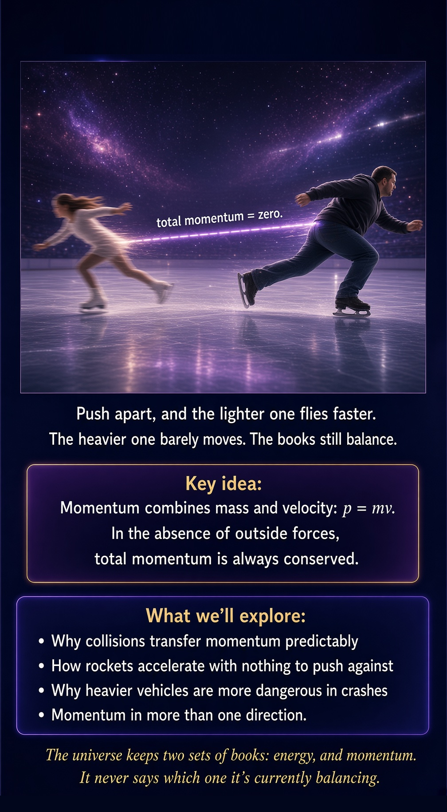
Two ice skaters stand facing each other on a frictionless rink. They push apart. One is small and light. The other is large and heavy. Which one flies backward faster?
If you have ever watched skaters, or curling, or two siblings arguing over who gets the good end of a see-saw, you probably already suspect the answer. The lighter skater goes flying. The heavier skater barely drifts. Both of them, however, are obeying the same rule with mathematical precision. Physics has a name for that rule: momentum.

What momentum actually is
Momentum is not exactly the same thing as energy, even though people often use the words interchangeably in everyday speech. A truck sitting still has zero momentum and zero kinetic energy. A truck rolling slowly has some of both. But momentum specifically combines mass and velocity in a very particular way:
p = mv
Momentum equals mass times velocity. A heavy, slow-moving truck can have the same momentum as a light, fast-moving motorcycle. Neither the mass nor the velocity alone tells you the whole story. You need both.
Unlike energy, momentum has a direction. A car moving east has momentum pointing east. The same car moving west has momentum pointing west, even if it is going exactly the same speed. This distinction turns out to matter enormously, because it means momentum can cancel.

Why the skaters fly apart at different speeds
Before the two skaters push off, their combined momentum is zero. Nobody is moving. Now here is the rule that makes physics feel almost magical: in the absence of outside forces, total momentum is conserved. It does not appear from nowhere, and it does not vanish. It only moves around.
So when the skaters push apart, the total momentum afterward must still add up to zero. That means the two skaters must have equal and opposite momentum. If the light skater has mass 50 kilograms and the heavy skater has mass 100 kilograms, and the heavy skater ends up moving at 1 meter per second, then the light skater must move at 2 meters per second in the opposite direction.
50 kg × 2 m/s = 100 kg × 1 m/s
Both sides equal 100 kilogram-meters per second, just pointing in opposite directions. The books balance. They always do.

This is just Newton's third law wearing a disguise
You may recall from an earlier chapter that when one object pushes on another, the second object pushes back with equal and opposite force. Momentum conservation is what you get when you take that idea seriously and let it run for a while. Every force the first skater exerts on the second is matched by an equal and opposite force pushing back. Add up all those forces over the time they act, and the total change in momentum of one skater exactly cancels the total change in momentum of the other.
This is one of those cases where physics has two ways of describing the same event. You can talk about forces moment by moment. Or you can talk about momentum before and after. Often the second approach is far easier, because you do not need to know the complicated details of exactly how the push happened. You only need to know the masses and the velocities at the beginning and the end.

Collisions: where momentum really earns its keep
Momentum conservation becomes especially useful when things collide, because collisions are usually complicated, messy, and difficult to analyze force by force. Two cars crash. A cue ball strikes another ball. A comet grazes a planet. In every case, momentum conservation gives you a shortcut.
Physicists sort collisions into two rough categories. In an elastic collision, kinetic energy is conserved along with momentum. Billiard balls come close to this. In an inelastic collision, some kinetic energy gets converted into heat, sound, or permanent deformation, even though momentum is still conserved. Two cars crumpling into each other is a very inelastic collision. So is a lump of clay hitting a wall and sticking.

A worked example: the shopping cart collision nobody wants
Imagine a shopping cart with a mass of 20 kilograms rolling at 3 meters per second. It collides with a stationary, identical empty cart and the two carts lock together, because someone left the child seat down and it caught on the other cart's frame. What happens?
Before the collision, only the moving cart has momentum:
p (before) = 20 kg × 3 m/s = 60 kg·m/s
After the collision, the two carts move together as a single 40-kilogram object. Momentum conservation tells us the total momentum afterward must still be 60 kilogram-meters per second:
40 kg × v = 60 kg·m/s
Solving for v gives 1.5 meters per second. The combined carts roll off at exactly half the original speed. Notice something important: kinetic energy was not conserved here. Before the collision, the moving cart had a certain amount of kinetic energy. Afterward, the combined carts have less. The missing energy became the crunch, the rattle, and the mild embarrassment of the person now steering two shopping carts at once.

Why heavier vehicles are more dangerous in crashes
This is not merely a curiosity for physics students. It is one of the most important safety facts in the modern world. When two vehicles of very different mass collide, momentum conservation guarantees that the lighter vehicle experiences a much larger change in velocity than the heavier one. A large change in velocity, happening quickly, means large forces on the people inside.
This is precisely why safety engineers worry about mismatches in vehicle size on the road, and why a collision between a small car and a large truck is so much more dangerous for the small car's occupants than a collision between two similarly sized cars. The physics does not care about fairness. It only cares about mass and velocity.

Rockets: the ultimate momentum trick
Momentum conservation also explains one of the strangest and most useful facts in engineering: how a rocket can accelerate in empty space with nothing to push against. A rocket does not need a road, water, or air. It only needs to throw something out the back.
Before the rocket fires its engines, the rocket and its fuel together have some total momentum, possibly zero if it is sitting still. When the engine burns fuel and expels hot gas backward at high speed, that gas carries momentum in one direction. For the total momentum to remain unchanged, the rocket itself must gain momentum in the opposite direction. The rocket does not need something external to push against. It only needs to push something away from itself, and momentum conservation supplies the rest.
This is also why rockets work better with fuel that can be expelled at very high speed. The faster you can throw the exhaust backward, the more momentum you transfer to the rocket for a given amount of fuel. Rocket engineers spend enormous effort chasing exactly this number.

Momentum in more than one direction
So far these examples have involved objects moving in straight lines, but momentum conservation applies in every direction independently. If a cue ball strikes another ball off-center, the balls can go flying in two completely different directions after the collision. Momentum in the direction of the original shot must still add up correctly. Momentum in the perpendicular direction, which was zero before the collision, must also still add up to zero afterward. Billiards players do this calculation intuitively every time they line up an angled shot, even though very few of them would describe it using the word momentum.

Why the universe bothers keeping this particular set of books
You might reasonably ask why momentum is conserved at all. The deep answer, discovered by the mathematician Emmy Noether and explored more fully later in this book, connects conservation of momentum to a symmetry of space itself: the laws of physics do not care where in space an experiment happens. Push a cart in New York, and it obeys the same rules as pushing an identical cart in Tokyo. That translational symmetry of space is mathematically tied to conservation of momentum in a precise and beautiful way. Momentum conservation is not an arbitrary rule someone wrote down. It is a direct consequence of space treating every location the same way.

The punchline
Momentum is the universe's other great bookkeeping system, running alongside energy but tracking something subtly different: mass in motion, with direction attached. Two skaters push apart, and momentum insists that the lighter one flies farther and faster. Two cars collide, and momentum tells you exactly how fast the wreckage will be moving, even before you know anything about the crumpling metal in between. A rocket in the vacuum of space accelerates by throwing part of itself backward, because momentum has nowhere else to go.
The next time you watch a game of pool, a car crash test video, or a rocket launch, you are watching the same conservation law, dressed in three very different costumes. The universe keeps track of momentum as carefully as it keeps track of energy. It simply never bothers to tell you which ledger it is currently balancing.

Science for Everyone

Chapter 7

Angular Momentum and Spin

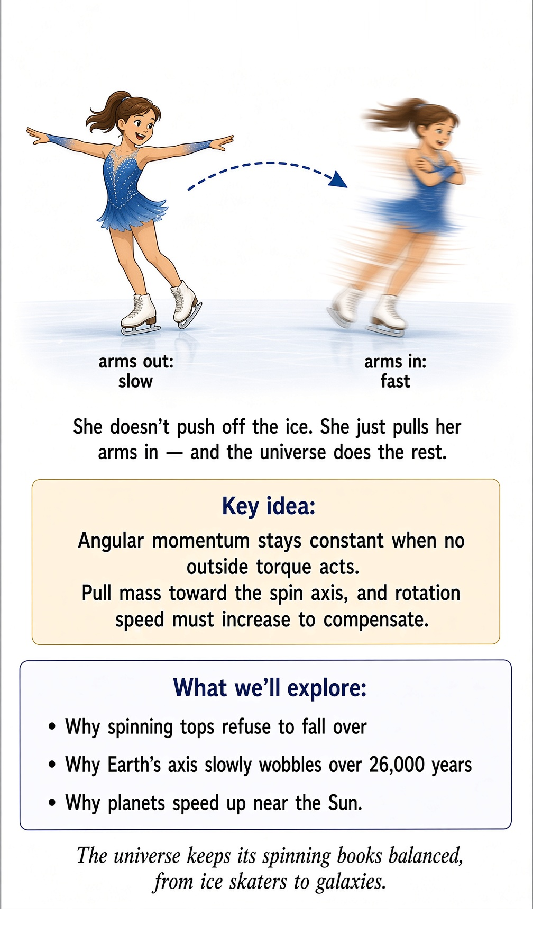
A figure skater spins slowly with her arms stretched wide. Then she pulls her arms in against her body. Without pushing off the ice, without any visible extra effort, she suddenly spins dramatically faster. No one gave her a shove. No hidden motor kicked in. She simply pulled her arms inward, and the universe did the rest.
This is angular momentum, and it is one of the most delightfully counterintuitive ideas in classical physics. It is also the reason spinning tops refuse to fall over, why bicycles are easier to balance while moving, and why the Earth itself keeps a remarkably steady tilt as it hurtles through space.

Momentum, but for spinning things
You already know about ordinary momentum: mass times velocity, describing how hard it is to stop something moving in a straight line. Angular momentum is the rotational cousin of that idea. Instead of asking how hard it is to stop something moving in a line, angular momentum asks how hard it is to stop something spinning or orbiting.
For a simple case, such as a small mass moving in a circle, angular momentum can be written as:
L = mvr
Here L is angular momentum, m is mass, v is speed, and r is the distance from the center of rotation. Notice that extra r. It is the crucial difference between ordinary momentum and angular momentum, and it is the reason the ice skater speeds up.

Why pulling your arms in makes you spin faster
Just as ordinary momentum is conserved when no outside force acts, angular momentum is conserved when no outside twisting force, called torque, acts on a spinning system. The skater on frictionless ice experiences essentially no external torque about her spin axis. That means her angular momentum must stay the same before and after she pulls her arms in.
Look again at the formula. Angular momentum depends on both speed and distance from the center. When the skater pulls her arms toward her body, she decreases r, the average distance of her mass from her spinning axis. If L must stay constant, and r goes down, then v must go up to compensate. Her rotation speed increases automatically, as a direct mathematical consequence of conservation, not because she worked harder.
Physicists usually describe this using a related quantity called moment of inertia, which captures how spread out an object's mass is relative to its spin axis. Extended arms mean a larger moment of inertia. Tucked arms mean a smaller one. Angular momentum equals moment of inertia multiplied by rotational speed, and if angular momentum stays fixed while moment of inertia shrinks, rotational speed must grow.

The same trick, everywhere you look
Once you know to look for it, this trick appears constantly. A diver leaping off a platform pulls into a tight tuck to spin rapidly through several somersaults, then extends fully just before entering the water to slow the spin down and enter cleanly. A gymnast on a high bar does the same thing during a release move. Even a cat, famously, uses a version of this trick to twist itself right-side up during a fall, tucking and extending different parts of its body in careful sequence.
None of these performers are consciously solving equations. Their bodies have learned, through practice, to exploit a law of physics that does not care whether you understand it, only whether you use it correctly.

Why spinning tops refuse to fall over
A stationary top falls over almost immediately, because gravity creates a torque that tips it sideways. A rapidly spinning top, however, can remain upright for a surprisingly long time, wobbling gently but resisting a full collapse. The explanation lies in angular momentum's directional nature.
Just like ordinary momentum, angular momentum has a direction, pointing along the spin axis. A rapidly spinning top has a large angular momentum vector pointing straight up. Gravity tries to tip the top over, applying a torque. But a torque does not simply flip angular momentum in the direction gravity would prefer. Instead, it causes the angular momentum vector to slowly sweep around in a cone, a motion called precession. The faster the top spins, the larger its angular momentum, and the slower and more resistant that precession becomes. A fast enough top can look almost magically stable, even while gravity is constantly, patiently, trying to knock it down.
This is precisely why a bicycle wheel spinning rapidly resists being tilted, and why gyroscopes are used in everything from ship navigation systems to spacecraft attitude control. A spinning gyroscope holds its orientation stubbornly, precisely because changing the direction of a large angular momentum requires a torque applied over time, not an instant shove.

The Earth is a giant, slowly wobbling top
Our planet is itself a spinning object with enormous angular momentum, and it behaves accordingly. The Earth's rotation axis does not point in a perfectly fixed direction forever. Gravitational tugs from the Sun and Moon on the Earth's equatorial bulge create a slow torque, causing the Earth's axis to precess in a large circle over a period of roughly 26,000 years. This is why the star currently near the north celestial pole, Polaris, was not the pole star in ancient Egyptian times, and will not be the pole star thousands of years from now. The stars have not moved. The Earth's spin axis has been slowly tracing out a cone in space, exactly the way a top's axis does, just far too slowly for a human lifetime to notice without careful astronomical records.

A worked example: the merry-go-round problem
Suppose a child of mass 30 kilograms stands at the edge of a playground merry-go-round, 2 meters from the center, while the whole system spins with some angular momentum. If the child then walks inward to a point just 1 meter from the center, what happens to the spin rate?
Angular momentum for the child's contribution is proportional to mv times r, and since angular momentum is conserved for the system, moving from r equals 2 meters to r equals 1 meter means the child's contribution to angular momentum can only stay the same if the associated speed doubles. In practice, the whole merry-go-round speeds up as mass moves closer to the center, which is exactly why playground merry-go-rounds feel like they suddenly accelerate when the kids near the edge scramble toward the middle. Nobody pushed harder. The geometry did the pushing.

Angular momentum and the shape of orbits
This same conservation law governs how planets move around the Sun. A planet in an elliptical orbit moves fastest when it is closest to the Sun and slowest when it is farthest away. This is not a coincidence or a separate rule; it is angular momentum conservation applied to an orbiting body. As the planet swings closer to the Sun, its distance r decreases, so its orbital speed v must increase to keep angular momentum constant. This relationship was discovered observationally by Johannes Kepler centuries before anyone had the modern language of angular momentum to explain why it must be true. Kepler saw the pattern in the data. Newton's mechanics, refined further over the following centuries, revealed the deeper reason.

Why this matters beyond the physics classroom
Angular momentum conservation is not merely a clever party trick for ice skaters. It shapes the structure of galaxies, which is why so many of them form flattened, rotating disks rather than random blobs: as a collapsing cloud of gas contracts under its own gravity, conservation of angular momentum forces it to spin faster and flatten out, exactly like the skater pulling in her arms, just on a scale of light-years instead of meters. It explains why neutron stars, the collapsed remnants of massive dying stars, can spin hundreds of times per second: as a star's core collapses from thousands of kilometers across down to a sphere only a few kilometers wide, conservation of angular momentum demands an enormous increase in spin rate.

The punchline
Angular momentum is what you get when momentum learns to think about rotation instead of straight-line motion, and it obeys the same fierce conservation instinct. Pull your mass toward the center of rotation, and your spin speed must increase to compensate. Push your mass outward, and your spin slows down. This single principle explains the figure skater's sudden burst of speed, the eerie stability of a spinning top, the slow multi-thousand-year wobble of Earth's axis, the strange fact that planets speed up near the Sun and crawl when far away, and the reason a dying star's core can end up spinning faster than a kitchen blender.
Nobody designed any of this on purpose. The universe simply insists on keeping its spinning books balanced, and everything from ice skaters to galaxies has learned to dance to that rule.

Science for Everyone

Chapter 8

Springs, Pendulums, and their Rhythm

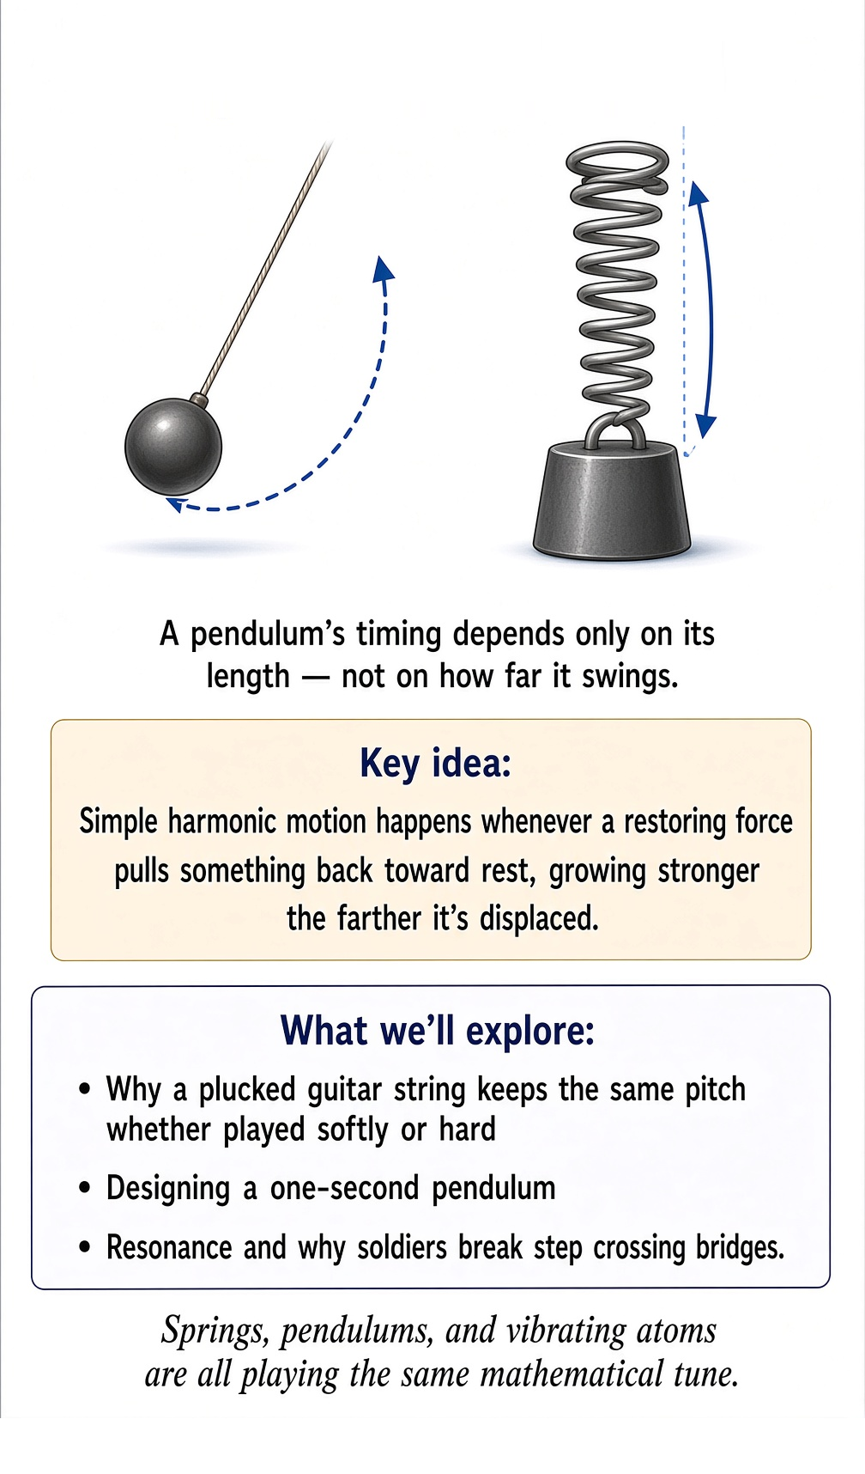

Push a child on a swing, and let go. The swing does not fly off into the yard, and it does not simply stop where you released it. It swings forward, slows, reverses, swings backward, slows, reverses, and keeps repeating the same back-and-forth motion, over and over, at a rate that barely changes even as the swinging gradually loses height to friction and air resistance.
Pluck a guitar string, and it vibrates back and forth at a very particular rate depending on its length and tension, not on how hard you plucked it. Bounce on an old mattress, and you feel a rhythmic up-and-down motion that repeats at roughly the same rate whether you bounce gently or with enthusiasm.
All of these are examples of one of the most useful patterns in physics: simple harmonic motion. It shows up constantly in nature and engineering, from clocks to bridges to the vibrations of atoms themselves, and once you understand the basic idea, you start noticing it everywhere.

The defining feature: a restoring force
Simple harmonic motion happens whenever something is pushed away from a resting position by a force that always points back toward that resting position, and whenever that restoring force grows stronger the farther away you are displaced. A stretched spring pulls back harder the more you stretch it. A swing pulled to the side experiences gravity pulling it back down toward the bottom of its arc, more strongly the farther it is pulled.
For an ideal spring, this relationship has a beautifully simple form, discovered experimentally by Robert Hooke and now called Hooke's law:
F = -kx
Here F is the restoring force, x is how far the object has moved from its resting position, and k is a constant describing how stiff the spring is. The minus sign is important: it tells you the force always points back toward the resting position, opposing whatever displacement just happened.

Why this produces an endless back-and-forth rhythm
Imagine pulling a mass on a spring away from its resting position and letting go. The spring immediately starts pulling the mass back. As the mass accelerates back toward the resting position, it picks up speed. By the time it reaches the resting position, the spring is no longer stretched, so there is no restoring force left, but the mass is now moving quickly and its own inertia carries it right through the resting point and out the other side.
Now the spring starts stretching in the opposite direction, and the whole process repeats in reverse. The mass slows, stops, and gets pulled back again. This is why simple harmonic motion oscillates rather than simply returning to rest and staying there. Inertia keeps the motion going past the resting point every single time, and the restoring force keeps reversing the motion once it has gone too far.

The remarkable independence from amplitude
Here is the detail that makes simple harmonic motion so useful for engineering, and especially for clocks: for an ideal spring or an ideal pendulum swinging through a small angle, the time it takes to complete one full cycle, called the period, does not depend on how far you pulled it before releasing it. A gently plucked guitar string and a firmly plucked guitar string vibrate at the same frequency; the firmly plucked one is simply louder, because it moves through a larger distance in the same amount of time.
For a mass on a spring, the period is given by:
T = 2π√(m/k)
Notice that the amplitude, how far you initially pulled the mass, does not appear anywhere in this formula. Only the mass and the spring stiffness matter. Pull the mass twice as far before releasing it, and it will simply move twice as fast at every point along the way, arriving back at the resting position in exactly the same amount of time.

The pendulum: gravity's own metronome
A swinging pendulum works through a slightly different mechanism, but produces the same beautifully rhythmic motion. Gravity constantly pulls the pendulum bob straight down, but because the bob is constrained to swing along an arc, only part of gravity's pull acts along the direction of motion at any given moment, and that component always points back toward the bottom of the swing. For small swinging angles, this restoring effect closely approximates the same mathematical pattern as Hooke's law.
For a simple pendulum swinging through a small angle, the period depends only on the length of the pendulum and the local strength of gravity:
T = 2π√(L/g)
Once again, notice what is missing: the mass of the pendulum bob does not appear in the formula at all. A heavy pendulum bob and a light pendulum bob of the same length swing back and forth at exactly the same rate, which is a beautiful echo of the same fact from earlier in this book, that all objects fall with the same acceleration regardless of mass. It is also, notably, missing amplitude, for the same reason as the spring: small swings take the same time as slightly smaller small swings.
This independence from amplitude is precisely why pendulum clocks became such a revolutionary technology when they were introduced. A clock built around a pendulum keeps reliable time even as the pendulum's swing gradually shrinks due to friction in the mechanism, because the timing depends only on the pendulum's length, not on how far it happens to be swinging on any given day.

A worked example: designing a one-second pendulum
Suppose you wanted to build a pendulum clock in which each full swing takes exactly 2 seconds, giving a comforting one-second tick on each half-swing. How long would the pendulum need to be? Using Earth's surface gravity of approximately 9.8 meters per second squared, and rearranging the pendulum period formula to solve for length:
L = g(T/2π)² ≈ 9.8 × (2/6.28)² ≈ 0.994 m
A pendulum just under a meter long, swinging through a small angle, ticks off one-second intervals with remarkable reliability. This is not a coincidence of history: early clockmakers, working entirely by trial and adjustment long before anyone wrote down this formula, converged on pendulum lengths extremely close to one meter for exactly this reason, and the connection between pendulum length and the definition of the meter was seriously debated when the metric system was first being designed.

Beyond springs and pendulums
Simple harmonic motion is not limited to obvious mechanical examples. Sound waves in air are, at their core, tiny parcels of air oscillating back and forth in simple harmonic motion as a wave passes through. The electrons in an antenna oscillate in simple harmonic motion as a radio wave washes over them, or as the antenna transmits a signal of its own. Atoms bonded together in a molecule vibrate around their resting separation in a pattern that, for small vibrations, closely resembles the same mathematics as a mass on a spring, which is part of how chemists study molecular structure using infrared spectroscopy.
Even electrical circuits containing certain combinations of components can oscillate in a manner mathematically identical to a mass on a spring, with electric charge playing the role of position and electric current playing the role of velocity. The same equations, the same period formula, the same underlying rhythm, appear again and again across completely different physical systems, simply because the same basic pattern, a restoring influence proportional to displacement, keeps showing up in nature's toolbox.

When the rhythm fades: damping and driving
Real pendulums and real springs do not swing forever. Friction, air resistance, and internal resistance in materials gradually drain energy from the oscillation, a process called damping, causing the amplitude to shrink over time even while the timing of each swing stays remarkably constant, at least for a good while. This is why a pendulum clock needs a mechanism to give the pendulum a small push on each swing, replacing the energy lost to friction, so the clock keeps running instead of gradually grinding to a halt.
The opposite situation, in which something pushes a system rhythmically at just the right rate, produces an effect called resonance, where the oscillation can grow to a surprisingly large amplitude even from small repeated pushes, provided the pushes arrive at the natural rhythm of the system. This is the same principle behind pushing a child on a swing effectively: timing your pushes to match the swing's own natural rhythm lets small efforts build into large, comfortable arcs. It is also the principle engineers must carefully guard against when designing bridges and buildings, since a structure pushed rhythmically at its own natural frequency, whether by wind, marching footsteps, or an earthquake, can develop dangerously large oscillations from what would otherwise be a modest disturbance.

The punchline
Simple harmonic motion is nature's favorite rhythm: a restoring force that always points back toward rest, combined with inertia that always overshoots, producing an endlessly repeating back-and-forth dance whose timing depends on the properties of the system itself rather than on how big the swing happens to be. Springs, pendulums, guitar strings, sound waves, vibrating molecules, and oscillating circuits are all, underneath their very different appearances, playing the same mathematical tune.
The next time you notice a swing gently arcing back and forth in a playground, or a plucked string humming at a steady pitch, you are watching one of the most universal patterns physics has to offer, quietly keeping its own rhythm regardless of who is watching.

Science for Everyone

Chapter 9

Waves: The Universe's Favorite Way to Move Without Moving


Drop a pebble into a still pond. Ripples spread outward in expanding circles. A leaf floating nearby bobs up and down as the ripple passes beneath it, but the leaf does not travel outward with the ripple. It stays roughly where it started, simply rising and falling, while the pattern itself, the wave, continues moving across the water.
This chapter opened the book with almost exactly this image, back when we first started asking what physics is actually about. It is worth returning to now, with the tools of momentum and simple harmonic motion freshly in hand, because waves turn out to be one of the most productive ideas in all of physics. Sound, light, radio, earthquakes, and even the quantum behavior of matter itself all borrow the same basic mathematical vocabulary that describes ripples on a pond.

A wave is a traveling pattern, not a traveling substance
The single most important idea to hold onto about waves is one we have already met: the thing that carries a wave is not necessarily the thing that travels with it. Water in a pond mostly moves up and down as a ripple passes, not outward with the ripple. Air molecules in a sound wave mostly jostle back and forth around a resting position, not stream from the speaker to your ear. What travels is the pattern, the disturbance, the coordinated rhythm passed from one part of the medium to the next.
This is possible because a wave is, at its heart, simple harmonic motion handed off from neighbor to neighbor. Each little bit of water, each little parcel of air, oscillates back and forth or up and down around its own resting position, exactly as described in the previous chapter. What makes a wave a wave, rather than just a lot of unrelated wobbling, is that neighboring bits of the medium are connected to each other, so that when one bit starts moving, it drags its neighbor into motion a moment later. The oscillation itself does not travel. The delay between one bit starting and its neighbor starting is what creates the appearance of motion sweeping across space.

The vocabulary of waves
A few measurements describe any wave completely. The wavelength is the distance between one repeating feature of the wave, such as one crest, and the next identical feature. The frequency is how many complete oscillations occur at a fixed point per second, usually measured in a unit called hertz, where one hertz means one complete cycle per second. The amplitude is how far the medium moves from its resting position at the peak of the oscillation, which for a sound wave corresponds to loudness and for a water wave corresponds to how tall the ripple stands.
These quantities are connected by one of the most useful relationships in all of wave physics:
v = fλ
Wave speed equals frequency times wavelength. This single equation is worth memorizing, because it applies to water waves, sound waves, light waves, and radio waves alike, with only the details of what v, f, and λ represent changing from one context to another.

A worked example: the speed of sound
Suppose you strike a tuning fork that vibrates at 440 hertz, a frequency musicians call the note A, and the resulting sound wave has a wavelength of about 0.784 meters in ordinary room-temperature air. Using the wave speed formula:
v = 440 Hz × 0.784 m ≈ 345 m/s
That value, roughly 345 meters per second, is indeed close to the accepted speed of sound in air at typical room temperature, which is why this example works out so neatly. Notice something important buried in this calculation: the speed of sound does not depend on which note you play. A much higher note has a higher frequency and a correspondingly shorter wavelength, but the two changes cancel out, leaving the speed unchanged, because the speed of sound in a given material depends on properties of the material itself, not on the particular wave passing through it.

Waves that need a medium, and waves that do not
Sound is what physicists call a mechanical wave: it requires some material medium, such as air, water, or a solid, to carry the disturbance from one place to another, because sound is fundamentally a pattern of compression and rarefaction passed from molecule to molecule. This is why sound cannot travel through the vacuum of space, a fact that makes most space battle scenes in movies scientifically incorrect but dramatically satisfying.
Electromagnetic waves, including light and radio waves, are different. As explored elsewhere in this book, an electromagnetic wave is a self-sustaining disturbance in the electric and magnetic fields themselves, and does not require any material medium at all. This is precisely why sunlight can cross the vacuum between the Sun and Earth, and why radio signals can travel between satellites in the emptiness of orbit. The wave mathematics remains the same, but what is doing the waving is fundamentally different: matter oscillating back and forth for sound, versus electric and magnetic fields oscillating for light.

Transverse and longitudinal: two ways to wiggle
Waves come in two basic flavors, distinguished by the relationship between the direction the medium oscillates and the direction the wave travels. In a transverse wave, the medium moves perpendicular to the direction the wave travels, the way a rope moves up and down while a pulse travels along its length. Light and other electromagnetic waves are transverse.
In a longitudinal wave, the medium moves back and forth along the same direction the wave travels, the way a slinky compresses and stretches along its own length when you push one end. Sound waves are longitudinal: air molecules jostle forward and backward along the same direction the sound is traveling, creating alternating regions of higher and lower pressure that sweep outward from the source.

When waves meet: interference
One of the most striking behaviors of waves is what happens when two of them overlap. Unlike solid objects, which collide and bounce or crumple, waves simply add together. Where two wave crests arrive at the same place at the same time, they reinforce each other into a taller crest, an effect called constructive interference. Where a crest from one wave arrives at the same place as a trough from another, they can cancel each other out almost entirely, an effect called destructive interference.
This is not merely a mathematical curiosity. Noise-cancelling headphones work by generating a sound wave that is precisely the inverse of the unwanted noise reaching your ear, so that the two waves interfere destructively and largely cancel before you perceive them. The colorful swirling patterns you see in a soap bubble or an oil slick on wet pavement come from light waves reflecting off the front and back surfaces of a thin film and interfering with each other, with different colors interfering constructively or destructively depending on the exact thickness of the film at each point.

Standing waves and the physics of music
When a wave is confined to a fixed region, such as a guitar string fixed at both ends or air inside a flute, something special happens: instead of a single pattern traveling continuously in one direction, the wave and its own reflections combine to create a standing wave, a pattern that appears to oscillate in place rather than travel anywhere, with certain fixed points, called nodes, that barely move at all, and other points, called antinodes, that oscillate with maximum amplitude.
Only certain wavelengths fit neatly into a confined space with the correct pattern of nodes at the fixed boundaries, which is precisely why a guitar string of a given length produces a specific musical pitch, called its fundamental frequency, along with a family of higher-pitched overtones corresponding to standing wave patterns with additional nodes in between. This is the actual physical mechanism behind musical pitch, timbre, and the entire structure of Western musical scales, all traceable back to which wavelengths happen to fit neatly into a vibrating string or column of air.

The Doppler effect: why sirens change pitch
You have almost certainly noticed that an ambulance siren sounds higher pitched as it approaches you and lower pitched as it moves away, even though the siren itself never changes its actual frequency. This is called the Doppler effect, and it happens because the source of the wave is moving relative to you. As the ambulance approaches, each successive wave crest is emitted from a position slightly closer to you than the previous crest, effectively compressing the wavelength and raising the frequency you perceive. As the ambulance recedes, each crest is emitted farther away, stretching the wavelength and lowering the perceived frequency.
The same effect applies to light, where it is called redshift or blueshift depending on the direction of relative motion, and it is one of the primary tools astronomers use to measure how fast distant galaxies are moving away from us, a topic explored more fully in the chapters on cosmology later in this book.

Why this chapter matters for everything that follows
Waves will return again and again throughout this book in increasingly strange disguises. Light will turn out to be an electromagnetic wave, as established elsewhere in these pages. Quantum mechanics will insist that particles themselves carry a wave-like character, with genuine interference patterns appearing even when individual particles are sent through an experiment one at a time. Gravitational waves will turn out to be ripples in spacetime itself, obeying much of the same vocabulary of wavelength, frequency, and speed developed here for something as ordinary as a ripple on a pond.

The punchline
A wave is a pattern that travels, built from countless small oscillations handed off from one part of a medium to the next, or in the case of light, from one point in space to the next without needing any medium at all. Wavelength, frequency, and speed are locked together by one simple equation that applies with equal force to a plucked guitar string, a foghorn, a beam of sunlight, and a radio signal crossing interplanetary space. Waves add together instead of colliding, confined waves settle into standing patterns that define musical pitch, and moving sources stretch or compress the waves they emit in a way astronomers now use to measure the expansion of the universe itself.
The ripple on the pond, it turns out, was never a small example. It was the whole idea.

Science for Everyone

Chapter 10

Least Action - Why Nature Takes the Lazy Route



The Universe Is Late for Everything
A ball rolls from here to there. You could describe every instant. Newton would be happy. But physics has another way: ask which entire path nature chooses. The answer involves the action. Nature chooses a path for which the action is stationary. It is as if the universe has solved the whole journey before setting off.

Cosmic Laziness
It is often called least action, although technically the action is stationary rather than always the smallest. Cosmic laziness is a useful intuition. The universe appears to prefer economical histories. It is an accountant with a very good calculator.

Light Gives Away the Secret
Fermat's principle says light follows a path for which travel time is stationary. When light enters glass it bends because its speed changes. The resulting path is not simply the shortest geometric line. It is the path selected by the variational principle.

Newton, Lagrange and Feynman
Newton describes forces. Lagrange reformulates mechanics with action. Hamilton pushes the formulation further. Feynman's path integral then considers contributions from many possible quantum paths, whose amplitudes interfere. The classical path emerges from the quantum calculation.

The Punchline
Newton asks what force acts now. Lagrange asks what path makes the action stationary. Feynman asks what happens if we consider all paths. The universe apparently replies: why are you making this so complicated?

Science for Everyone

Chapter 11

Light - The Fastest Thing in the Universe Has a Lot to Explain

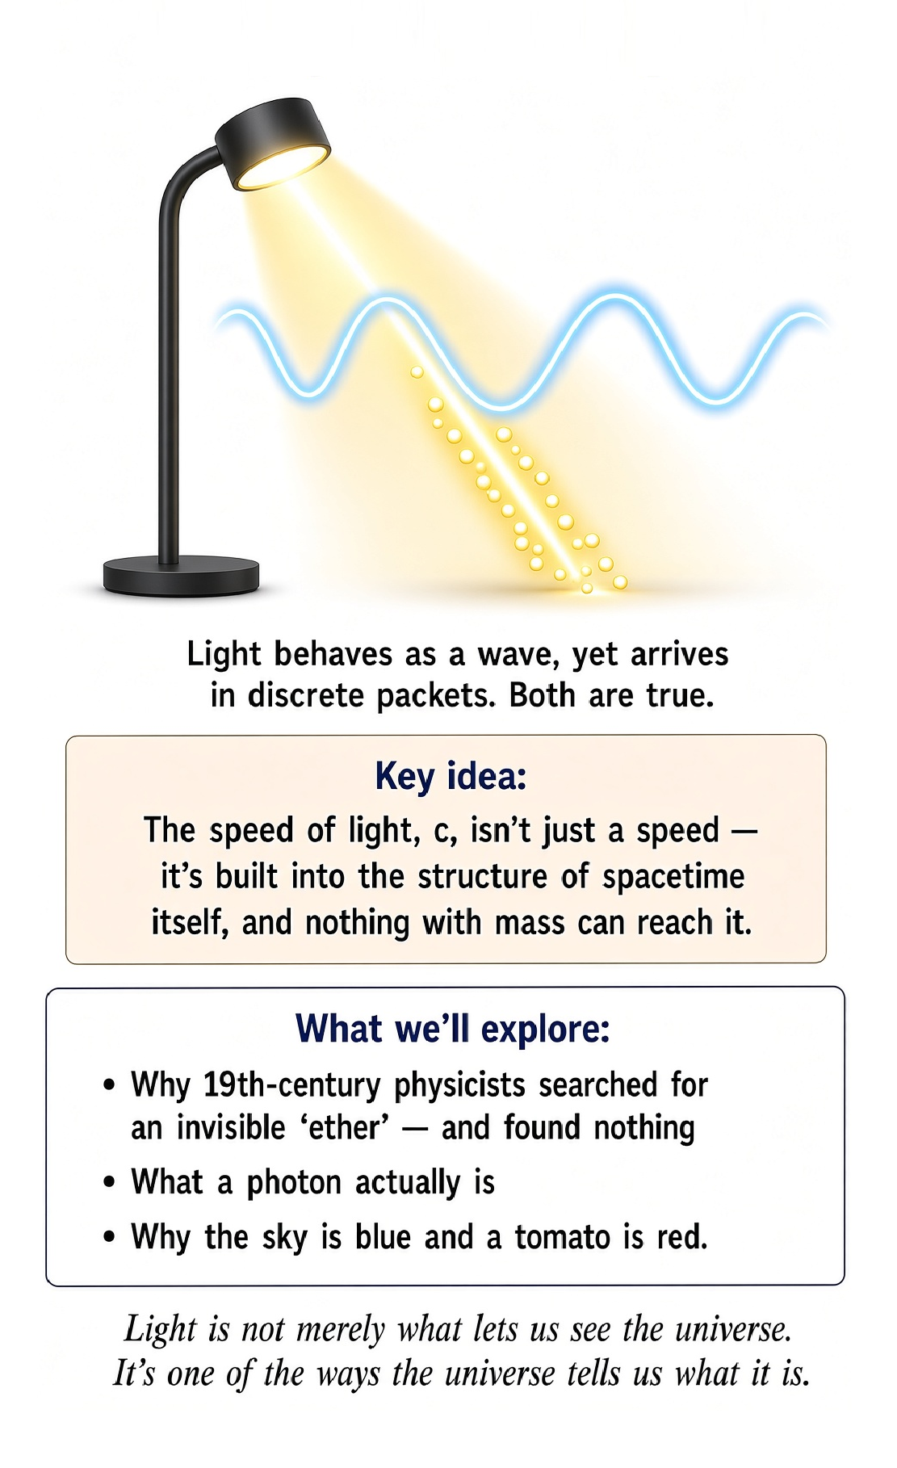

Turn On a Lamp
The room changes almost instantly, but light travels at a finite speed. That speed is not merely the speed of one particular object. It is built into spacetime.

The Speed Limit Is Weird
A car has a maximum speed because of engineering. Light is different. The speed c is a feature of relativity. Massive objects can approach it but cannot cross it. The universe has not merely hidden a better engine.

Light Needs No Ether
Water waves need water. Sound needs a medium. Nineteenth-century physicists therefore imagined an ether for light. Experiments failed to reveal it. Maxwell's electromagnetic waves do not require such a medium.

Then Came the Photon
Light behaves as a wave, yet arrives in discrete quanta. Quantum theory does not make light indecisive; it makes our classical categories inadequate.

Colours Are Quantum Physics
Why is a tomato red, gold yellow, and the sky blue? Quantum energy levels, electromagnetic interactions, scattering and interference determine the colours we see.

The Punchline
We started with a lamp and ended with relativity, quantum fields, photons and atoms. Light is not merely what lets us see the universe. It is one of the ways the universe tells us what it is.

Science for Everyone

Chapter 12

Why Does Time Have a Direction?

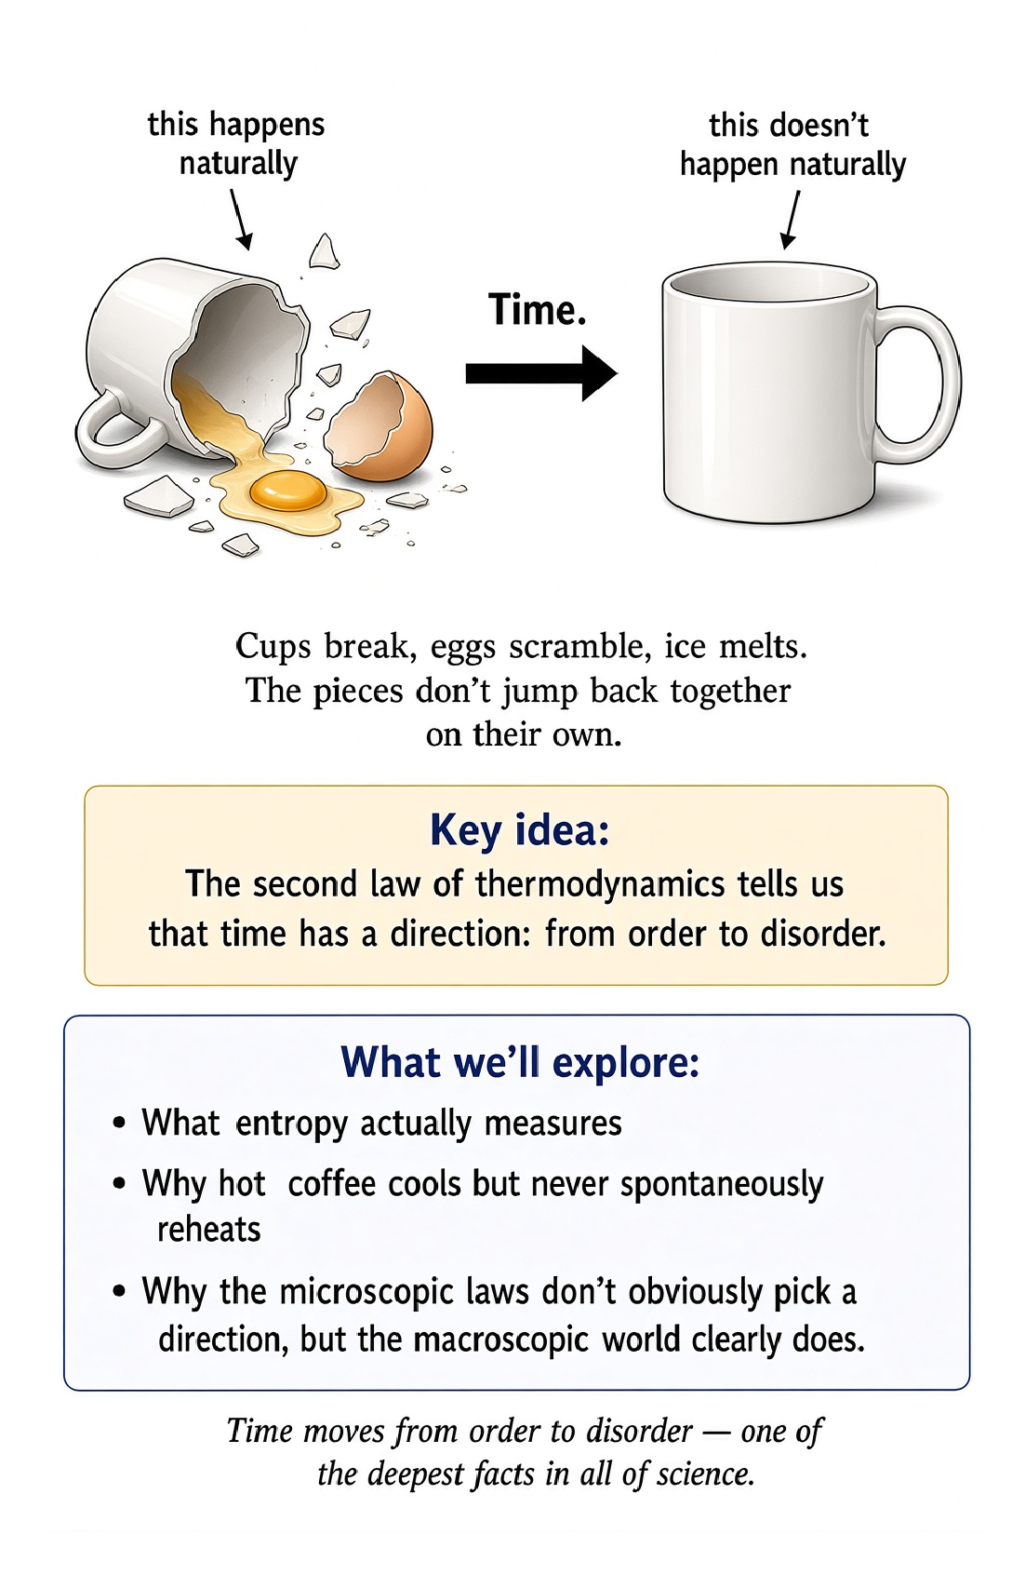
You can remember yesterday. You can make plans for tomorrow. But you cannot remember tomorrow. This sounds so obvious that it hardly seems worth mentioning. Yet it is one of the strangest facts about the universe.
A movie can show a glass falling from a table and smashing on the floor. You would have no difficulty believing it. Show the movie backward, and the glass suddenly becomes suspicious. You see the pieces on the floor leap upward, assemble themselves into a glass, and land neatly on the table.
Nothing in the basic laws of motion seems to contain the words “GLASS MUST NOT DO THAT.” So why does the real world have a direction in time?

The strange one-way street
Most of the things we have learned so far work equally well whether time runs forward or backward. Imagine two billiard balls colliding. One ball rolls toward another. They collide. The first slows down, and the second speeds up.
Now record the event and play it backward. The second ball rolls toward the first. They collide. The first speeds up, and the second slows down.
It still looks like physics. The equations of mechanics do not seem particularly offended by the reversal. But now replace the billiard balls with a cup of hot coffee sitting in a cold room. The coffee cools.
The room becomes microscopically warmer. Play the movie backward. The coffee becomes hotter while the room becomes colder. That would be extraordinary.
You could watch it happen every morning if nature allowed it. It does not. At least, not spontaneously. This gives us a remarkable puzzle: The microscopic laws can be reversible, while the everyday world has a very definite direction.

The coffee knows something you don't
Put a hot cup of coffee on a table. Leave it alone. Come back twenty minutes later. The coffee is cooler.
Come back two hours later. It is probably colder still. Eventually it reaches roughly the temperature of the room. Now imagine the reverse.
You walk into the kitchen and discover that the coffee, which had been sitting there for two hours, has become piping hot while the surrounding room has become slightly colder. You would not say, “Ah, thermodynamics.” You would say, “What on Earth happened?” And you would probably stop drinking the coffee.
The important point is that the reverse process does not obviously violate conservation of energy. Energy could be transferred from the room into the coffee. The total energy could still balance perfectly. So something besides energy conservation is deciding which direction ordinary processes prefer to go.
That something is connected to entropy.

Entropy is not just “messiness”
Entropy is often introduced by saying that it measures disorder. That is not completely wrong. It is also not quite enough. A better first picture is this: entropy is related to the number of microscopic ways a macroscopic situation can be arranged.
Imagine a box divided into two halves. Put all the gas molecules on the left side. Then remove the divider. The molecules spread throughout the box.
Nothing is stopping them from returning to the left side. In principle, they could. But there are enormously more ways for the molecules to be spread throughout the whole box than there are ways for every molecule to be packed into the left half. So the spread-out condition is overwhelmingly more probable.
The molecules do not “want” to spread out. Molecules do not have wants. They simply move according to the laws of physics, and there are vastly more microscopic arrangements corresponding to the ordinary spread-out state. That is the statistical heart of entropy.

The deck of cards
Take a brand-new deck of cards. It is in a neat order. Ace through king, perhaps, in four suits. Now shuffle it.
You get a mixed-up deck. Could you shuffle it back into perfect order? Of course. If you are extraordinarily lucky.
But there is a gigantic difference between the number of shuffled arrangements and the number of perfectly ordered arrangements. There are an enormous number of possible arrangements of a deck of cards. Only a tiny fraction look neatly ordered. So if you randomly shuffle the deck, disorder is overwhelmingly likely.
The cards do not have a physical law saying, “Thou shalt be messy.” The point is statistical. There are simply far more messy arrangements than neat ones. This is why entropy is often more illuminating than the word “disorder.”
Nature is not necessarily forbidding the neat arrangement. It is overwhelmingly favoring the many alternatives.

Why the egg doesn't unbreak itself
Drop an egg. It breaks. You now have a small domestic disaster. You could, in principle, imagine the reverse movie.
The shell pieces fly upward. The egg reassembles. The contents leap neatly back inside. The egg rises from the floor.
It lands intact on the counter. Physics does not contain a simple rule saying that this is impossible at the microscopic level. But the probability is fantastically tiny. There are an enormous number of microscopic ways to have a broken egg.
There are extraordinarily few ways to have exactly the right arrangement of atoms making one intact egg. So the natural direction is overwhelmingly toward the broken state. The egg does not know which way time is going. The statistics do.

A room full of molecules
Imagine a room containing air. Billions upon billions of molecules are flying around. They collide with one another. They collide with the walls.
They move in every direction. At the microscopic level, the motion is chaotic. Yet at the macroscopic level, the room behaves in an astonishingly predictable way. The temperature is roughly the same throughout.
The pressure is roughly the same throughout. The air does not spontaneously gather into one corner. You could wait a very long time. You would not expect all the oxygen molecules to politely assemble on the left side while the nitrogen molecules move to the right.
Why not? Because there are vastly more microscopic arrangements corresponding to ordinary mixed air than to that peculiar separated state. The universe has not banned the separated arrangement. It has simply made it absurdly improbable.

The arrow of time
This gives us a phrase that sounds almost poetic: the arrow of time. We experience time as having a direction. Eggs break. Coffee cools.
Smoke spreads. People grow older. We remember the past. We do not remember the future.
These things seem deeply connected. The arrow of time is not simply a clock ticking. A clock can tick in either direction. The deeper question is why physical processes have a preferred direction.
Thermodynamics gives us part of the answer. In an isolated system, entropy tends to increase. That statement is one of the great principles of physics. It is also one of the reasons you should not expect your kitchen to clean itself.

But wait: isn't everything made of particles?
Here is where things become really interesting. If the fundamental laws governing particles are largely reversible, and if the particles are simply moving according to those laws, why should entropy increase? Why doesn't the microscopic world simply run backward as often as it runs forward? The answer involves probability and something else that is easy to overlook.
The universe began in a very special state. The early universe was remarkably smooth on large scales. That smoothness gave the universe an enormous amount of room for entropy to increase as structure developed. Galaxies formed.
Stars formed. Planets formed. Complex chemistry became possible. Life appeared.
You appeared. And now you are sitting somewhere reading a chapter about entropy, which is a rather elaborate consequence of the universe having started in an unusual condition.

The refrigerator cheat
Your refrigerator provides another useful example. A refrigerator can make its interior colder than the surrounding room. That might seem to violate the natural tendency for heat to spread out. It does not.
The refrigerator uses energy to move heat from the cold interior to the warmer room. Open the refrigerator door. The room does not become cooler overall. The refrigerator simply transfers heat from one place to another while dumping additional heat into the room.
The back of your refrigerator gets warm for a reason. It is paying the entropy bill. This is a useful lesson: local decreases in entropy are perfectly possible. What matters is the total entropy of the larger system.
You can make a beautifully ordered refrigerator. You just cannot do it for free.

Life does not violate the second law
Sometimes people hear that entropy increases and ask a perfectly sensible question. What about life? A living organism is highly organized. Plants grow.
Animals develop. Brains build memories. A human being is considerably more complicated than a pile of atoms. So hasn't life somehow defeated entropy?
No. Life maintains and creates local order by using energy and exporting entropy into its surroundings. A plant absorbs energy from sunlight. A human eats food.
Your body uses chemical energy to maintain its structure. And you release heat into the environment. You are not violating the second law of thermodynamics. You are participating in it.
In fact, life is one of the most fascinating examples of how far a system can go while still obeying the rules.

Why we remember the past
Now we can return to the strangest part. Why do you remember yesterday? Why don't you remember tomorrow? Memory itself is a physical process.
Your brain changes when you learn something. Information becomes encoded in physical structures and patterns. Creating those patterns involves physical processes and energy. The traces left by the past are records of events that happened.
There is no corresponding physical record of events that have not happened yet. This does not mean that physics has a separate law saying, “Brains may remember Tuesday but not Thursday.” It means that memory is embedded in the same physical world whose processes have a thermodynamic direction. The arrow of time appears in the world around us, in our bodies, in our memories, and in the records we leave behind.

The universe is not running a movie
It is tempting to imagine the universe as a movie being projected one frame at a time. Frame one. Frame two. Frame three.
But physics does not necessarily work that way. The laws describe relationships between physical states. Time is part of the description. What we call “the past” and “the future” emerge from how those states are related and from the special conditions of the universe.
This is one reason relativity will later force us to rethink time itself. For now, however, we can keep one idea firmly in mind. There is a difference between the laws being reversible and the world looking reversible. A film of two billiard balls can plausibly run backward.
A film of a scrambled egg practically screams at you that something is wrong.

A thought experiment with two universes
Imagine two universes. Universe A begins in a very smooth, low-entropy state. Universe B begins in a highly disordered state. Both universes obey the same microscopic laws.
Which one develops a strong arrow of time? Universe A has enormous room for entropy to increase. Universe B has much less room. This suggests something profound.
The direction of time that we experience may be connected not only to the laws of physics, but also to the initial condition of the universe. In other words, the arrow of time may be something the universe inherited. That is a much stranger idea than simply saying that time “flows.”

Time, finally
We began this chapter with a simple observation. You remember yesterday. You do not remember tomorrow. Now we have a possible physical explanation for why the world around us has this asymmetry.
Entropy gives us a direction. Heat flows from hot things to cold things. Eggs break rather than spontaneously unbreak. Smoke spreads rather than spontaneously gathers.
Information about the past accumulates. And the universe evolves from states of lower entropy toward states of higher entropy. This does not mean that every single process must move monotonically in one direction. Tiny fluctuations happen.
Local order appears. Reversible processes are possible. But on the large scale, there is a statistical arrow. And that arrow points toward increasing entropy.

One last cup of coffee
Tomorrow morning, make yourself a cup of coffee. Watch the steam rise. Watch the heat leave the cup. Listen to the room.
Nothing dramatic is happening. And yet, in that ordinary cup of coffee, you are watching one of the deepest facts about the universe. The microscopic particles are moving according to fundamental laws. The energy is being conserved.
The coffee is cooling. Entropy is increasing. And your brain is recording the event as a memory. A few minutes later, the coffee will be colder.
You will know that it was hotter before. You will not know what temperature it will be an hour from now unless you make a prediction. That distinction between memory and prediction is not an accident. It is part of the same extraordinary asymmetry.
Time seems to have a direction. And once you notice it, you begin to see that direction everywhere. The next question is even stranger: If time has a direction, what exactly is time?
For that, we are going to need Einstein.

Science for Everyone

Chapter 13

What Is Time Anyway?


A clock seems like one of the simplest objects in the world. It ticks. Numbers change. You look at it and discover that you are late.
But what exactly is the clock measuring? That question sounds harmless until you try to answer it carefully. We often talk about time as though it were a substance flowing through the universe. Time passes. Time moves on. Time flies when you're having fun and apparently crawls when you are waiting for a software update.
But physics asks a more troublesome question: Is time actually something that flows? And if it does, what is it flowing through? To answer that, we have to abandon one of the most comfortable assumptions in everyday life: that everyone, everywhere, agrees about what time it is.

The clock on the wall
Imagine two identical clocks sitting next to each other on a table. They agree perfectly. You take one clock on a journey. You leave the other at home.
When you return, the clocks disagree. Your first reaction might be that one of them is broken. That would be reasonable. But suppose you test them carefully and discover that both clocks are working perfectly.
The disagreement is real. This is not a manufacturing problem. It is a property of nature. The amount of time measured by a clock depends on how that clock moves and, as we will discover later, on the gravitational environment in which it exists.
This sounds impossible because our everyday experience is based on speeds so small compared with the speed of light, and gravitational differences so modest, that the effect is normally far too tiny to notice. But tiny does not mean imaginary. Modern technology has to take these effects seriously. Your GPS receiver would become wrong by several miles every day if engineers ignored relativity.
So the universe has apparently decided that your phone's navigation app requires Einstein.

The strange business of simultaneity
Suppose two lightning bolts strike opposite ends of a railway platform. A person standing exactly halfway between the strikes sees both flashes at the same time. Easy. Now imagine a passenger on a train moving toward one of the flashes and away from the other.
The passenger receives the light from one strike before the other. That alone is not surprising. The train passenger moved toward one flash and away from the other. But now ask a deeper question: Did the two lightning strikes actually happen at the same time?
In ordinary Newtonian thinking, there must be one universal answer. Einstein said no. Whether two separated events are simultaneous can depend on the motion of the observer. This is called the relativity of simultaneity.
It is one of those ideas that sounds like a philosophical trick until you realize that it follows from two very simple principles: the laws of physics work the same way for observers moving at constant velocity, and the speed of light is the same for all such observers. Once those two facts are accepted, our old idea of universal time has to go. The universe has no master clock hanging in the sky.

The speed limit of the universe
Light travels extraordinarily fast. About 300,000 kilometers per second. That is roughly 186,000 miles every second. You could circle Earth more than seven times in one second if you could travel at the speed of light.
You cannot. Neither can anything carrying information or ordinary matter. The speed of light is not merely a very high speed limit imposed by a particularly strict traffic officer. It is built into the structure of spacetime.
This creates a remarkable consequence. If two observers move relative to one another, they cannot both use ordinary Newtonian rules for space and time and still agree that light travels at the same speed. Something has to give. Einstein's solution was radical.
Space and time themselves must adjust. Distances can contract. Clocks can run at different rates. And the separation between “space” and “time” becomes less absolute than we normally imagine.
The universe has replaced one rigid ruler and one universal clock with something much more subtle.

The moving clock
Imagine a very simple clock. It consists of two mirrors facing each other, with a pulse of light bouncing between them. Every trip from one mirror to the other and back is one tick. If the clock is sitting still relative to you, the light travels straight up and down.
Now imagine the clock is moving sideways at a constant speed. From your perspective, the light no longer travels straight up and down. It follows a zigzag path. The light still travels at the same speed.
But the zigzag path is longer. Therefore each tick takes longer. The moving clock runs slow relative to you. This is time dilation.
It sounds like science fiction, but the reasoning is almost embarrassingly simple. The speed of light stays fixed. The path gets longer. The time between ticks must therefore increase.
Nothing is wrong with the clock. Time itself is behaving differently for the moving observer.

You are already a time traveler
Suppose you board a spacecraft and travel at an enormous fraction of the speed of light. You spend a year traveling according to your own clock. When you return to Earth, more than a year may have passed for people who stayed behind. You have traveled into Earth's future.
This is not merely a clever way of speaking. It is a real physical effect. The faster you move relative to someone else, the more your elapsed time can differ from theirs. At ordinary speeds, the difference is tiny.
At speeds close to light speed, it becomes dramatic. Imagine leaving Earth when your child is ten years old. You travel at an extreme speed, experience five years on board, and return. Your child could now be considerably older than you expected.
You have not violated the laws of nature. You have simply taken a different path through spacetime. Unfortunately, the ticket price for this particular vacation is currently beyond most people's budgets.

Time is not a universal river
We are now forced to abandon a very old mental picture. There is not one giant cosmic river called Time flowing at the same rate everywhere. Instead, every object carries its own history through spacetime. A clock records the time along its particular path.
Change the path, and the amount of elapsed time can change. This is called proper time. You do not need to master the mathematics yet. The essential idea is enough: different paths through spacetime can contain different amounts of elapsed time.
Two people can meet, separate, travel differently, and meet again with different amounts of time having passed for each. Neither person's clock is wrong. They simply followed different paths. Nature is not asking, “What time is it really?”
Nature is asking, “How much time elapsed along this particular path?”

So what is spacetime?
Here is where Einstein's picture becomes even more elegant. Instead of treating space and time as completely separate things, relativity combines them into a four-dimensional structure called spacetime. Three dimensions describe where something is. One dimension describes when.
An event therefore has both a location and a time. For example: “The coffee cup broke at 10:17 a.m. on the kitchen floor.” That is an event.
You need both the place and the time to identify it completely. Different observers may disagree about the distance between events and about the time separating them. But there is a deeper quantity that remains consistent. Spacetime itself has a geometry.
This is the key insight that will eventually allow Einstein to reinterpret gravity. And that is where things become seriously weird.

Gravity gets an upgrade
Newton described gravity as a force pulling masses toward one another. It works extraordinarily well. You can calculate the orbit of a planet, predict an eclipse, launch a spacecraft, and drop a bowling ball on your foot with impressive accuracy. But Einstein asked a disturbing question.
What if gravity is not really a force in the ordinary sense? What if massive objects change the geometry of spacetime itself? Imagine placing a heavy ball on a stretched rubber sheet. The sheet bends.
A smaller ball rolling nearby follows a curved path because the surface is curved. This picture is useful, but it is also dangerous. Real spacetime is not a rubber sheet sitting in some larger ordinary space. The analogy is only meant to suggest the idea of geometry being changed by mass and energy.
In general relativity, matter and energy influence the geometry of spacetime, and that geometry influences how matter moves. In a memorable phrase: Matter tells spacetime how to curve; spacetime tells matter how to move.

The falling elevator
Einstein had a beautiful thought experiment. Imagine you are inside a sealed elevator. You suddenly feel yourself pressed against the floor. You cannot see outside.
How do you know whether the elevator is sitting on Earth, where gravity is pulling you downward, or whether the elevator is accelerating upward in empty space? Locally, the two situations can be indistinguishable. This is the equivalence principle. It connects gravity with acceleration.
Einstein realized that this was not merely a curiosity. It was a clue. If acceleration and gravity can be locally equivalent, perhaps gravity is not a conventional force at all. Perhaps what we call gravity is connected to the geometry of spacetime.
That idea eventually became general relativity. The elevator had just become a physics laboratory.

Gravity changes time
Remember our moving clocks? Motion changes elapsed time. Now gravity gets involved. A clock deeper in a gravitational field runs more slowly relative to a clock farther away.
The difference is tiny on Earth, but it is measurable. A clock at sea level and a clock on a mountain do not experience exactly the same amount of elapsed time. The effect becomes much stronger near extremely massive objects. Near a black hole, the difference can become enormous.
This is gravitational time dilation. So time is affected by both motion and gravity. The universe has taken what we thought was a simple quantity and turned it into something dependent on circumstances. You cannot simply ask, “What time is it?”
You have to add: “Where are you, and how are you moving?”

The GPS problem
This may sound like an exotic effect with no practical importance. It is not. GPS satellites carry extremely precise clocks. Those clocks are moving rapidly relative to clocks on Earth, which produces one relativistic effect.
They are also farther from Earth's gravitational field, which produces another. The two effects go in opposite directions. The gravitational effect makes the satellite clocks run faster. The motion effect makes them run slower.
The net difference is small. But GPS depends on extraordinary precision. If the system ignored relativity, the position calculated by your receiver would drift rapidly. So when your phone tells you where you are, you are benefiting from Einstein's theory.
This is a rather impressive achievement for a man who published the theory in 1915 and did not have a smartphone.

The light cone
Relativity gives us another beautiful way to think about cause and effect. Imagine an event happening somewhere in spacetime. From that event, light can travel outward in all directions. The set of places that light could reach forms a kind of boundary called the light cone.
Anything inside the future light cone can potentially be influenced by the event. Anything outside it cannot be reached by a signal from that event without traveling faster than light. This gives us a deep connection between relativity and causality. The speed of light is not merely about fast cars.
It determines which events can influence which other events. The universe has built a causal structure into spacetime itself. And that is one reason faster-than-light travel is such a serious problem for ordinary ideas of cause and effect.

Time travel gets complicated
At this point someone usually asks the obvious question. Can we travel backward in time? Relativity contains some mathematical situations in which paths through spacetime can behave in astonishing ways. But turning those mathematical possibilities into a practical time machine is another matter entirely.
There is no known technology that allows a person to travel into their own past. And backward time travel creates a spectacular collection of logical headaches. Suppose you travel into the past and prevent your parents from meeting. Then you are never born.
But if you were never born, who traveled into the past? Congratulations. You have just created the kind of family reunion that makes ordinary family reunions seem wonderfully uncomplicated. For now, we will leave backward time travel to the mathematicians, philosophers, and science-fiction writers.

A new picture of reality
We began by asking what time actually is. We have not produced a simple definition. Instead, we have discovered something more useful. Time is part of spacetime.
Different observers can measure different amounts of elapsed time. Motion affects clocks. Gravity affects clocks. Simultaneity is not universal.
And the speed of light is woven into the structure connecting space and time. This does not mean that time is imaginary. Quite the opposite. Time is real enough to age you, power GPS, make coffee go cold, and cause you to wonder where the last twenty years went.
But time is not the universal ticking background that Newton imagined. It is part of the geometry of the universe.

One last look at the clock
Look at a clock. It seems to be telling you something absolute. It is not. It is telling you how much time has elapsed along its particular path.
Usually, that distinction is so tiny that nobody cares. But once objects move very fast, or sit in significantly different gravitational fields, the difference becomes measurable. And suddenly the universe looks different. There is no single cosmic “now” shared by every observer.
There is no universal master clock. There is spacetime, with events embedded in it and paths running through it. That is a much stranger universe than the one we started with. And yet it is the universe our experiments keep confirming.
Next, we are going to ask an even more uncomfortable question. If gravity is geometry, what exactly is bending? And what does it mean for space itself to be curved?

Science for Everyone

Chapter 14

Does Time Really Exist? Julian Barbour and the End of Time



The Most Annoying Question in Physics
We have been talking about time as though it were an obvious thing. Seconds pass. Clocks tick. Yesterday becomes today.
Tomorrow becomes yesterday. You get older. So what could possibly be the problem? Here is the problem: physics does not actually require us to imagine a mysterious substance called “time” flowing through the universe.
Julian Barbour has pushed this idea much further than most physicists are comfortable with. His provocative proposal is that time, in the familiar sense of something that flows, may not exist fundamentally at all.

The river in your head
Imagine a river flowing past you. It is tempting to imagine time in exactly the same way. The present is the bit of river you are standing beside. The past is the water that has gone downstream.
The future is the water still coming toward you. But there is an immediate problem. What is the river of time flowing through? What is doing the flowing?
And what would “flowing” even mean if time itself is what defines change? The metaphor seems obvious until you ask it one question too many.

Einstein makes the problem worse—in a wonderful way
Special relativity tells us that different observers can disagree about which distant events are simultaneous. There is no universal cosmic clock that everybody agrees is ticking “now.” That does not prove that time does not exist. But it does destroy the simplest version of the idea that the universe has one shared present moment.
The present becomes local and observer-dependent. The universe is starting to look less like a movie being projected frame by frame and more like a four-dimensional structure.

The block universe
One way of taking relativity seriously is the block universe idea. Think of the universe as a four-dimensional whole. Different events occupy different locations in spacetime. Your breakfast this morning, your graduation years ago, and an event far away tomorrow are not necessarily pieces of a universal cosmic movie being generated one frame at a time.
They are events in spacetime. The strange part is that our experience strongly suggests that only one moment is real: this one. Physics does not obviously contain such a moving spotlight.

But surely the present is real!
Of course it is. You are reading this sentence now. The important question is not whether the present exists in ordinary language. The question is whether the present is a fundamental feature of reality, built into the laws of physics as a universal moving boundary between past and future.
That is a much stronger claim. And modern physics gives us very little reason to believe in a universal present. The feeling that time is flowing may be a feature of our experience rather than a feature of the fundamental equations.

Barbour's radical move
Barbour takes the idea seriously enough to ask whether we can remove time from the fundamental description altogether. Instead of imagining reality as something that changes through time, imagine reality as a collection of complete configurations. A configuration is a complete arrangement of the physical contents of the universe. One configuration might contain you sitting at breakfast.
Another might contain you reading this book. Another might contain you asleep. If the laws of physics can be formulated as relationships between such configurations without requiring a fundamental flowing time, perhaps time is something we construct from the relationships between them.

The universe as a collection of “Nows”
Barbour uses a striking idea: the universe may consist fundamentally of complete configurations, sometimes described as Nows. A Now is not a slice through a moving universe. It is a complete physical state. There is no tiny clock above it saying “this is Now Number 7,428,391.”
Each configuration simply exists as a possible or actual arrangement. The feeling of motion through time then needs an explanation. And that is where things get really interesting.

Why do we remember the past?
If there is no fundamental flow of time, why do you remember yesterday but not tomorrow? Barbour's answer points toward the structure of configurations. Some configurations contain records of other configurations. Your brain contains memories.
A photograph contains information about a previous arrangement of matter. A fossil contains information about an ancient organism. A computer hard drive contains records of earlier states. A universe can therefore contain physical structures that function as records.
The existence of records can create the extraordinarily powerful impression of a past that has happened.

The movie illusion
Imagine opening a book. Every page already exists. Page 17 contains a sentence saying that the character has just left the house. Page 18 contains the character walking down the street.
The character experiences a sequence. The book does not have to physically manufacture each page as you read. Our experience is obviously not literally a book. But the analogy exposes the conceptual possibility.
Perhaps the universe does not need to “move” from one configuration to the next. Perhaps what we call movement is the relationship between different configurations.

Change without time?
This sounds impossible. How can anything change if there is no time? The trick is that “change” normally means a comparison between different states. The temperature of the coffee is different from the temperature later.
The planet is in one position relative to the Sun in one configuration and another position in another configuration. You do not necessarily need a fundamental flowing substance called time to describe the difference. You need relationships between physical configurations. The controversial question is whether those relationships can be fundamental while time itself is not.

Clocks do not create time
A clock does not contain little pieces of time. It is a physical system that changes in a regular, countable way. A pendulum swings. A quartz crystal oscillates.
An atomic transition occurs. We compare one physical process with another and call the comparison “elapsed time.” That makes time extraordinarily useful. But usefulness is not the same thing as fundamental existence.
A ruler does not contain centimeters. A clock may not contain seconds either.

Why clocks disagree
Relativity makes this even more obvious. Two clocks following different paths through spacetime can accumulate different amounts of proper time. This is not because one clock has a better supply of time. Their physical paths are different.
Their readings are different. We use those readings to quantify the spacetime interval along each path. So time, as measured by clocks, is already deeply entangled with physical processes and geometry.

Time may be like temperature
Here is a more familiar example. Temperature feels fundamental. A room is 72 degrees. The soup is hot.
The ice cream is cold. But temperature is not an elementary ingredient like an electron. It emerges from the collective behavior of enormous numbers of particles. You can therefore have something that is completely real and completely useful while not being fundamental.
Perhaps time is like that. Perhaps “time” is a large-scale concept that emerges from relationships among physical configurations.

The arrow of time
Even if the fundamental laws do not contain a flowing time, our world has an unmistakable direction. Eggs break but do not spontaneously unbreak. Smoke spreads through a room but does not spontaneously gather itself back into the cigarette. You remember the past, not the future.
Why? This is the arrow of time problem. One major clue comes from entropy and the second law of thermodynamics. The universe appears to have begun in an extraordinarily special low-entropy state.
From there, entropy generally increases. That gives physical processes a direction. The direction may be emergent even if fundamental laws are more time-symmetric.

A broken egg knows something your equations don't
Drop an egg. It breaks. Now wait. You will not normally see the pieces leap upward, assemble themselves, and become an unbroken egg.
The microscopic laws governing the particles are much more reversible-looking than everyday experience. The mystery is therefore not simply “why does time flow?” It is also “why does the universe contain such a strong distinction between remembered past and unknown future?” Barbour's approach encourages us to separate these questions.
Maybe the fundamental world is timeless, while the arrow of time emerges from the special structure of the configurations we inhabit.

What is a “moment” made of?
Here is the childishly simple question that causes grown-up physicists trouble. What exactly is a moment? Is there a little physical boundary separating the present from the past? Can you point to it?
Can you measure its thickness? Can you find it in an equation? Physics can assign coordinates to events. It can calculate intervals.
It can compare clocks. But that does not automatically give us a fundamental moving “now.” The present may be something our brains construct from the information available to us.

The brain is a time machine
Your brain is constantly collecting records. Light reaches your eyes. Sound reaches your ears. Signals from your body arrive in your nervous system.
Your brain combines current information with stored information. That creates an enormously useful model: “This is happening now, and that happened before.” The model is so powerful that it feels like direct access to the flow of time. But perception is not necessarily a window onto the fundamental ontology of the universe.
It is a survival machine.

Does this mean nothing ever happens?
No. This is where the phrase “time does not exist” can become dangerously misleading. Barbour is not saying that your dinner, a supernova, or the birth of a star is imaginary. Events are real in the relevant physical description.
What is questioned is the idea that events are carried along by a separate substance called time. So we should say carefully: The fundamental universe may not contain time as a flowing entity. That is very different from saying:
Nothing changes and nothing happens.

Does this mean the future already exists?
That depends on what you mean by “exists.” In the block-universe picture associated with eternalism, past, present, and future events can all be part of the four-dimensional spacetime description. But Barbour's more radical timeless picture is not simply identical to every version of eternalism. There are different ways to formulate a timeless ontology.
This is why we should treat the chapter as an exploration of an idea, not as a settled experimental fact. The philosophy of time contains competing positions, and modern physics does not provide a universally accepted final answer.

A dangerous but useful thought experiment
Imagine that tomorrow you discover a perfect photograph of yourself eating breakfast. You have never seen the photograph before. The photograph contains detailed information about the breakfast, the room, the weather outside, and the exact expression on your face. You would infer that the breakfast happened.
But the photograph itself is a physical configuration. It contains information. The same idea applies to memories, fossils, tree rings, geological layers, and records in computers. The universe is full of physical evidence of other configurations.
Perhaps what we call “the past” is, at least in part, the network of records contained in the present configuration.

The arrow may be an emergent phenomenon
This is one of the most attractive possibilities. The fundamental laws may not need to say, “Time flows from yesterday toward tomorrow.” Instead, a special class of configurations can contain records and correlations that make one direction stand out. Entropy increases in that direction.
Memory works in that direction. Biological processes work in that direction. We call it the past-to-future direction. The arrow of time could therefore be a property of the universe's state, not a fundamental ingredient of its laws.

Why this matters for quantum gravity
This is not merely philosophical entertainment. Our two greatest theories describe time differently. General relativity makes time part of a dynamical spacetime geometry. Quantum mechanics normally uses time as an external parameter in the evolution of quantum states.
When physicists try to combine quantum mechanics with general relativity, the role of time becomes deeply problematic. Some formulations of quantum gravity produce equations in which the familiar time variable is absent from the fundamental equation. That does not prove Barbour is right. But it explains why the question is taken seriously.

The frozen universe is not as frozen as it sounds
Suppose the fundamental description contains no flowing time. Would the universe be frozen? Only if we imagine that something must move through time in order for change to exist. But perhaps “motion” is a relationship among configurations.
A person in one configuration is sitting. In another, they are standing. In another, they are walking. The complete set of relationships can contain everything needed to describe what we call a life.
The flow may be something the observer experiences when moving through that relational structure.

Barbour's beautiful provocation
The great value of Barbour's idea is not that we can currently declare, “Time has been disproved.” We cannot. The value is that it forces us to ask what we actually mean by time. Is time a substance?
Probably not. Is the passage of time a fundamental physical process? That is deeply disputed. Are clocks real?
Obviously. Are changes real? Obviously. Does the universe possess a universal moving present?
Relativity gives us very good reasons to be suspicious. Could time emerge from deeper relationships among physical configurations? That remains a fascinating possibility.

One final second
Look at a clock. The second hand moves. Your brain says: “Time is passing.” But what did the clock actually do?
A physical object changed configuration. What did your brain do? Neurons changed configuration. What did the universe do?
It occupied a particular physical state containing records of other states. Perhaps that is all there ever was. Perhaps time is not the river carrying the universe along. Perhaps the universe is the landscape, and what we call time is the structure of the relationships between its different configurations.
That is a radical idea. It may be wrong. But it is exactly the kind of wrong—or possibly right—idea that teaches us to look at something familiar in a completely new way.

Science for Everyone

Chapter 15

The Direction of Time: Reichenbach, Entropy and the Arrow


The Universe Has a Favorite Direction
We have just asked a terrifying question: perhaps time does not fundamentally flow at all. Now comes an even stranger question. If the fundamental laws do not obviously distinguish past from future, why does almost everything we experience do exactly that? You remember breakfast.
You do not remember tomorrow's breakfast. Eggs break. They do not normally leap off the floor and reassemble themselves. Smoke spreads through a room.
It does not ordinarily gather itself back into the cigarette. Hans Reichenbach devoted his book The Direction of Time to this puzzle: what could make one temporal direction physically special?

A film played backward
Imagine filming yourself making a cup of coffee. Play the film forward. You pour water. The water spreads through the cup.
Steam rises. The coffee cools. Everything looks normal. Now play the film backward.
The coffee suddenly becomes hotter. Steam dives neatly back into the cup. Water climbs into the kettle. The scene looks ridiculous.
But here is the shocking part: many of the microscopic equations underlying these processes are compatible with reversing the direction of time. So why does the world around us look so strongly one-way?

The microscopic laws are not obviously one-way
Newton's equations can generally be run backward. Classical electromagnetic theory has important time-reversal symmetries, although electromagnetic radiation and boundary conditions introduce subtleties. Quantum mechanics also has deep time-reversal structure. Yet macroscopic physics has an arrow.
Something happens. Then something else happens. The reverse sequence is possible in the equations in a formal sense but fantastically unlikely in ordinary circumstances. Reichenbach's question was not merely “why does entropy increase?”
It was: how does the statistical behavior of physical systems create the direction we call time?

Entropy enters the story
Entropy is often introduced as “disorder.” That is useful until it becomes misleading. A better first idea is that entropy measures, roughly speaking, how many microscopic arrangements are compatible with the same macroscopic description. A neatly arranged room corresponds to relatively few microscopic arrangements.
A thoroughly mixed room corresponds to enormously many. So when a system moves toward higher entropy, it is moving toward macroscopic states that can be realized in vastly more microscopic ways. The second law tells us that entropy tends to increase for isolated macroscopic systems. But “tends to” is doing important work.

The broken glass is not forbidden to unbreak
Nothing in the basic microscopic equations says that the pieces of a broken glass are mathematically forbidden from rearranging themselves into the original glass. The problem is probability. There are unimaginably many microscopic arrangements corresponding to “broken glass on the floor.” There are vastly fewer corresponding to “perfect glass sitting on the table.”
The reverse process is not impossible in the strict mathematical sense. It is simply so fantastically improbable that you should not plan your household maintenance around it.

So where did the arrow come from?
This is the key problem. If the underlying laws do not supply a strong arrow, perhaps the arrow comes from the particular state of the universe. Reichenbach takes this route. The universe is not assumed to be in a completely typical equilibrium state.
Instead, it has a special thermodynamic history, with an entropy gradient. The direction in which entropy increases becomes the direction we call the future. That sounds simple. But Reichenbach wanted to explain much more than the second law.
He wanted the same direction to explain records, causal asymmetry, and the behavior of many separate systems.

Branch systems
Here comes Reichenbach's most distinctive idea. A branch system is a subsystem that becomes sufficiently isolated from the larger system for a period of time. Think of a box of gas. Think of a camera.
Think of a glass of water. Think of your brain. Think of a leaf falling from a tree. These systems interact with the rest of the universe, but they can also become approximately isolated for periods of time.
Reichenbach argued that the universe's overall entropy gradient is reflected in the entropy behavior of enormous numbers of such branch systems.

Why the branches matter
Imagine a huge tree. The trunk represents the larger physical system. Branches split off. Each branch can develop its own local history.
Reichenbach's picture is not literally about trees. It is about statistical structure. A large universe can contain many subsystems that become approximately independent for a while. If the overall system is on an entropy slope, the overwhelming majority of these branches tend to have entropy increasing in the same direction.
That common direction is what gives the arrow of time its remarkable consistency.

The arrow is not hidden inside every atom
This is an important point. A single microscopic particle does not need to carry a little arrow pointing toward Tuesday. The direction emerges statistically from large numbers of systems and their correlations. That makes the arrow of time somewhat like temperature.
One molecule does not have a temperature. A large collection of molecules does. Likewise, the universe does not need a microscopic “future particle.” The temporal direction can emerge from the statistical organization of many physical systems.

Why does your coffee cool?
Suppose you pour hot coffee into a cold room. The coffee cools. The room warms imperceptibly. Eventually they approach thermal equilibrium.
The reverse process—cold coffee spontaneously becoming hot while the room becomes slightly colder—is not prohibited by microscopic mechanics in the simple absolute sense. But it is fantastically unlikely. The high-entropy direction is overwhelmingly favored statistically. Your coffee therefore behaves as though time has an arrow.
The arrow is not a separate force. It is a statistical asymmetry.

Why do we remember the past?
Now the problem becomes more interesting. Entropy explains why broken eggs stay broken. But why do you have memories? Why are there photographs of yesterday but not tomorrow?
Why can a fossil tell us about an ancient animal? Why can a footprint tell us that someone walked through the sand? These are records. Reichenbach devoted substantial attention to the connection between entropy, information, and registering instruments. His book contains separate sections on producing and recording, common causes, entropy and information, and the time direction of information.

A record is a physical object
A memory is not magic. Your brain is a physical system. A photograph is a physical pattern. A footprint is a physical rearrangement of grains of sand.
A fossil is a physical structure. Each contains information correlated with some earlier event. Creating such a record generally involves an irreversible-looking increase in entropy somewhere in the larger system. The universe leaves traces.
Those traces overwhelmingly point in one temporal direction. That is why the past seems packed with evidence while the future is not.

The common-cause principle
Reichenbach also connected temporal direction with a powerful idea about causality. Suppose two events are correlated. You see wet streets and umbrellas. A sensible explanation is rain.
The rain is a common cause. Reichenbach's principle of the common cause says, roughly, that when events are correlated in a way that needs explanation, we should look for a common cause in their causal past. The principle became an important part of twentieth-century thinking about causality and statistical dependence.

Why the future does not leave records
Imagine finding a photograph on your desk showing you eating breakfast tomorrow. That would be extraordinary. A normal photograph is a record of a physical interaction that already happened. It is not a record of an event that has not yet occurred.
Reichenbach's framework tries to explain this asymmetry through entropy and the statistical structure of branch systems. Records are physical correlations. Those correlations are overwhelmingly produced along the direction in which entropy increases. The arrow of information follows the thermodynamic arrow.

Cause and effect
We normally think causes come before effects. Reichenbach asked whether this temporal asymmetry could itself be explained physically. Consider the footprint. A foot presses into sand.
The result is a distinctive pattern. If you reverse the sequence, you have a footprint disappearing in exactly the right way while a foot somehow rises from the sand. The equations may not make the reverse trajectory mathematically impossible. But the forward process is naturally produced by ordinary interactions, while the reverse would require an extraordinary coordination of microscopic states.
Causality and entropy are therefore deeply entangled.

The universe as an entropy slope
Imagine plotting the universe's entropy against a time coordinate. Reichenbach's picture requires a broad region in which the universe is on an entropy slope rather than sitting at equilibrium. Then local branch systems inherit the same preferred direction. Their entropy tends to rise.
Records accumulate. Macroscopic causes precede effects. The statistical direction of time becomes common across enormous numbers of otherwise separate systems. This is the basic architecture of Reichenbach's explanation.

The subtle point: entropy does not simply define time
We should not say, “Entropy increases, therefore time exists.” That is too strong. Reichenbach's project is more subtle. He wants to replace the vague idea of an intrinsic direction of time with a physically meaningful direction characterized by entropy and causal structure.
Modern discussions still debate whether this fully succeeds. Some philosophers argue that the explanation risks assuming part of the asymmetry it is trying to explain. Others regard Reichenbach's branch-system idea as an important precursor to modern attempts to understand the thermodynamic arrow. So this is a conceptual framework, not a finished proof.

The arrow is global, not merely local
A single subsystem can temporarily behave in an unusual way. Entropy can fluctuate downward. Tiny systems can do strange things. The second law is statistical, not an absolute prohibition against every microscopic fluctuation.
What matters is the overwhelming large-scale pattern. Reichenbach's branch-system picture is designed to explain why a vast collection of subsystems tends to share the same entropy direction. That commonality is exactly what makes our experience of time so consistent.

And now quantum mechanics enters
Reichenbach did not stop with classical thermodynamics. The later parts of The Direction of Time explicitly address quantum physics, including the indeterminism of quantum mechanics, quantum statistics, the entropy concept of quantum statistics, and even particles traveling backward in time. This matters because quantum mechanics changes our understanding of probability and physical states.
The arrow-of-time problem therefore cannot simply be postponed forever. Eventually we have to ask how thermodynamic asymmetry fits with the quantum description of matter.

Time reversal is not the same as running a movie backward
This distinction is easy to miss. A time-reversal symmetry of an equation does not mean that a real macroscopic movie can simply be played backward. To reverse a physical process, you would have to reverse the microscopic state with astonishing precision. For a macroscopic system, that means coordinating an enormous number of particles.
The equations may allow the trajectory. The universe almost never prepares the required initial condition. Probability does the practical work.

The arrow may be a property of the universe's state
This is perhaps the most important philosophical lesson. The laws may be largely indifferent to which temporal direction we call forward. The particular state of the universe need not be. If the universe began—or simply happens to be—in an extraordinarily low-entropy condition, then there is a direction away from that condition in which entropy tends to rise.
That direction becomes our future. The arrow may therefore belong not to the laws alone, but to the combination of laws and boundary conditions.

The egg, the photograph, and you
An egg breaks. A photograph records the event. Your brain remembers seeing it. All three processes point the same way.
The egg breaking is thermodynamic. The photograph is informational. The memory is biological. Yet they share an arrow.
Reichenbach's great ambition was to explain this unity rather than treating each arrow as a separate mystery. That is why his book remains so interesting.

What Reichenbach did not prove
Reichenbach did not prove that entropy is a mystical substance that flows through time. He did not prove that the universe has a metaphysical arrow built into the fabric of reality. And he did not eliminate every philosophical problem about causality. His contribution was more useful.
He showed how several apparently unrelated asymmetries—entropy increase, records, causation, and macroscopic irreversibility—might be connected through a common statistical structure. That is a powerful way to organize the problem.

Barbour and Reichenbach together
Now our two chapters fit together. Barbour asks: Does time itself really exist as a flowing thing? Reichenbach asks:
If time has no intrinsic direction, why does the physical world have such a powerful arrow? Those are different questions. We might eventually discover that time is emergent and that its direction is emergent too. Or we might discover that one of these ideas is wrong.
The important thing is that we have separated the problems. Existence of time. Direction of time. They are not the same mystery.

One last broken egg
Break an egg. Watch the pieces. Now imagine the microscopic universe from which those pieces are made. The fundamental equations do not contain a tiny instruction saying, “Thou shalt never reassemble.”
Yet the egg stays broken. Why? Because the broken state belongs to an overwhelmingly larger set of microscopic possibilities than the pristine egg state. And because the universe appears to have begun its large-scale history in a remarkably special low-entropy condition, enormous numbers of physical processes share the same statistical direction.
We call that direction the future. Perhaps time does not flow. Perhaps the laws do not point. Perhaps the universe's state does.
And perhaps that is why you can remember yesterday, but you still cannot remember tomorrow.

Science for Everyone

Chapter 16

The Omega Point: Outside Space and Time

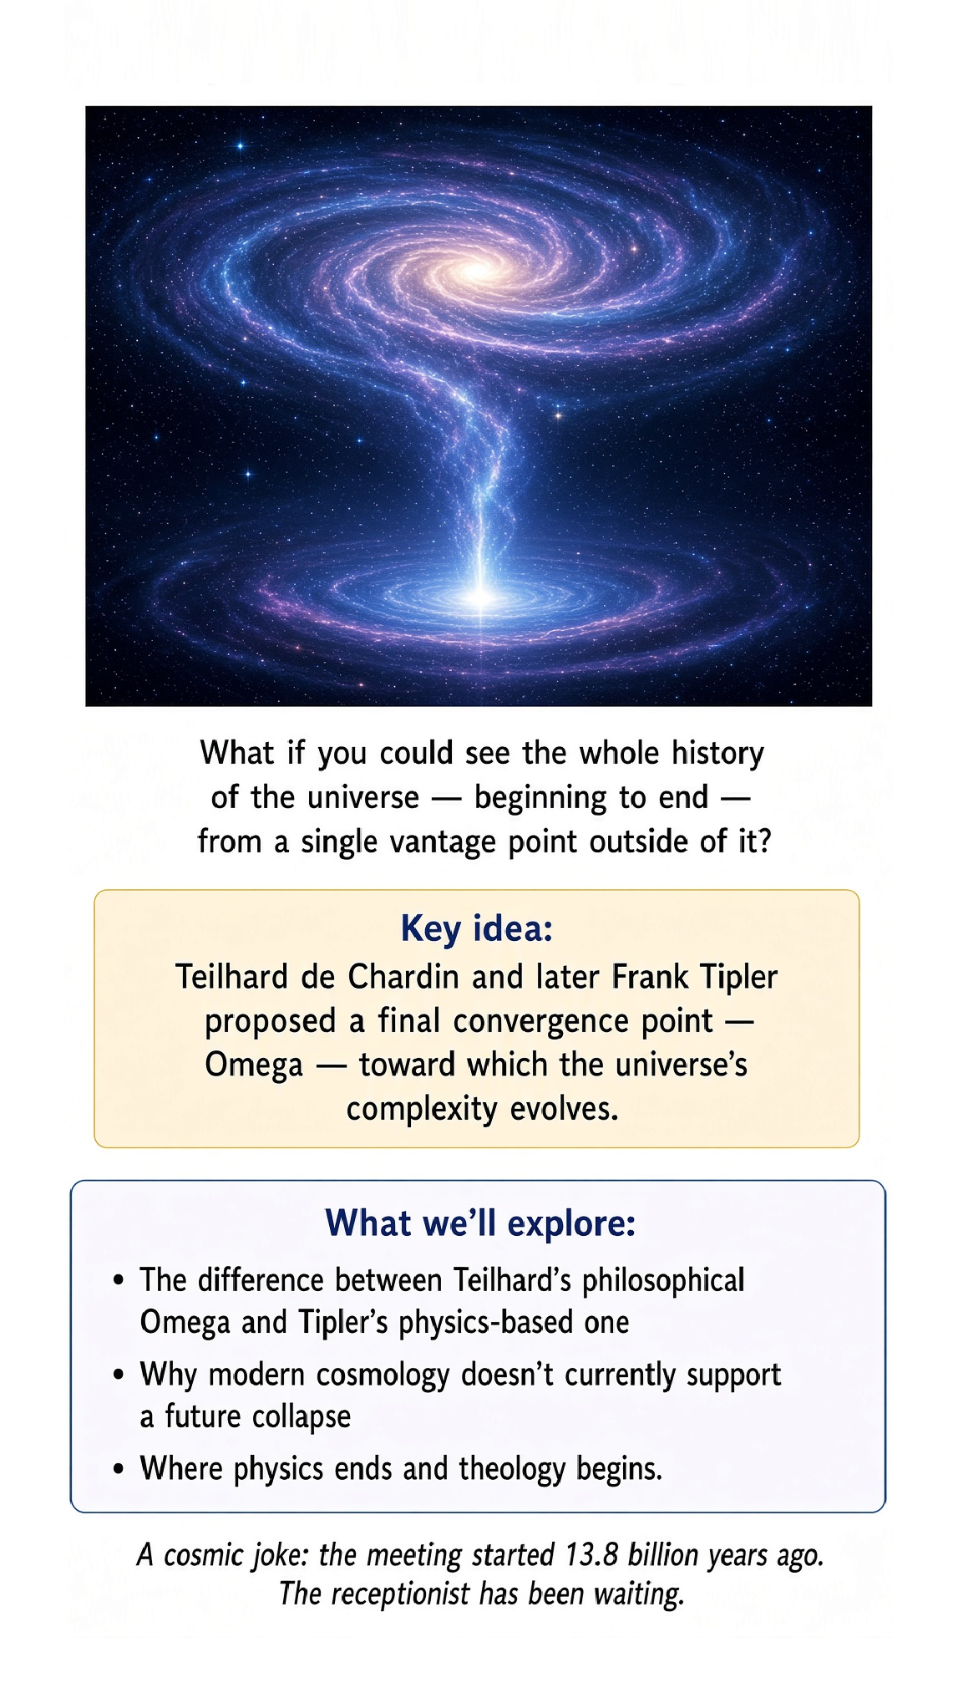

What If You Could Stand Outside Time?
Imagine a viewpoint from which you could see the entire history of the universe at once. Not yesterday. Not today. Not tomorrow.
All of it. The Big Bang. The first stars. The formation of Earth.
Your birth. This sentence. The last stars. The final state of the cosmos.
You would not be sitting somewhere at a later time looking backward. The strange idea is that the viewpoint itself would somehow be outside ordinary space and time. That is where our story of the Omega Point begins.

Teilhard's extraordinary idea
Pierre Teilhard de Chardin was a Jesuit priest, paleontologist, and philosopher who tried to understand cosmic evolution as a process moving toward increasing complexity and consciousness. His Omega Point was the proposed ultimate convergence of that evolutionary process. Omega was not simply the last event on a cosmic calendar. It was conceived as a transcendent point toward which evolution converges.
Teilhard's language was deeply philosophical and theological. He was not writing a modern physics textbook. But the idea became influential precisely because it asked an enormous question: Could the universe have a final state that is not merely another event inside the universe, but somehow transcends ordinary space and time?

A universe with a destination?
Modern cosmology does not tell us that the universe has a predetermined destination. The standard scientific picture describes how the universe evolves from its early state according to physical laws. Whether there is a final cosmic purpose is a different question. Teilhard made that question central.
He imagined evolution not as a random wandering through possibilities, but as a process in which matter becomes increasingly organized, life appears, consciousness develops, and everything converges toward Omega. That is a gigantic claim. And it is exactly the sort of claim that becomes interesting when we separate what physics establishes from what philosophy proposes.

The outside viewpoint
Here is the idea that connects beautifully with our previous chapters. If time is not fundamental, perhaps there is no requirement that the ultimate description of reality be written from the viewpoint of an observer moving along a timeline. A complete description might contain relationships among configurations without requiring an external clock. From such a hypothetical perspective, the entire history could be treated as one structure.
This is not a demonstrated physical viewpoint. It is a conceptual experiment. But it gives us a remarkable way to think about Barbour, relativity, and the Omega Point in the same conversation.

Omega is not simply “the end of the universe”
This distinction matters. If a star explodes tomorrow, that is an event in spacetime. If the universe reaches some final cosmological state billions or trillions of years from now, that is also an event or boundary described within a cosmological model. The Omega Point, in Teilhard's conception, is more radical.
It is not merely the last page of the book. It is something like the point toward which the whole book is converging. And Teilhard's language goes beyond ordinary spacetime altogether. That is where philosophy and theology enter the room.

Then Tipler arrives with a calculator
Frank Tipler took the Omega Point idea and attempted something radically different. Instead of treating Omega primarily as a metaphysical or theological endpoint, he tried to formulate an Omega Point cosmology using general relativity, quantum theory, thermodynamics, and ideas from computation. His book The Physics of Immortality develops the proposal at enormous length. And when I say enormous, I mean that the table of contents contains sections on cosmology, quantum mechanics, the Omega Point boundary condition, computation, resurrection, and even an appendix for scientists.
Tipler was not exactly afraid of ambition.

Tipler's universe gets very weird
Tipler proposed a future cosmological scenario in which the universe ultimately approaches a special final state—the Omega Point. As the final state is approached, he argued that the available computational capacity could become extraordinarily large. This led him to a breathtaking chain of ideas involving information, intelligence, consciousness, and the possibility of reconstructing or emulating past persons.
In his published formulation, Tipler explicitly identified the Omega Point with a God-like final state and described it as transcendent to spacetime while also being related to the physical universe. This is not standard cosmology. It is a highly speculative theory with philosophical and theological consequences.

The resurrection problem
Tipler pushed the idea even further. If sufficiently advanced intelligence could eventually perform enormous amounts of computation, could it reconstruct the informational patterns corresponding to people who lived in the past? That is the basic physical intuition behind his proposed “resurrection.” The idea is astonishing.
It is also enormously controversial. To be clear, modern physics has not established that people can be resurrected by computation at the end of the universe. Tipler proposed a cosmological framework in which something like this could occur. That distinction is essential.

The universe as a computer
Now we encounter another theme. Information. We have already seen information appear in quantum mechanics, entropy, black holes, and the arrow of time. Tipler connected the Omega Point to the ultimate computational capacity of the universe.
If the universe approaches a special final cosmological state, perhaps the amount of computation that can be performed becomes enormous. The deeper philosophical question is then: Is information more fundamental than we usually think? Could a sufficiently complete physical description of a person amount to the information needed to reconstruct that person?
That question takes us far beyond ordinary cosmology.

The final observer
Here is where the “outside time” idea becomes especially seductive. Imagine an observer at the Omega Point. The observer is not simply sitting at the end of a very long timeline with a wristwatch. The claim is that the final boundary itself can have a special relationship to the entire history of the universe.
From that limiting perspective, the distinction between “earlier” and “later” can become radically different from our everyday experience. In Tipler's theory, the Omega Point is associated with a final boundary condition and with an extraordinary computational capacity. But again: this is a speculative cosmological proposal, not an established fact about the universe.

This sounds suspiciously like God
Yes. That is not an accidental feature of Tipler's theory. Tipler explicitly developed the Omega Point as a model with God-like properties. His 1989 paper describes the Omega Point theory as a model for an omnipresent, omniscient, omnipotent, evolving personal God who is both transcendent to spacetime and immanent in it.
That makes the proposal fascinating even if you reject its theological conclusion. It forces us to ask where the boundary lies between physics, metaphysics, and theology. And it gives us an excellent opportunity to practice intellectual hygiene: A mathematical possibility is not automatically a physical fact, and a physical hypothesis is not automatically a theological proof.

The Teilhard–Tipler difference
Teilhard and Tipler use the same striking name, but their projects are very different. Teilhard begins with evolution, consciousness, and a philosophical-theological vision of convergence. Tipler begins with cosmology, general relativity, quantum theory, computation, and a proposed final boundary condition. Teilhard's Omega is primarily a metaphysical and theological endpoint of cosmic evolution.
Tipler tries to turn Omega into a physical cosmological model and then draws theological consequences from it. The family resemblance is obvious. The methods are not.

And what does modern cosmology say?
Modern cosmology does not currently establish a future Omega Point of the kind proposed by Tipler. The observed universe is undergoing accelerated expansion. The simplest standard cosmological model does not predict a future collapse into a final singularity of the sort required by the classic Omega Point scenario. That is a serious problem for the original physical picture.
It does not make the philosophical question disappear. It simply means that we must not confuse an intriguing speculative model with the current best-supported cosmological model.

A cosmic joke about the end of time
There is something wonderfully absurd about the idea. We spend our lives worrying about being late. The universe may have an ultimate destination at which the entire concept of “late” becomes meaningless. Imagine arriving at the Omega Point and asking:
“Sorry I'm late.” Late for what? The meeting started approximately 13.8 billion years ago. The receptionist has been waiting.

Does the Omega Point solve Barbour's problem?
Not really. Barbour asks whether time is fundamentally real. The Omega Point asks whether the entire cosmic history could converge toward a final boundary with a special status. Those ideas can be combined conceptually, but one does not prove the other.
A timeless theory does not automatically contain an Omega Point. An Omega Point model does not automatically show that time is unreal. They are different ideas that happen to illuminate each other.

Does the Omega Point solve Reichenbach's problem?
Again, not automatically. Reichenbach asks why the universe has a temporal direction. An Omega Point proposal could supply a special boundary condition at the end of the universe. But that does not by itself explain why entropy increases in the direction we call future.
In fact, the relationship between boundary conditions, entropy, information, and the arrow of time is one of the deepest issues in cosmology. So our three chapters now create a useful triangle. Barbour asks about the existence of time. Reichenbach asks about its direction.
Omega Point ideas ask whether the whole history has a special ultimate boundary or convergence.

The dangerous phrase: “outside spacetime”
We should be very careful with this phrase. If spacetime is the arena in which physical events occur, what does it mean for something to be outside spacetime? It cannot simply mean “very far away.” Far away is still somewhere in space.
It cannot simply mean “very late.” Late is still a time. “Outside spacetime” is therefore a conceptual statement that requires a very different ontology. Teilhard uses the language metaphysically.
Tipler tries to connect it to a cosmological boundary. Neither usage should be casually translated into “there is a place outside the universe where someone is standing.”

The cosmic book analogy
Imagine a novel. The characters live inside the story. They experience one page at a time. They cannot jump to Chapter 17 and inspect it.
But the complete physical book contains every page simultaneously. From outside the story, “before” and “after” are relationships between pages. The analogy is imperfect. Our universe is not literally a book.
But it captures the conceptual leap. A viewpoint outside the ordinary temporal experience of the universe would not necessarily experience time as a sequence. It might instead relate to the whole structure. That is the intuition behind the phrase “outside time.”

But who is reading the book?
Now the analogy starts causing trouble. If the universe is the book, who is holding it? Where is the reader? What does “outside” mean?
If the reader is another physical object, then we have simply created a larger universe and moved the problem one level up. This is exactly why “outside spacetime” cannot be treated as an ordinary physical location. The phrase may be meaningful only in a very different mathematical or metaphysical sense. And that is where our humility should begin.

Why this belongs in science for everyone
The Omega Point is a perfect example of why science is not only about collecting facts. Sometimes a scientific idea leads directly into questions that mathematics alone cannot settle. What is time? What is consciousness?
Is information fundamental? Can the universe have a final boundary? Does a complete physical description of a person preserve what we mean by that person? Can a physical theory say anything about God?
These questions overlap physics, philosophy, cosmology, and theology. Our job is not to pretend they are all the same subject. Our job is to see exactly where one ends and another begins.

The scientific warning label
We should put a large warning label on this chapter. Teilhard's Omega Point is a philosophical and theological conception. Tipler's Omega Point theory is a speculative cosmological proposal. Neither is part of the established Standard Model.
Neither has demonstrated that consciousness survives death. Neither has demonstrated that the universe ends at an Omega Point. And the existence of a mathematically describable final boundary would not by itself prove the existence of God. But none of that makes the ideas useless.
A good thought experiment can be valuable even when nature eventually tells us that it was wrong.

One last look from nowhere
Imagine the impossible viewpoint again. No clock. No map. No “here.”
No “now.” The entire history of the universe is present as one vast structure. Stars appear. Planets form.
Life evolves. Brains become conscious. You open this book. You ask what time is.
Then the cosmic story continues toward whatever future the laws of physics actually permit. Perhaps there is an Omega Point. Perhaps there is not. Perhaps time itself is emergent.
Perhaps the universe simply expands forever. We do not know. But by asking whether there could be a viewpoint beyond space and time, we have reached the edge of a remarkable conceptual territory. And that is exactly where science becomes most fun.
Because at the edge, the honest answer is sometimes not “here is the answer.” It is: “We have no idea. Let's see what the universe says.”

Science for Everyone

Chapter 17

A History of Measuring Time

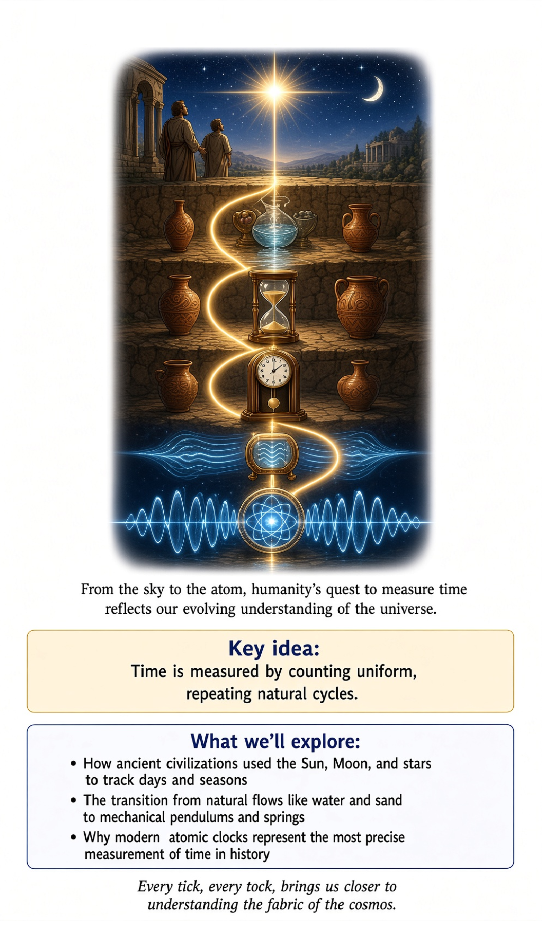
Before we let Einstein loose on the very concept of time, it is worth pausing to ask a more old-fashioned question: how did anyone ever measure time in the first place? Long before relativity taught us that time is relative, tangled up with space and motion, humans still needed to know when to plant crops, when to show up for a meeting, and how many hours of daylight remained before the wolves started sounding closer than they should.
The history of timekeeping is really the history of finding something, anything, that repeats reliably, and then agreeing to count the repetitions. It turns out that finding something reliably repetitive is much harder than it sounds, and the story of that search runs directly through astronomy, physics, and eventually the strange quantum world explored later in this book.

The first clock was the sky itself
The earliest timekeeping device available to humanity required no construction at all: the sky. The Sun rises and sets, giving us the day. The Moon waxes and wanes through a predictable cycle, giving us something close to a month. The stars shift position through the seasons, and the Sun's path against the background stars traces out a full circuit in a year. Ancient civilizations across the world, often with no contact with one another, independently built elaborate calendars and monuments to track these celestial rhythms, from Stonehenge to the pyramids to the astronomical observatories of ancient China and Mesoamerica.
The trouble with the sky as a clock is precision. It tells you the day, and roughly the season, but it does not easily tell you the hour, and it certainly does not tell you the minute. For that, humans needed to build something.

Shadows, water, and sand
The sundial was one of the earliest deliberately constructed timekeeping devices, using the Sun's position to cast a shadow onto a marked surface. Sundials are elegant, requiring no moving parts and no maintenance, but they have an obvious flaw: they stop working entirely at night, and they become unreliable on a cloudy day. They also, more subtly, do not divide the day into perfectly equal hours in the way we now expect, because the length of daylight itself changes with the seasons, a complication that ancient timekeepers solved in various clever but imperfect ways.
Water clocks, called clepsydrae, addressed the nighttime problem by measuring time through the steady dripping of water from one container to another, with markings indicating elapsed time as the water level fell. Variants of the water clock were used in ancient Egypt, Greece, China, and Persia, and some became remarkably sophisticated, incorporating gears and mechanical displays. Sand-filled hourglasses worked on a similar principle, and remained useful for centuries afterward for measuring fixed, short durations, such as timing a sermon or a ship's speed through the water.
All of these devices share the same fundamental weakness: they rely on a physical process, flowing water or falling sand, whose rate can be disturbed by temperature, humidity, wear, or simple manufacturing imperfection. None of them offered the kind of steady, self-correcting rhythm that the previous chapter's pendulum would eventually provide.

The pendulum changes everything
As covered in the previous chapter, a pendulum swinging through a small angle keeps remarkably steady time because its period depends only on its length and the local strength of gravity, not on the size of its swing. Galileo Galilei is often credited with first noticing this property, reportedly while watching a lamp swinging in a cathedral and timing it against his own pulse, though the full mechanical clock built around the idea came later, largely through the work of the Dutch scientist Christiaan Huygens in the seventeenth century.
The pendulum clock was a genuine revolution in timekeeping precision. Earlier mechanical clocks, driven by a slowly unwinding weight or spring and regulated by comparatively crude mechanisms, might lose or gain many minutes per day. Huygens' pendulum clock reduced that error to a matter of seconds per day, an improvement of roughly two orders of magnitude, achieved simply by harnessing a physical principle that had been swinging in front of humanity's eyes for the entire history of the species, waiting to be noticed.

The problem pendulums could never solve
Pendulum clocks had one enormous limitation: they only work properly when held still and level. A pendulum on a rocking, rolling ship is useless, since the ship's motion disturbs the pendulum's swing far more than gravity's steady pull. This was not a minor inconvenience. For centuries, the inability to keep accurate time at sea was a matter of life and death, because determining a ship's longitude, its east-west position on the globe, required comparing local time, determined from the Sun's position, against the time at a known reference location, such as home port. Without an accurate clock that could survive weeks at sea, sailors had no reliable way to know how far east or west they had traveled, and ships regularly wrecked on coastlines their navigators believed to be safely distant.
This problem became so severe that the British government offered a large cash prize, the Longitude Prize, for anyone who could solve it. The eventual solution came not from an astronomer but from a self-taught carpenter and clockmaker named John Harrison, who spent decades designing and refining a series of marine chronometers, mechanical clocks that used carefully balanced springs and temperature-compensating mechanisms instead of a pendulum, allowing them to keep accurate time despite a ship's rocking motion and changing climate. Harrison's fourth and most successful design, completed in 1759, lost only a few seconds over a voyage of many weeks, a staggering achievement of mechanical engineering that finally made reliable ocean navigation possible.

Quartz: letting a crystal do the counting
The next major leap in timekeeping precision came from an entirely different physical phenomenon: the piezoelectric effect, in which certain crystals, most notably quartz, generate a small electric voltage when mechanically stressed, and conversely vibrate at a very precise, stable frequency when an oscillating voltage is applied to them. A properly cut quartz crystal vibrates at a rate determined by its size and shape with extraordinary consistency, far steadier than any mechanical pendulum or spring could achieve, because the vibration depends on the crystal's rigid atomic structure rather than on moving mechanical parts subject to friction and wear.
Quartz clocks and watches, which became widely available to consumers starting in the 1960s and 1970s, typically keep time to within a few seconds per month, an enormous improvement over the best mechanical watches, and they achieve this using nothing more exotic than a tiny sliver of vibrating crystal and some simple electronics to count the vibrations. This is why an inexpensive modern quartz wristwatch keeps far better time than the most exquisitely crafted mechanical pocket watch from a century earlier.

Atoms: the clock that changed the definition of the second
Even quartz crystals, however, are not perfectly consistent, since their vibration rate depends slightly on temperature, aging, and manufacturing variation. The most precise clocks ever built rely on something even steadier: the internal structure of atoms themselves. Electrons within an atom can only occupy certain specific, discrete energy levels, a fact explored more fully in the quantum mechanics chapters of this book, and an atom transitioning between two particular energy levels absorbs or emits electromagnetic radiation at an extremely precise, unchanging frequency, determined entirely by the fundamental physics of that type of atom, identical everywhere in the universe.
Modern atomic clocks, most commonly built around the element cesium, measure time by counting the oscillations of microwave radiation corresponding to a specific transition in the cesium atom. This method is so reliable that in 1967 the international scientific community formally redefined the second itself, no longer in terms of Earth's rotation or orbit, but as exactly 9,192,631,770 oscillations of the radiation corresponding to a particular transition in a cesium-133 atom. The best atomic clocks today are accurate to better than one second over many millions of years, a level of precision that would have seemed like pure fantasy to anyone squinting at a sundial or nursing a dripping water clock through the night.

Why any of this matters for the rest of the book
This entire progression, from shadows to water to swinging pendulums to vibrating crystals to oscillating atoms, is a story about finding increasingly reliable repeating processes and agreeing to count them. It is worth keeping in mind as this book turns next to Einstein's relativity, because relativity does not merely add a philosophical wrinkle to an otherwise settled concept of time. It directly concerns the behavior of clocks, real physical clocks, built from real physical processes exactly like the ones in this chapter.
When relativity says that a moving clock runs slow, it means precisely that: an atomic clock, or in principle even an old-fashioned pendulum clock, genuinely ticks at a different rate when it is moving relative to an observer, or sitting in a different gravitational environment, compared to an identical clock at rest nearby. This is not a statement about perception or measurement error. It is a statement about the actual physical rate of a real repeating process, the same kind of repeating process humanity has been chasing, refining, and trusting more and more precisely, for as long as we have cared what time it is.

The punchline
Keeping time has always meant finding something that repeats reliably and counting the repetitions: the Sun's daily arc, a dripping trickle of water, a swinging pendulum, a vibrating quartz crystal, and finally the quantum transitions of a cesium atom, each one steadier than the last by orders of magnitude. Every improvement in timekeeping accuracy has come from physics, not from cleverer counting, and every one of those improvements eventually made something new possible, from safe navigation across oceans to GPS satellites accurate enough to guide you to the correct coffee shop.
Now that you have seen how hard-won an accurate clock actually is, the next chapter's claim, that clocks themselves can be persuaded to run at different rates depending on how they move through the universe, should feel less like a philosophical trick and more like the next entry in a very long and very physical story.

Science for Everyone

Chapter 18

Special Relativity: The Geometry of Light

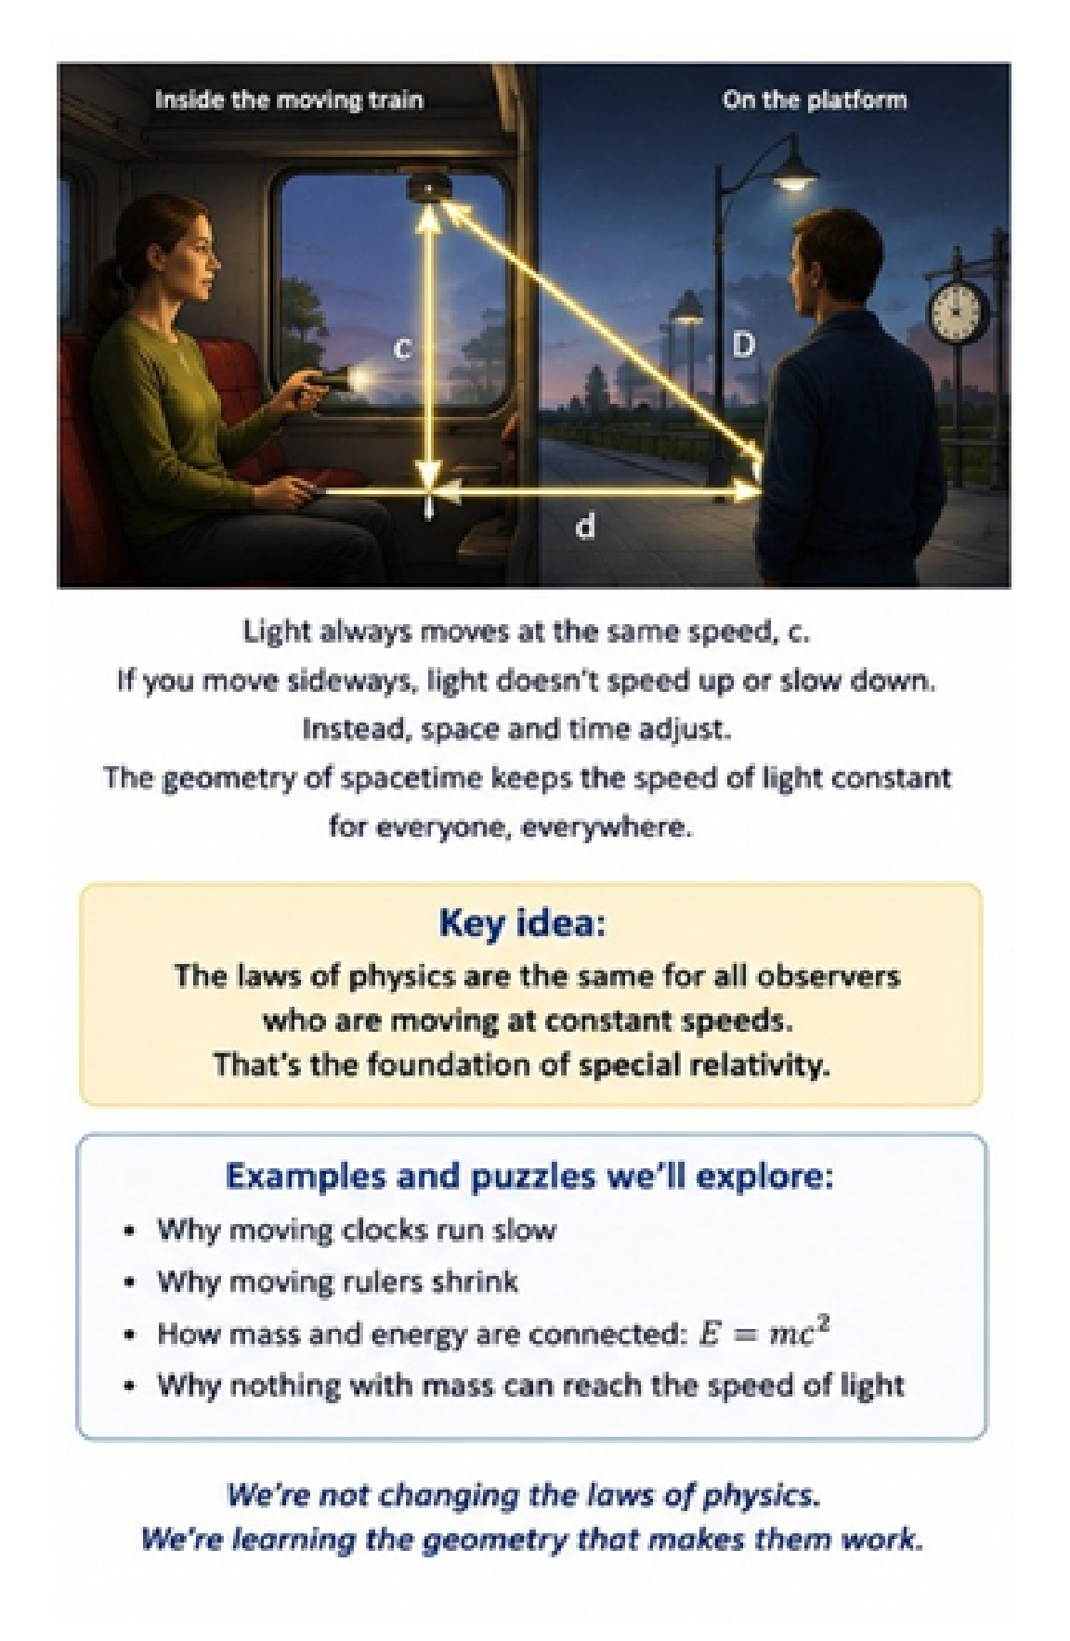
We are now ready for one of the great shocks of physics. Until this point, we have been talking about motion, time, and energy as though they were separate ideas. Special relativity ties them together. And the surprising part is that we can begin without Einstein's equations.
We can begin with a circle.

Thales, Pythagoras, and a very useful circle
More than two thousand years ago, mathematicians noticed a beautiful relationship between circles and right triangles. Draw a circle. Choose two points at opposite ends of a diameter. Choose a third point anywhere on the circle.
Connect the three points. The triangle you have created is always a right triangle. This is the famous theorem associated with Thales. Now we can bring in Pythagoras.
For a right triangle, the square of the hypotenuse equals the sum of the squares of the two shorter sides. If the sides are x and y, and the hypotenuse is r, then:
x² + y² = r²
This is not yet relativity.
It is geometry. But it gives us a wonderfully simple way to think about motion.

The light clock
Imagine a very simple clock. It consists of two mirrors, one above the other, with a pulse of light bouncing between them. Light travels upward. It reflects from the top mirror.
It travels downward. It reflects from the bottom mirror. Each round trip is one tick. If the clock is sitting still, the light travels straight up and down.
Now put the clock on a spaceship moving sideways. From the perspective of someone watching the spaceship fly past, the light does not travel straight up and down. It travels diagonally. The clock's light pulse now follows the diagonal of a triangle.
And here is the crucial point: Everyone measures the speed of light to be c. The person on the spaceship says the light traveled straight up and down at c. The person watching from Earth says the light traveled along a longer diagonal path at c. Both must be right.
So something has to change. The answer is time.

x is space, y is time
Let's make the picture even more useful. Put the spatial distance traveled by the spaceship along the horizontal axis. Call it x. Put the amount of time measured by the moving clock along the vertical axis.
Call it y for the moment. The light's path is the diagonal. We now have exactly the geometry of a right triangle. The diagonal represents the path of light.
The horizontal side represents motion through space. The vertical side represents motion through time. And the speed of light gives us the scale connecting them. This is where the picture becomes extraordinarily powerful.
The moving observer and the stationary observer do not agree on how much of the story belongs to “space” and how much belongs to “time.” But they agree on the deeper spacetime relationship. It is as though they are looking at the same geometric object from different angles.

Everything is moving through spacetime
Now comes one of the most beautiful ideas in this subject. Think of an object as always having a kind of motion through spacetime. If you are sitting perfectly still in your chair, you are not moving through space. But you are moving through time.
Your entire “motion budget,” in this picture, is directed along the time axis. Now stand up and walk across the room. Some of your motion is now through space. You are still moving through time, but the geometric description has changed.
Run across the room. More of the motion is directed through space. The extraordinary Epstein insight is to picture the total spacetime motion as having a fixed magnitude related to c. In the simplest visual version, space and time form the two perpendicular legs of a Pythagorean triangle, while the light-speed scale forms the diagonal.
This is a powerful intuition for special relativity. But we need to be careful. Ordinary Euclidean Pythagoras is not the exact mathematical geometry of spacetime. Minkowski spacetime has a different metric, with a crucial minus sign between the spatial and temporal parts.
So the picture is an intuition, not the final equation. That distinction matters. Good physics gives you a picture first, and then tells you exactly where the picture stops being literal.

Why moving clocks run slow
Now the famous result almost falls out of the picture. Suppose your entire spacetime motion is represented by a fixed diagonal. If you are stationary in space, the diagonal points entirely along the time direction. You experience the maximum possible passage of your own proper time.
Now you begin moving through space. The spacetime direction tilts. Some of the geometric separation is now associated with spatial motion. The amount of proper time between events is therefore different from the time measured by an observer who sees you moving.
This is time dilation. The faster you move through space, the less proper time elapses between the same pair of events along your path. At ordinary speeds, the difference is absurdly tiny. At speeds close to c, it becomes enormous.
You are not “breaking” your clock. Your clock is faithfully measuring the time along its own path through spacetime.

The speed of light is the limit
There is a remarkable consequence. An ordinary massive object cannot simply keep increasing its spatial speed until it reaches c. As its speed approaches c, the relativistic effects become increasingly extreme. The amount of energy required to accelerate the object further rises dramatically.
For an object with mass, reaching c would require an impossible amount of energy. Light is different. A photon has no rest frame in the ordinary sense, and light travels at c in vacuum. So you can think of c not merely as “the speed of light,” but as a fundamental conversion factor connecting space and time and defining the causal structure of spacetime.
That is why writing time as ct is so useful. Time multiplied by c has units of distance. A year of time corresponds to one light-year of light travel. A second corresponds to about 300,000 kilometers of light travel.
Space and time have suddenly become quantities that can be drawn on the same diagram.

The Thales circle becomes a spacetime picture
Now return to our circle. For ordinary Euclidean geometry, the points on a circle satisfy:
x² + y² = r²
For special relativity, we have to modify the geometry.
The invariant quantity is not ordinary Euclidean distance through spacetime. Instead, the spacetime interval has the structure:
(cΔt)² − (Δx)²
in one spatial dimension, with corresponding additional terms when there are more dimensions.
The minus sign is not a small technical detail. It is what makes relativity relativity. It separates time-like, light-like, and space-like intervals and gives spacetime a geometry fundamentally different from the geometry of an ordinary sheet of paper. So the Thales-and-Pythagoras picture gets us to the doorway.
Minkowski geometry takes us through it.

Why different observers disagree
Imagine two people watching the same spaceship. One person is on Earth. The other is inside the spaceship. They do not agree about the ship's motion through space.
That is expected. But now the spacetime picture tells us something deeper. They also do not agree about how much time passes between certain events. And they do not necessarily agree about whether two distant events happened simultaneously.
This is not because one observer made a mistake. There is no hidden master answer waiting to be revealed. The observers are slicing spacetime into space and time differently. Their measurements of space and time can differ while the underlying spacetime interval remains the same.
That invariant is the thing nature protects.

The train and the lightning bolts
Let's revisit our railway platform. Two lightning bolts strike opposite ends of the platform. An observer standing halfway between them sees the flashes arrive simultaneously. Now a train moves toward one flash and away from the other.
The passenger receives one flash first. In Newton's universe, we would say that the passenger and the platform observer disagree about when the light arrived, but they must still agree about when the strikes happened. Special relativity says something more radical. They can disagree about the simultaneity of the strikes themselves.
There is no universal “now” stretching across the universe. The spacetime picture makes this less mysterious. Different observers are using different decompositions into space and time. They agree on the physical events.
They can disagree on the time coordinate assigned to those events.

A tiny bit of algebra
We can now write the famous Lorentz factor:
γ = 1 / √(1 − v²/c²)
The Greek letter gamma appears everywhere in special relativity. As v becomes small compared with c, the quantity v²/c² is tiny, and gamma is very close to 1.
That is why Newtonian physics works so well in ordinary life. But as v approaches c, gamma becomes very large. This is where time dilation, length contraction, and relativistic energy become impossible to ignore. The equation is not magic.
It is the mathematical consequence of demanding that the laws of physics work consistently for all inertial observers while everyone measures the same speed of light. That is an extraordinary amount of physics packed into one square root.

The twin story
Suppose twins are born on Earth. One stays home. The other boards a spacecraft and travels at a speed extremely close to c. The traveling twin returns.
Less time has elapsed for the traveler. The twins are no longer the same age. This is the famous twin paradox. There is no contradiction.
The situation is not perfectly symmetric because the traveling twin changes reference frames when turning around and coming home. The spacetime picture makes the answer almost visual. The twins followed different paths through spacetime. Different paths can contain different amounts of proper time.
The traveler took the shorter proper-time path between the departure and reunion events. So the traveler is younger. This sounds like science fiction. It is a consequence of geometry.

You are not standing still
Look at yourself sitting in a chair. In everyday language, you are stationary. In spacetime, that is only partly true. You are moving through time.
The Earth is rotating, so you are moving through space as well. The Earth orbits the Sun. The Sun moves through the galaxy. And all the while, your worldline—the path you trace through spacetime—is continuing.
You do not need to imagine yourself racing through the universe. You simply need to stop thinking of “space” and “time” as completely separate boxes. Your life is a path through spacetime. Every event in your life is a point on that path.
Birth. Breakfast. Your first day of school. The moment you read this sentence.
Whatever you do next. Physics calls the collection of those events your worldline.

What special relativity really changed
Special relativity did not merely tell us that clocks can run slow. It changed our picture of reality. Space and time are not independent absolute stages. They are intertwined.
Different observers can measure different distances and different elapsed times. But they agree on deeper spacetime relationships. The speed of light is the same for all inertial observers. Causal influence cannot simply outrun light.
And mass and energy are connected through the famous equation:
E = mc²
That equation is part of the same revolution. Once you see the geometry, the strange results stop looking like a collection of unrelated tricks. Time dilation.
Length contraction. Relativity of simultaneity. Mass-energy equivalence. They are all consequences of the same underlying structure.

One last picture
Imagine drawing a circle. Draw a right triangle inside it. Think of one direction as space and the other as time. Think of the diagonal as the fixed light-speed scale.
Now imagine rotating the observer's viewpoint. The horizontal and vertical components change. The deeper invariant remains. That is the heart of special relativity.
Not clocks behaving badly. Not rulers shrinking mysteriously. Not Einstein performing mathematical magic. Geometry.
The geometry of spacetime. And once you become comfortable with that picture, the universe becomes much less mysterious. It is still weird. But now it is weird in a way you can draw.

Science for Everyone

Chapter 19

Limits of Nature

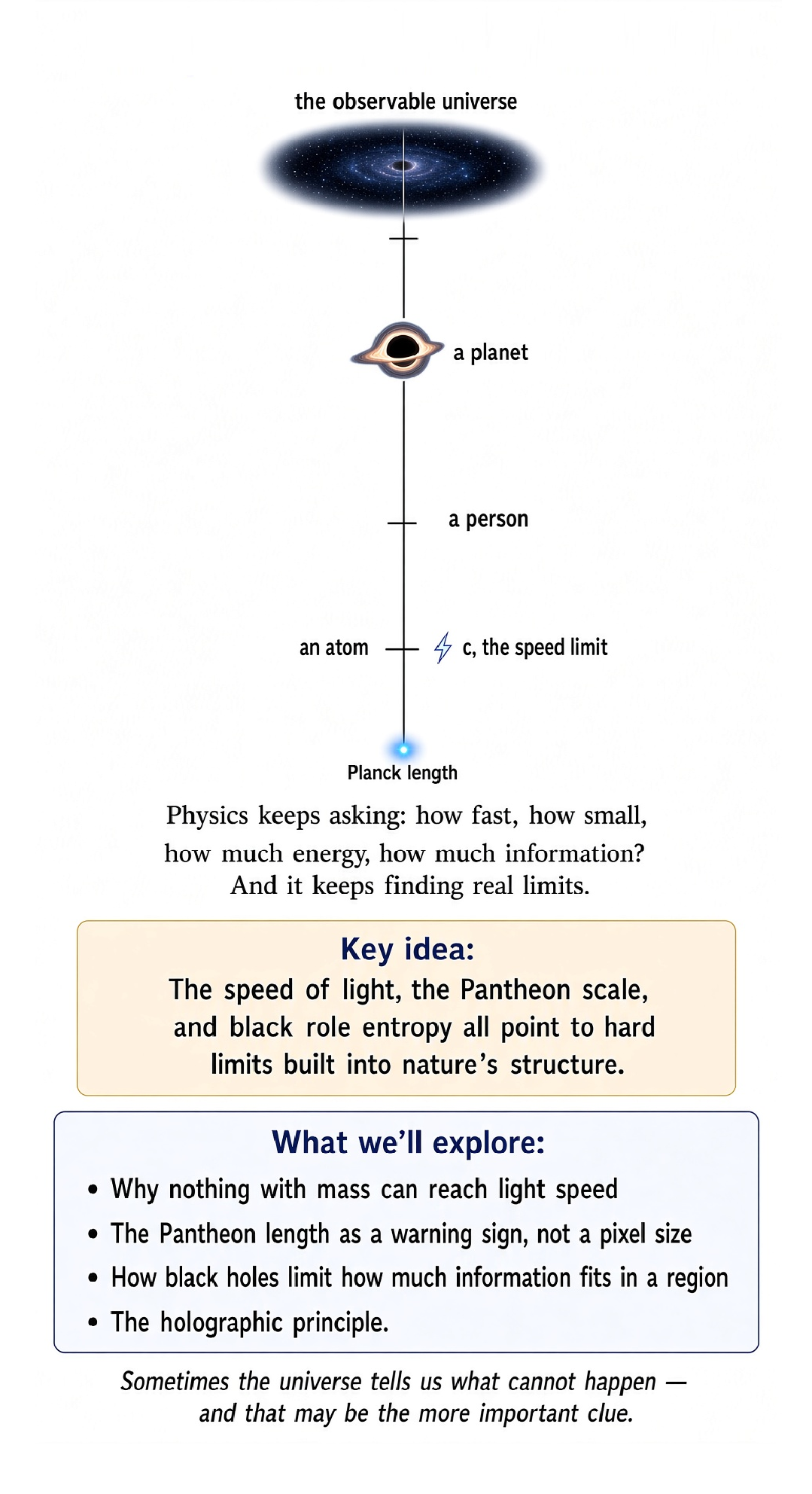

The Universe Has Rules
There is a peculiar habit in physics. We keep asking: How fast can it go? How small can it get?
How much energy can we pack into something? How much information can a physical system contain? These sound like engineering questions. But physics keeps answering with something much more interesting:
There are limits built into nature itself.

The Most Famous Limit
Start with the obvious one. The speed of light. Nothing with rest mass can be accelerated through c. This is not because our engines are inadequate.
It is not because the universe has a particularly annoying speed camera. The speed c is part of the causal structure of spacetime. As a massive object approaches c, the energy required to accelerate it further rises dramatically. Reaching c would require an unbounded amount of energy in special relativity.
The limit belongs to the geometry.

But c Is More Than a Speed
Calling c “the speed of light” is convenient. Calling it the invariant speed is deeper. Light travels at c in vacuum because electromagnetic waves obey the relativistic structure of spacetime. But c also determines how space and time fit together.
It appears in the Lorentz transformations. It determines causal cones. It connects mass and energy through the relationship:
E = mc²
It is less like the top speed of a particular object and more like a conversion factor built into reality.

The Quantum Limit on Action
Quantum mechanics gives us another fundamental constant: ħ, the reduced Planck constant. It sets the scale of quantum action. Classical physics can often treat action as continuously variable.
Quantum mechanics introduces a characteristic scale at which the discreteness of quantum effects becomes unavoidable. This does not mean every physical action literally comes in chunks of ħ. It means ħ tells us when classical intuition stops being adequate.

Build a Length From Three Constants
Now combine three constants: c — the invariant speed. G — Newton's gravitational constant. ħ — the quantum of action.
Dimensional analysis lets us construct natural scales from them. The result includes the Planck length, approximately 1.6 × 10⁻³⁵ metres. That number is absurdly small. It is not the size of a known particle.
It is a warning sign. At scales around the Planck length, quantum mechanics and gravity are both expected to matter strongly. Our existing theories are no longer expected to tell the whole story.

The Planck Time
The same constants produce a natural time scale: the Planck time, roughly 5.4 × 10⁻⁴⁴ seconds. Again, this does not prove that time is made of Planck-sized ticks. It tells us that if we push our present theories toward sufficiently extreme conditions, this is the scale at which quantum gravity becomes unavoidable.
Nature has not handed us a stopwatch that clicks every Planck time. We should resist the temptation to invent one.

Can Space Be Smaller Than That?
This is where things become speculative. Some approaches to quantum gravity suggest that the Planck scale may represent a fundamental limit to how sharply spacetime can be defined. Other approaches do not necessarily interpret it that way. The safe statement is:
the Planck scale is where our current theories are expected to need replacement or unification. That is already astonishing enough. We do not need to turn a warning label into a confirmed fact.

The Universe Has a Gravitational Limit Too
Gravity introduces another kind of constraint. Pack enough energy into a small enough region and gravity becomes overwhelmingly strong. Eventually, you can form a black hole. The important lesson is not simply that black holes exist.
It is that gravity can turn attempts to concentrate information or energy into a geometric object with an event horizon. You cannot keep squeezing forever without changing the nature of the system.

Black Holes Put a Limit on Information
Here physics gets truly strange. Black-hole thermodynamics tells us that black-hole entropy is proportional to the area of its horizon, not the volume inside it. That was one of the clues behind the holographic principle. A gravitational system seems to have an information capacity related to its boundary area.
The universe has apparently installed a storage limit. And, in classic physics fashion, the storage medium is a black hole.

A Maximum Force?
There is also a provocative line of thought involving a natural gravitational force scale of order c⁴/G. The exact interpretation and status of such a “maximum force” depend on the formulation and on what assumptions are made. So this is not in the same experimental category as the invariant speed c. It is better treated as a clue about the scales at which gravity and relativity impose natural constraints.
This distinction matters. Not every elegant dimensional combination is automatically a law of nature.

Thermodynamics Says: Not So Fast
The second law of thermodynamics gives us another kind of limit. Entropy tends to increase for an isolated macroscopic system. You can reverse individual microscopic equations. But you cannot casually reverse a scrambled egg.
The number of possible microscopic arrangements corresponding to a macroscopic state matters. Thermodynamics therefore limits what macroscopic processes can accomplish spontaneously.

Information Has a Physical Price
Information sounds abstract. Physics does not let it remain abstract for long. Erasing information has thermodynamic consequences. Quantum information has physical states.
Black holes have entropy. Computers require energy and produce heat. The boundary between information and physics has become one of the most fascinating areas of modern science. The bit, it turns out, is not weightless philosophy.
It lives in matter.

The Holographic Surprise
If black-hole entropy scales with area, perhaps the amount of information in a region of space is fundamentally constrained by its boundary. This inspired the holographic principle. In certain well-defined theoretical settings, such as the AdS/CFT correspondence, a gravitational theory in a higher-dimensional spacetime can be related to a quantum theory living on a lower-dimensional boundary.
That is a powerful result. But it does not mean we have experimentally proved that our everyday universe is literally a hologram. Again: beautiful clue, not permission to overstate it.

The Smallest Scale and the Biggest Question
At one end we have the Planck length. At the other, the observable universe. Between them lies roughly everything we can currently observe. Physics has learned astonishingly much across that range.
But the extremes are where the theories begin to complain. Quantum mechanics works extraordinarily well. General relativity works extraordinarily well. Yet at the Planck scale, we need a theory in which both are true at once.
That missing theory is one of the great problems of physics.

Limits Are Clues, Not Walls
A limit in physics is not necessarily a brick wall. The speed c does not mean nothing interesting can happen near it. The Planck length does not necessarily mean space has pixels. The entropy bound does not mean the universe has a literal hard drive.
The point is subtler. When a theory produces a natural invariant scale, it tells us something about the architecture of the theory—and possibly about the deeper theory that replaces it.

A Dangerous Habit: Turning Numbers Into Myths
Physics produces famous numbers. c. ħ. G.
The Planck length. The Planck time. The Hubble scale. People then turn them into slogans.
That is useful until it isn't. A number becomes a myth when we forget what was actually derived, what was measured, and what remains conjectural. The cure is simple: always ask what the number means.
Part of what makes these numbers feel mythical is a bit of an accident: they look strange mainly because of the units we happen to use. The speed of light is a peculiar 299,792,458 meters per second only because the meter and the second were defined by human-scale concerns, a fraction of Earth's meridian and a fraction of a day, long before anyone knew light had a speed worth measuring. Choose units more suited to the universe itself, and the strangeness can simply disappear. Physicists call this system natural units, and in the most common version of it, c, ħ, and G are all defined to equal exactly 1. Distances, times, and masses are then measured in multiples of the Planck length, the Planck time, and the Planck mass, and the equations of relativity and quantum gravity lose most of their clutter of constants.
That should sound like a magic trick, and in a sense it is. It does not mean the universe secretly prefers the number 1, or that the speed of light is not really extreme. It means that 299,792,458 meters per second was never a fact about nature so much as a fact about the awkward relationship between the meter, the second, and the actual invariant speed built into spacetime. The universe does not care what units we use. But we do, because a natural-units physicist casually saying that a journey took 4 lightyears of time is precise and elegant, while a human trying to picture 4 in the abstract has nothing to hold on to. Meters and seconds are clumsy, historically arbitrary, and completely indispensable, because they are sized to match bodies, rooms, and heartbeats rather than photons and singularities. The large or tiny numbers are not the universe being mythical. They are the price of using units built for creatures like us.

What We Know, What We Suspect
Here is the status check. ESTABLISHED: c is invariant in special relativity; quantum mechanics contains ħ; black holes exist; black-hole entropy follows the area law in the appropriate theoretical framework; thermodynamic entropy has enormous experimental support. STRONGLY MOTIVATED: quantum gravity should become important around the Planck scale. ACTIVE RESEARCH: holography, quantum gravity, microscopic interpretations of spacetime.
SPECULATIVE: that the Planck length is literally the smallest possible length, or that every proposed “maximum force” is a universal fundamental law.

The Deeper Pattern
Look at what keeps happening. Relativity gives us a causal limit. Quantum theory gives us a quantum scale. Gravity gives us horizons.
Thermodynamics gives us entropy. Black holes connect gravity, thermodynamics and information. The apparent limits begin to look less like unrelated restrictions and more like pieces of one deeper structure. That is one reason physicists take them so seriously.

The Punchline
We began by asking how fast something can go. Then we discovered that nature also cares about how sharply we can define things, how much information can fit into a region, how much entropy a system can contain, and how violently we can concentrate energy before gravity takes over. The universe is not an infinitely flexible playground. It has rules.
Some we understand. Some we strongly suspect. Some we are still arguing about. And the most interesting limits may be telling us where the next revolution in physics is hiding.
The universe does not merely tell us what can happen. Sometimes it tells us what cannot happen—and that may be the more important clue.

